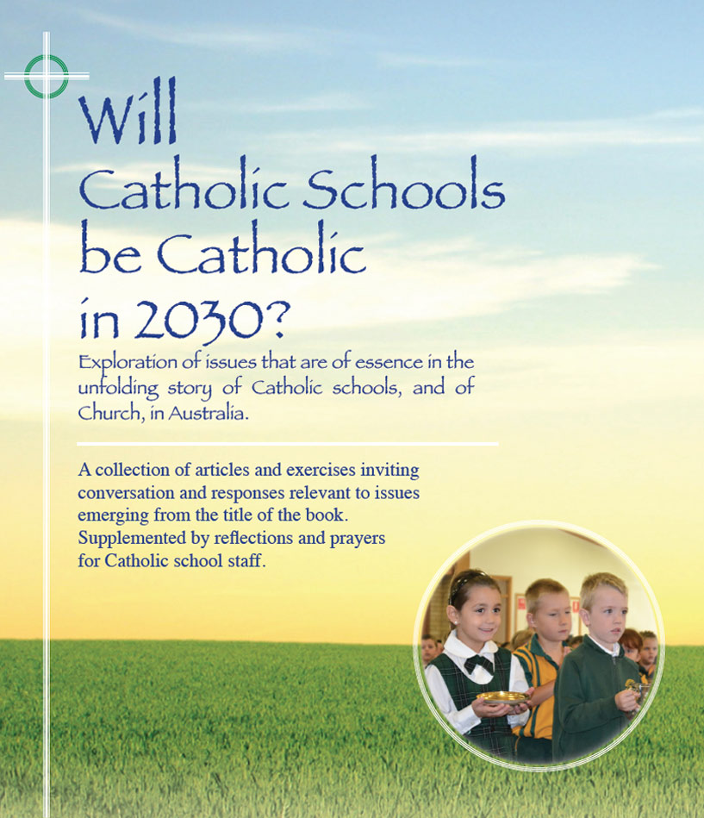
Themes
Pages 22-27

Will Catholic schools be Catholic
in 2030? – School Principals reflect

- ‘Given the faith commitment I witness among many school leaders and teachers, I am confident that the schools will be authentically Catholic in 2030. Let us make sure however that we do not take this for granted’ (Sr Brenda Kennedy)
- ‘Religious -Sisters and Brothers mainly- were integral to the development and identity of Catholic schools for many generations. I have been a beneficiary of their rich legacy. Likewise, as a last member of ‘that tribe’, I feel privileged and inspired to be part of the new generation of school leaders and staff.’ (Br Nicholas Harsas)
- ‘When the time came for Xavier College to have a ‘front door’, this is the first message I wanted to be seen by everyone who entered: ‘Christ: the reason, the teacher, the model and the inspiration.’ I believed that I would want no other mission statement’
‘My hope is that this belief filters down to all members of the Xavier community. Whether that person is a teacher or a student, or a parent, our actions should be shaped by the person of Christ, the most charismatic and courageous change agent of all time’
(Tricia Maidens)

For discussion

- Fifty years ago - 1965 - there were over 3,600 Religious, mainly nuns and brothers, actively engaged as teachers and leaders in Catholic schools in NSW. Now Sr Brenda and
Br Nicholas are among the small handful that marks the ‘last of the tribe’ in that ministry. What are some of their hopes for the future of Catholic schools that resonate with your hopes?
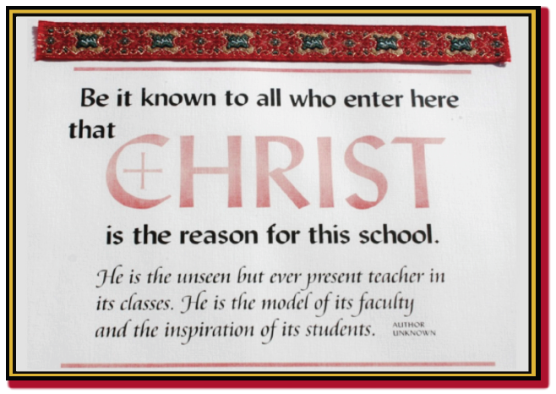
- Have a look at the inscription on the plaque that greets visitors to Xavier College, North Penrith, NSW. How would you feel about having a similarly inscribed plaque in the foyer of your school? To ensure that the plaque would not be but a pious aspiration, what initial education/ formation of staff might be necessary?

- Any other matters arising from the content of these pages?

Click on icon for PowerPoint

