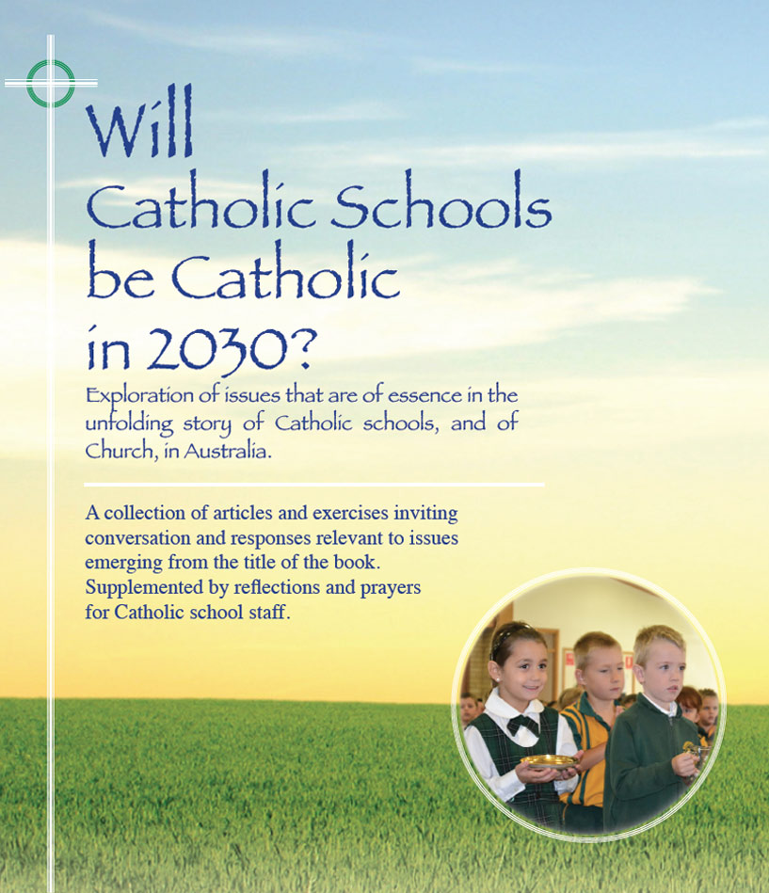
Themes
Pages 18-21

Will Catholic schools be Catholic
in 2030? – Dr Paul Monkerud

- ‘If the current trend continues, whereby fewer students, parents and teachers in Catholic schools participate in Sunday Eucharist, will Catholic schools be Catholic in 2030? It depends on whether regular Sunday worship is the sole criterion for assessing the Catholicity of the school.’
- ‘A Catholic school will be Catholic in 2030 to the extent that it fosters the call to discipleship of each of its members no matter what their stage of faith development, and honours its call to be a community of disciples that represent Jesus Christ and his teachings to the world. The Christocentric focus of the Catholic school will ensure that its teaching and learning outcomes intend the formation of the whole person – intellectual, physical, emotional, social and spiritual – rather than just the acquisition of knowledge and skills.’
- ‘If a school is to be Catholic in 2030, parents nominating their child for enrolment will be expected to accept all aspects of its Catholic charter. While the views of students, teachers and parents who are non-active Catholics or not Catholic will be respected, they will have to show a willingness not only to tolerate the Catholicity of the school but to embrace and promote it as far as possible, particularly its Christian values.’
- ‘The ongoing formation as religious leaders of Principals in particular but also Assistant Principals and RECs will be crucial if schools are to be Catholic in 2030... The religious dimension of their role will be amplified by the sacramental nature of Catholicism –the mediation of the sacred through symbols, whether objects, roles, or persons.’

For discussion

- Pick an issue arising for you in any of the quotes given above. In twos or threes, share your thoughts and feelings about Fr Paul’s assertion:’It depends on whether regular worship is the sole criterion for assessing the Catholicity of the school’.
What are some other criteria you would propose as authentic indicators of the Catholicity of the school?
- In your perception, is there frequently a mismatch between what a majority of parents are seeking and what the school publicly aspires to, in the religious domain especially?
If so, how does the school deal with this tension?
- Any remaining matters in pages 18-21 you find affirming? challenging? other?
Click on icon for PowerPoint

