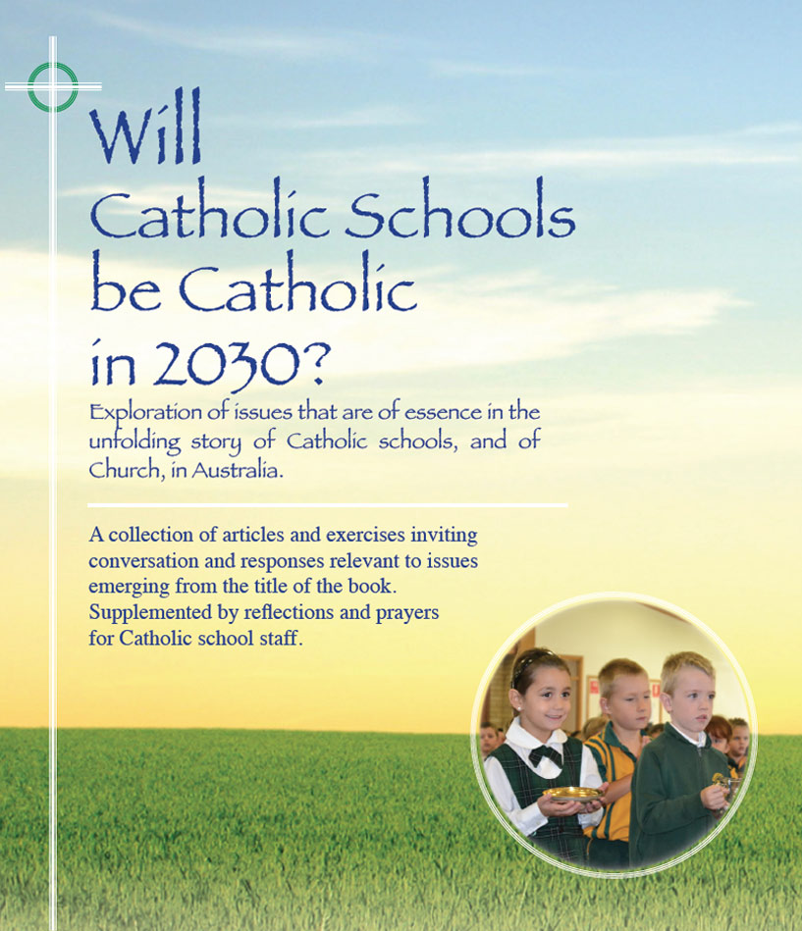
Themes
pp 135-140

Together we are better -
Towards partnerships that count

- Catholic schools exist to elevate and to sanctify the human condition. They can only do this effectively if they work in partnership with their constituents and associate agencies.
- Foremost among their constituents are the parents who commit their children to the care of the school.
- Parents are the primary educators of their children and in most cases, have been educating their children from the time of birth. Parents’ role as educators of their children does not stop when their children enter more formal phases of education. This is especially true in the social, spiritual, and moral domains of education.
- It is a responsibility of schools to honour these principles in action as well as in theory.

- Parents have a diverse range of expectations of schools. It is reasonable to assume however that a common expectation is that their child will learn to his/her fullest potential and that the wellbeing of their child will be a priority of the school.
- Hence, prompt and specific information ought to be communicated to parents where learning problems are perceived and where there is evidence of significant social problems. A sensitive sharing of such information ought to be but a first step in a dialogue between school and parents about a shared process in addressing perceived problems.
- Most schools are well advanced in policies and procedures to be proactive in initiating such dialogue. Occasional parent surveys may be helpful in providing data to guide a review of existing practices.
- Conventional wisdom and widespread research increasingly testify to the fact that students develop more positively and engage more actively within the school’s total curriculum where there is good rapport between school and home.
- Increasingly too, many parents seek some knowledge and understanding of the school’s policies and practices in the teaching and learning agenda. This development needs acknowledgement and response in the strengthening of partnership. Commonly schools address this issue in revised formats for parent-teacher meetings and through the use of the school website and newsletters.
- Parent expectation of schools covers a wide spectrum. A special challenge to schools is the establishment of rapport with parents who may not be at ease in communicating with schools except in the case of serious incidents. Recently arrived migrant families may fit into this category and are deserving of special sensitivity and encouragement by the school.
- Catholic parents especially have played a proud role in the story of Catholic schools. Through their financial and general support, they enabled Catholic schools to exist and to develop in the many years when no government money was available to church schools in Australia. It is good for present generations of system and school leaders and teachers to be mindful of this legacy.
- The Catholic school exists as an agent of the Church’s mission in the world. Because of this, Catholic schools, especially diocesan systemic schools, are called to work in close partnership with the parishes in which they are located.
- It devolves on the Catholic school to be proactive in initiatives that strengthen partnerships with the parish, especially in programs and practices which support religious and spiritual ministry to members of the school community.
- Collaboration in parish sacramental programs and ceremonies provides a favoured opportunity for schools and parishes, especially primary schools, to work closely in the provision of very significant and public religious experiences for students.
- It is a greater challenge for secondary schools to work thus closely with the wider variety of parishes from which the students are drawn. Nevertheless, many secondary schools have been sensitive and creative in hosting meetings of clergy from feeder parishes enabling the development of policies and strategies to ensure the regular provision of a sacramental ministry to students and to devise back-to-parish initiatives.
- Most parishes now have a core of committed lay people who exercise leadership in parish ministries and programs. Provision of a forum where some such parishioners could inform students of their role in the life of the church could be a helpful strategy in strengthening school-parish partnerships especially in cases where it may lead to shared projects.
- In general, wherever Catholic schools are situated, the aim should be, not just to be ‘in the place’ but to be ‘of the place’ in the manner in which they relate to communities, agencies and associations in the wider community.
For reflection and discussion

- ‘Parents are the primary educators of their children’. In what ways do we honour this principle in our school?
- Identify some examples of how, in our dealings with parents, we are….i) sometimes at our worst ? ii) sometimes at our best ?
- How does our present format for parent-teacher meetings strengthen a spirit of mutuality in the shared process of the student’s education and general development? What practices and attitudes have we found most helpful in this context?
- Are there any other issues that impact on our aim to have a healthy rapport with parents generally?
- What are our common policies and practices that help us to build and sustain good relationships with our local parish and feeder parishes?
- Are there further initiatives our school might take in the interest of developing strong partnerships with our parishes? What are possible challenges?......possible opportunities?

