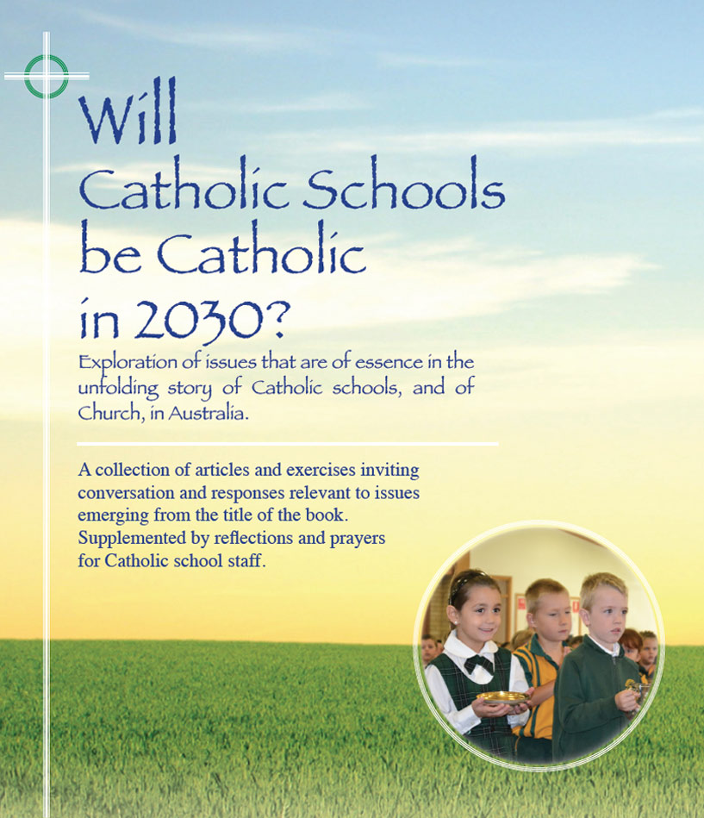
Themes
Pages 46-55

Spiritual heritage -
Deep story and charism

- The Members of almost 40 religious congregations played some active part in the story of Catholic schools in Australia. These women and men are often referred to as the ‘unsalaried workforce’ that sustained and expanded the Catholic school sector, especially through the period of non-government funding.
- Though all shared in the church’s mission of seeking to integrate life, culture, and faith through education, each had its own collective ‘way’ in virtue of its founding vision and its history. This ‘way’ is now commonly called its ‘deep story’ or its ‘charism’.
- In church understanding, charism is a particular gift of the Holy Spirit and the expression of a great variety of such charisms has been a defining feature in the story of Catholic schools in Australia. Frequently now schools will have slogans such as: In the Mary Mackillop tradition, the Marist way, The La Sallian way, In the Mercy tradition… - all referring to a nuanced way of commitment to the mission of Catholic school education.
- The charism is not a static entity, fixed in time. To be authentic it must be organic, that is open to growth. To remain relevant and life-giving the charism continually invites fresh expression, holding on to what is of essence while continually adapting in response to ever-changing circumstances and needs.
- A positive feature of our time is the growing of charisms through the weaving of the faith and spiritualities of so many Catholic educators with the charisms of various religious congregations with whom they have some association. Is this blossoming of older charisms through the engagement of lay leaders and teachers a sign of the Spirit at work in our times?

For reflection and discussion

- From the 1880s to the late 1950s, Catholic schools almost completely staffed by religious … nuns, brothers and priests. What are your thoughts and feelings about the possible impact of this selective staffing on the emergence of the story of Catholic schools?
- What is your understanding of the notion of ‘charism’ as commonly applied to schools with linkages to particular religious congregations? Are you aware of features of different charisms?

- What are some ways in which the charism may influence the culture of a Catholic school. How may schools ‘grow the charism‘ in ways that enhance the culture of the school?
- How may more recently established Catholic schools, with no formal association with religious congregations, enable their own charism to evolve ?

