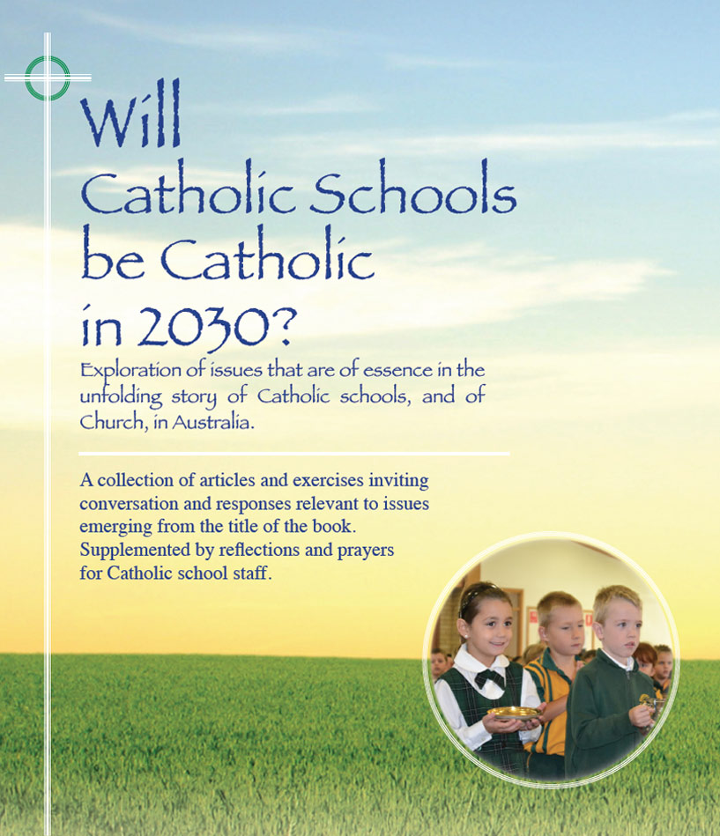
Themes
Pages 31-33

Snapshots –
From Ireland, Rome and the U.S.A.

- The focus of the Catholic school is not so much an education for Catholics as a Catholic education for all. Catholic education is person-centred. It goes beyond training in skills and the competition for qualifications. It helps individuals to seek wholeness, truth and hope in their lives.
- The young people we are educating today will become the leaders of the 2050s. What will religion’s contribution be to educating younger generations to peace, development and fraternity in the universal community? How are we going to educate them to faith and in faith? How will we educate them to prayer?
- The re-definition of Catholic schools’ identity for the 21st century is an urgent task.
- ‘Do not be disheartened in the face of the difficulties that the educational challenge presents! Education is not a profession but an attitude, a way of being. In order to educate it is necessary to step out of ourselves and be among young people, to accompany them in the stages of their growth and to set ourselves beside them. Give them hope and optimism for their journey in the world. Teach them to see the beauty and goodness of creation and of people who always retain the Creator’s hallmark ‘
-- Pope Francis
- An excellent Catholic school, adhering to mission, provides a rigorous academic program for religious studies and catechesis in the Catholic faith, set within a total academic curriculum that integrates faith, culture, and life envisioned.

For reflection and discussion

- In browsing through pages 31,32 & 33 identify some common threads coming from the three different sources. How do these threads align with your perception of attitudes and practices in Catholic schools in Australia?
- An Irish quote (Clegg) speaks of ‘a pressing need to discover a Christian and Catholic spirituality of leadership’. What are your thoughts and feelings about this assertion? What might it look like?
- What are your thoughts about the content and nuancing of Standards 1,2,3 & 4 on page 33? What convictions of your own do they (i) Affirm? (ii) Challenge?
- Any other issues arising from the content of these three pages?
Click on icon for PowerPoint

