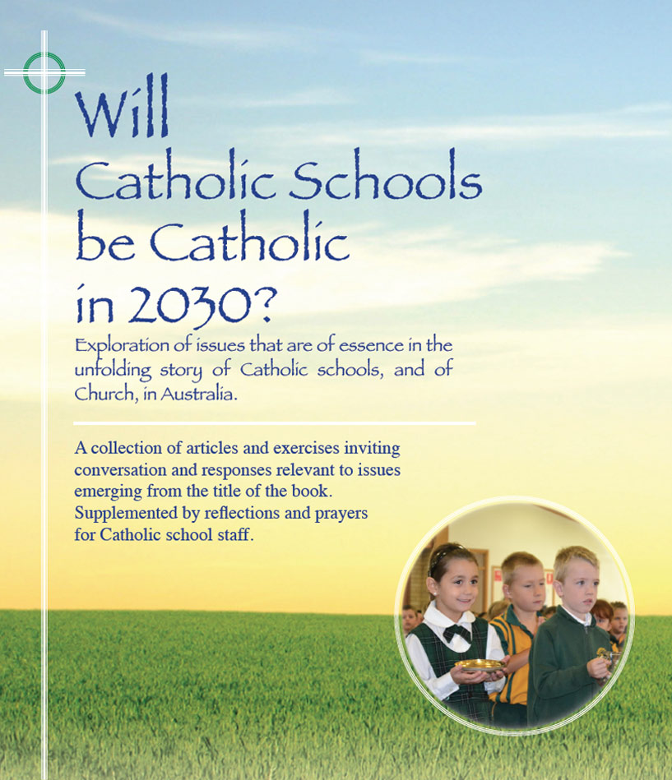
Themes
Pages 34-38

Snapshots – Then and Now
Emerging context and development of Catholic schools

- From the earliest times in Australia, Catholic schools were the ‘third leg of the stool’ in their integral partnership with church and parents in the transmission of faith. The vast majority of students, teachers, and parents were culturally Catholic. In more recent decades over 85% of all baptised Catholics are un-affiliated with parish and many are ambivalent about their identity as Catholics.
- In the highly secular age of the 21st century, religion is at the periphery, if at all, for a majority in Australian society. In their commitment to the mission of Jesus, Catholic schools are very counter-cultural.
- With the introduction of the Public Instruction Act of the 1880s – schooling became ‘compulsory, free, and secular.’ Catholic school were cut adrift from any government funding in their decision to ‘go it alone.’
- For almost 80 years Catholic schools survived and expanded without a cent of government money thanks mainly to the heroic generosity of local Catholic communities and an unsalaried workforce of nuns, brothers and priests. This was a defining period in the story of Catholic schools in this country.
- Migration - mainly European post-war, along with the ‘baby-boom’ led to the crowding and rapid expansion of Catholic schools in the 1950s and 1960s especially. Huge classes and very limited resources were the norm. Fight for ‘State Aid’ for Catholic schools.
- Transition from Religious to Lay:
1950s Almost 100% Religious;
1965 Religious 70% (3,654); Lay 30% (1,628);
2015 Almost 100% Lay
- With the advent of government funding - late 1960s (State) and early 1970s (Federal): rationalising of staffing; increased profile of Catholic Education Offices; formalisation of structures and policies; increased public accountability.
- Latter decades of 20th century: professionalization of teachers and leaders; increase in non-teaching staff; proliferation of compliances; record enrolments in Catholic schools

For reflection and discussion

- Have a look at the scenario outlined on page 34. What are your thoughts and feelings about this snapshot? Does it ring true? What big challenges have emerged for Catholic schools in the changes of society and church in the past100 years?

- There were great risks and hardships involved in the many years of no government funding. Why did they do it?! How do we best honour the legacy of the generations that sustained and shaped Catholic schools in very trying circumstances?
Click on icon for PowerPoint

- Any other matters arising from these pages?

