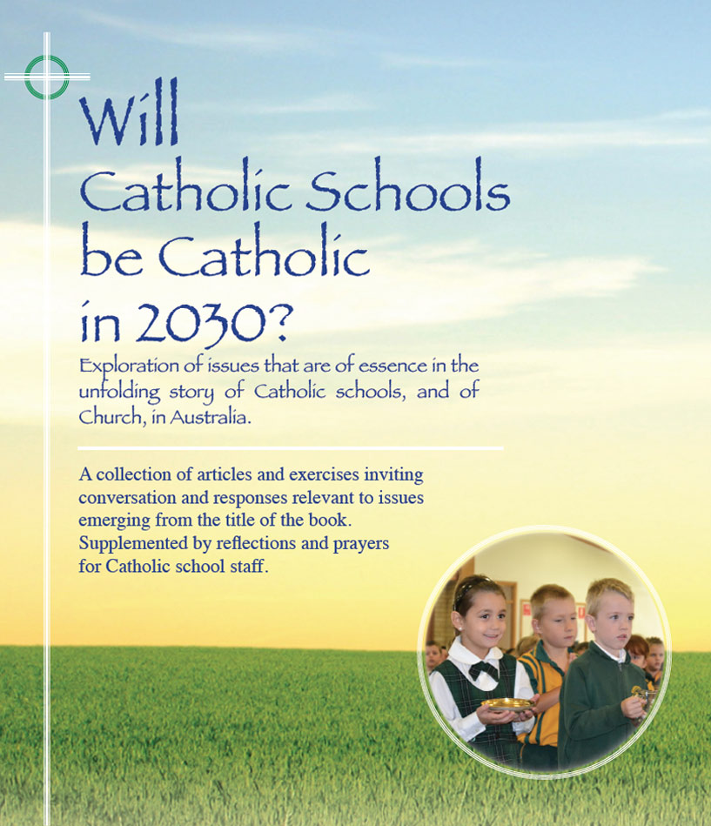
Themes
Pages 75-82

Sacramental Program Initiatives -
Parish and school initiatives

These pages, 75-82, describe some initiatives taken by schools on the assumption that among the considerable proportion of students who are not of the Catholic faith in Catholic schools there may be some who feel called to enter more fully into the life of the Catholic church.
In the first instance, these students may come from nominal Catholic families but, for a variety of reasons, they have never received the sacraments of initiation. Others may come from another faith, or non-faith, backgrounds. It is possible that some of these students may wish to integrate more fully into the prayer and liturgical life of the school and so may be open to a catechesis that is sensitive to their condition.
In response to such scenarios it has become more common in Catholic schools that policies and programs are being developed to formalise and to promote options for students who want to ‘catch-up on sacraments of initiation’ or to ‘become Catholics’. Words of caution here. While it is important that such options are made available, it is very important that all implications are fully explained to students and parents/guardians. It is likewise important that the option is seen as an invitation only and that there are no hints of compulsion or expediency. A given of course is that there be clear communication and collaboration with the relevant local Catholic clergy
It is probable that many Catholic schools are already taking similar initiatives to those described in pages 75-82 of this book. Their inclusion here is just by way of naming projects that are possible and getting the issue on the agenda in the context of other themes in this book.
For reflection and discussion

- What are your thoughts and feelings about issues arising from the initiatives taken at Patrician Brothers College, Blacktown, St Matthew’s Primary, Windsor, and Holy Cross College, Ryde?
- To what extent do these considerations apply in our school now?
- Are there policies and practices we need to consider in order to be more proactive in enabling some students, who so desire, to enter into a more formal communion with the Catholic Church?
Click here for PowerPoint

