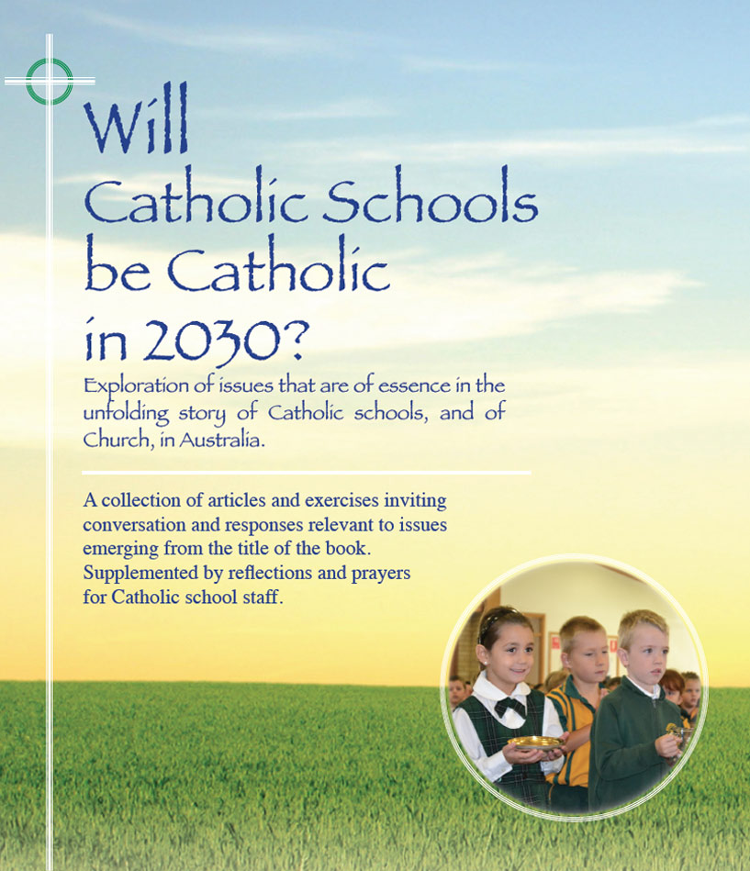
Themes
Pages 102-106

Religion and Spirituality

- Despite the advances and sophistication of life in the Western world, fear, anxiety, insecurity, and lack of trust are at unprecedented levels . Some symptoms: widespread addictions, increased incidence of mental health problems, fragmentation of traditional family structures, proliferation of security provisions and public surveillance, economic volatility, corporate corruption, global warming and many more.
- At a time of apparent loss of surety about once enduring life pillars, many are drawn to search for deeper sources of meaning and purpose within themselves.
- A pervasive materialist mentality, along with a variety of forms of religious fundamentalism and church scandals, have led to widespread disaffection with institutionalised religion.
- In the face of what is sometimes called this ‘loss of soul’ in Western culture, recent decades have witnessed a considerable increase in a range of quests for spirituality. Melbourne-based author and speaker, David Tacey (2007), calls it a ‘spiritual revolution’. At best, this new added interest in spirituality is a response to a hunger of the soul, a yearning for personal commitment to transcendence, and is a refreshing move worthy of encouragement.
- The truth is that spirituality is a broad umbrella. All human beings possess a spiritual dimension. See page 103 in the book for a list of commonly held qualities of a spiritual person. There may be billions of people in the world who have those qualities in varying degrees but who are not committed to any religious faith.
- Authentic Christian spirituality differs from other spiritualities in that it has as a base belief in God along with a belief in the Incarnation whereby God became human in the person of Jesus. The ‘way of Jesus’ is integral to Christian spirituality thereby giving it an orientation to others whereas many other spiritualities have a strong ego focus. The concept of Christian spiritualty entered the human narrative from the writings of St Paul in his frequent mention of ‘people of the Spirit’.
- In a general sense, religion may be taken to describe the norms, structures, symbols and rituals which give identity and expression to sacred and cherished beliefs. It is as old as the human race. In more recent times especially, religion has assumed a bad image because of many apparently senselesss things done in the name of religion. Besides, religion is frequently and unfairly caricatured in the public forum through misunderstanding and bias. Ideally, religion and spirituality are two sides of the one coin, partners not strangers. Increasingly, people may be heard to say: ‘I’m spiritual but I’m not religious’…a false dichotomy?
- Scholar and author, Sandra M. Schneiders (USA) articulates a proposition with much merit (page 106 in the book): ‘Religion that is uninformed by spirituality is dead, and often deadly; while spirituality that lacks the structural and functional resources of institutionalised religious tradition is rootless, often fruitless, for both the individual and society.’

For reflection and discussion

1:1 Sharing
- Think of a person you know, or have known, whom you would regard as a spiritual person. Name the qualities you see in this person that support your perception.
1:1 Sharing followed by plenary sharing of perceptions and issues arising
- In your ordinary understanding, what are some perceived differences between religion and spirituality? Likewise, can you name instances where religion and spirituality enrich each other in your own life?

- How do these considerations of religion and spirituality apply to the building of a Catholic culture within our school?

- Pages 105 & 106 in the book have short extracts that offer perspectives on the dance between religion and spirituality in a Catholic context. What are some perspectives that you find (i) Affirming? (ii) Challenging? (iii) Perplexing?
Click here for PowerPoint

