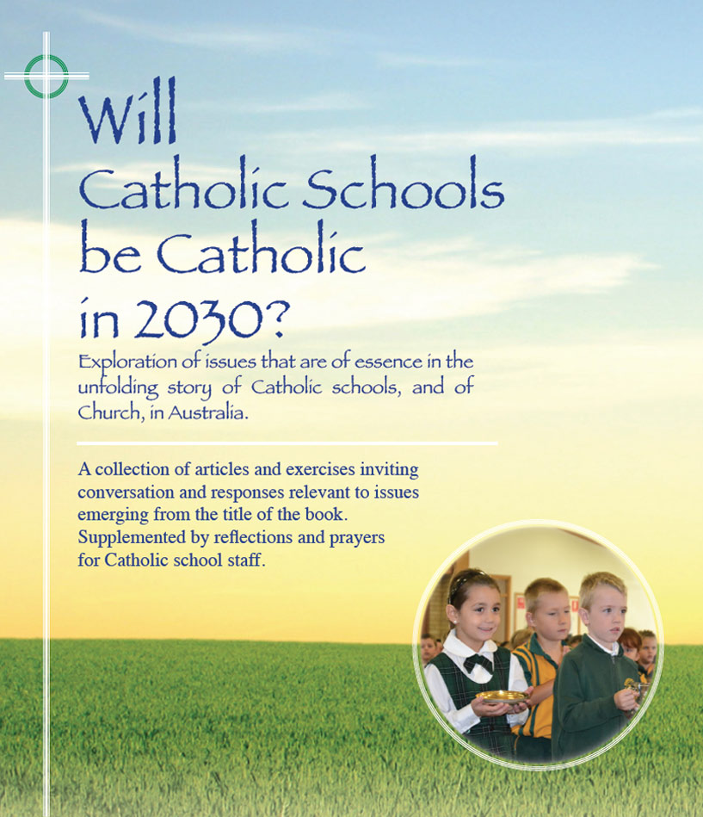
Themes
Pages 95-101

Ongoing Staff Formation

- From the 1880s until the 1950s, at least, members of religious congregations had a defining role in shaping the identity and the story of Catholic schools in Australia.
- Even though most of these religious would have come from a strong culturally
Catholic background, a number of years of faith and spiritual formation were deemed an integral part of developing their vocation in preparation for ministry in Catholic schools. This priority to mind and soul preparation is part of the formula which served Catholic schools well in difficult circumstances and is part of the legacy bequeathed to present generations of Catholic educators.

- The context and circumstances of Catholic schools are very different now. Staff in Catholic schools are more professionally qualified than ever. Simultaneously it is probable that at no time in the history of Catholic schools has there been such a high level of ‘un-affiliation’ from church traditions and parish life by baptised Catholics generally, including Catholics working in schools and CEOs.

- There remains however a strong commitment to the mission of the Catholic school by a majority of system and school leaders and teachers even though there may be a lack in religious literacy and in a familiarity with church norms, customs and practice. Many are no longer regular participants in the liturgical and sacramental life of the church while still conscientiously regarding themselves as Catholics.
- Personal assent is an essential aspect of authentic formation where the desired outcome is commitment, not compliance.
- The process of formation as implied throughout this book is understood as the intentional provision of a range of formal and informal programs/ experiences which invite and enable growth in faith and spirituality. At the end of the day, people must be agents of their own formation with the help of the Holy Spirit.
- In staff formation the focus in on the WHO who teaches, the WHO who leads
- It is most likely that whether Catholic schools are Catholic in 2030, or not, will depend on the quality of such formation more than on any other single factor.
- It could well be a sobering experience for systems and schools to do a tally on their expenditure on staff formation as against expenditure on other aspects of school life, especially technology.
- Ideally, at least one day each year is set aside for all staff to participate in a more formal formation experience that builds on and strengthens a union of hearts and minds amongst staff. The effectiveness of such days in enhanced when they are understood as but a high point in an ongoing culture that nourishes minds and souls for the mission of the school.

For reflection and discussion

- As applied to staff within the context of our school (system), what is your understanding of the term ‘formation’?

- In our shared understanding, give an example of a formation program or experience that you have found personally - (i) positive & helpful?
(ii) unhelpful , or even upsetting? What factors contributed to the difference?

- What are your thoughts and feelings about present system and school policies and practices in staff formation and their capacity to affect shared commitment to the mission of the school?

- How can we as staff continue to nurture the WHO who teaches, and the WHO who leads, within our school community?

- Any other issues that ought to be considered under this ‘formation’ umbrella?
Click here for PowerPoint

