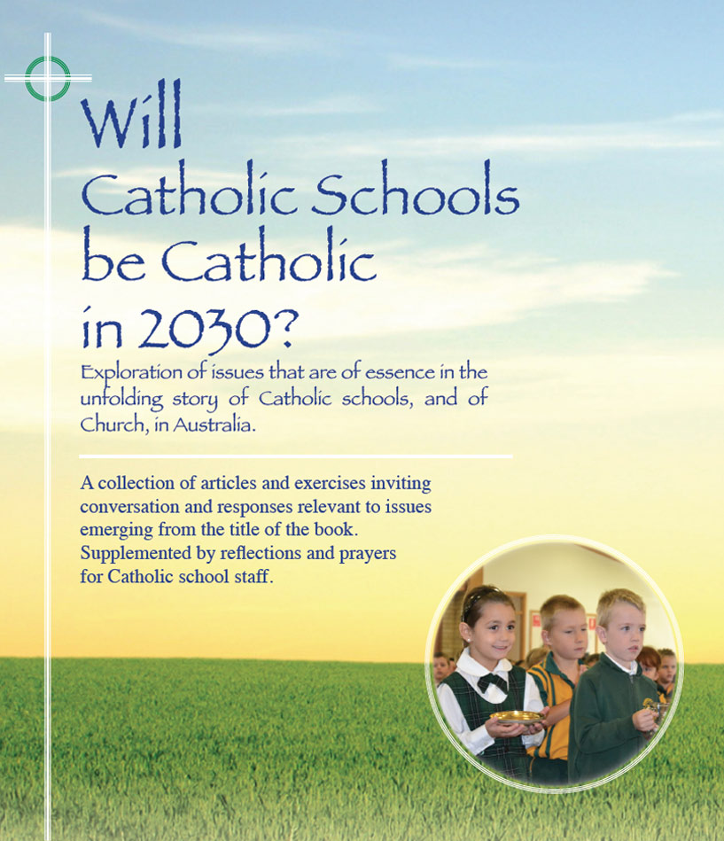
Themes
Pages 9-17

Will Catholic schools be Catholic
in 2030? – Guest articles

- ‘The whole of education ought to be an opening up to new persons, objects, activities and ideas that growing people can love. If it does not produce a profound sense of meaning in life through an abundance of love, education has failed.’
Bishop Geoff Robinson
- ‘In an increasingly secular society, successful Catholic schools will be unambiguously Catholic, led by well prepared and committed lay women and men who are passionate about the Gospel of Jesus and anxious to provide a high quality education in a Catholic context.’
Brother Kelvin Canavan (Executive Director Emeritus, Sydney Archdiocese)
- ‘Of more concern is the risk of building a culture of superficiality. Simply having the tools to search the Internet which builds our information base at an exponential rate does not build knowledge, values and wisdom. The Catholic school tradition draws upon a wealth of culture and narrative which values the past as well as the instant, immediate present. As a harbinger of hope, I expect the 2030 Catholic school will atune its graduates to being socio-critical, to addressing social transformation in our world.’
Brother Tony Whelan (Former Director of Catholic Schools, Broken Bay Diocese))
- ‘The critical lever in building future Catholic schools that are vibrantly Catholic is a commitment to the ongoing professional learning of Catholic school teachers and leaders ( at both school and system level) in the rich heritage of our faith and in their own maturing faith formation and spirituality. This requires a significant ongoing investment in high quality professional development and formation. Will church and educational system leaders be willing to make that investment now to make Catholic schools more catholic in 2030?’
Dr Anne Benjamin (Former Executive Director, Catholic Schools, Parramatta Diocese)

For discussion

- Read through the selected Themes above. Pick one quote that appeals to you and/or challenges you. In twos or threes, share your thoughts and feelings.
- In the four articles, pages 9-17, name some (i) common themes; (ii) single perspectives
- Discuss any other issues arising from these articles that have personal or collective implications?
Click on icon for PowerPoint

