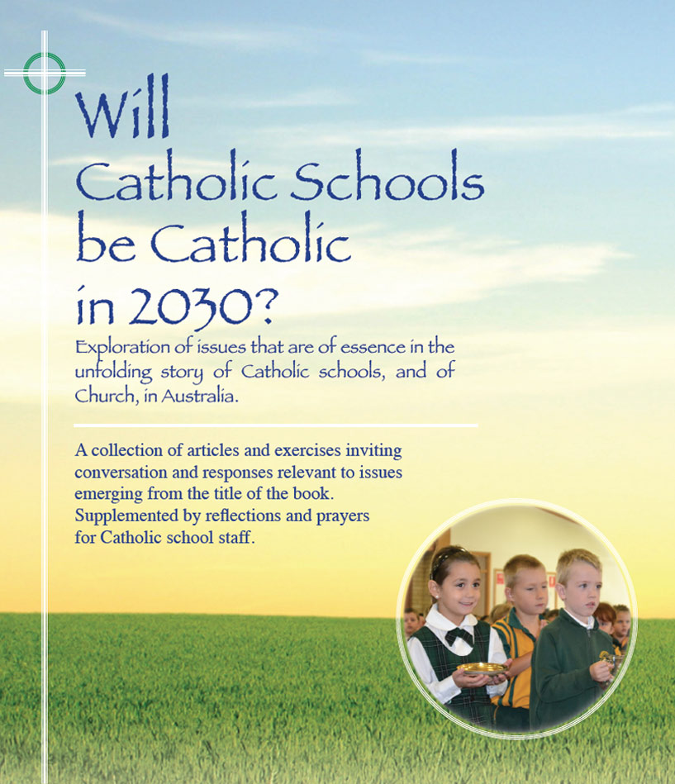
Themes
Pages 4-8

A New Pope – A defining phase
in the story of the Catholic Church

- The election of Pope Francis gave fresh life to the papacy in a way that evoked widespread positive attention both within and beyond the church.

- The wide acclaim of Pope Francis in the secular media to mark his first year in office is an interesting phenomenon in a world where matters spiritual and religious are increasingly consigned to the periphery.

- From a leadership perspective, Pope Francis has demonstrated in his simplicity, his humanity, and his courage, how a leader may transform and inspire.

- In its title, and in its content, the Apostolic Exhortation of Pope Francis --Evangelii Gaudium invites reform in church policies and practices and invites a joyful proclamation of the Gospel as GOOD News.

- Pope Francis urges the church to be more sensitive to the presence of God in the world generally and to enter into conversation with ‘the world’ from a Gospel perspective and in a spirit of openness and compassion.

- Drawing on his years of pastoral experience, Pope Francis has the earnest wish that the church becomes better known as a church of the poor, and for the poor.

- The vision and aspirations that Pope Francis has for the church can only be achieved if Catholics at every level in the church take up the challenges to bring about the kind of transformation envisioned.

For discussion

- In your perception, what are some of the qualities that Pope Francis has brought to his role that appear to have had an impact beyond the norm?
- In the book, ‘Will Catholic Schools be Catholic in 2030?’ there are some quotes from the Apostolic Exhortation of Pope Francis, Evangelii Gaudium, on pages 5 & 6. Pick the quote that appeals most to you and share your reasons.
- On page 8 in ‘Will Catholic Schools be Catholic in 2030?’ speaking of Pope Francis, has the assertion: “His abiding passion is to embrace the world as it is while ardently seeking to transform it in the light of the Gospel”
What are some of the challenges and opportunities for Catholic educators who find inspiration in this passion of Pope Francis?
http://catholicschools2030.weebly.com/uploads/8/1/5/4/8154351/the_francis_effect.pptxClick on icon for PowerPoint

