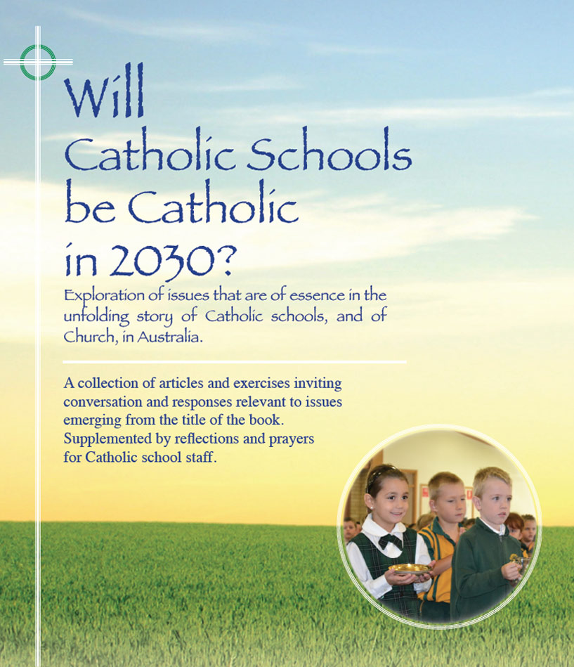
Pages 120-121
Themes

World Youth Day –
A sign in our times

This short article is included in that it puts a focus on the religious and spiritual orientation of a representative group of young people who have spent all, or most of their school life in Catholic schools. The World Youth Day phenomenon was an initiative of St Pope John Paul 11 who presided over the gathering of approximately 300,000 young Catholics, mainly European, in the inaugural WYD experience in Rome in 1984.
Since then the WYD concept has been embraced enthusiastically by many national churches, especially in countries of the Western World.
An estimated 3.8 million youth and accompanying lay carers, clergy and religious gathered in Rio de Janiero, Brazil in August 2013 where the recently elected Pope Francis spoke to the hearts of the pilgrims.

What was initially seen as a gathering of Catholic youth from many nations for devotions and culminating solemn liturgy presided over by the Pope has in more recent times become a strategically organised series of pilgrimages, immersion experiences and the like with much opportunity for catechesis and evangelisation. As before, the grand finale is the ‘WYD Mass’ with the Pope. This Mass is usually a great expression of faith and devotion that has left a defining and lifetime memory for many participants.
There would be general agreement that the WYD experience is a positive one for most participants in terms of getting them to reflect seriously on their religious faith, their spirituality, and their Catholic heritage. What is less clear is its ongoing impact on the practice of their religious faith as traditionally understood -- regular Sunday worship within a parish community. Anecdotal evidence suggests that whereas there may be a slight increase in numbers at youth parish Masses, sustained increases that are in any way proportionate to the numbers of pilgrims who travelled, are rare. For this reason mainly, ‘WYD Euphoria’ is not universally shared, especially by many of the clergy, given an apparent lack of evidence of sustained transformation, despite the massive investment of resources, and despite the public narrative.
No doubt there are many non-quantifiable outcomes in terms of strengthened identity and faith commitment for participants. Occasionally one hears of seeds of priestly or religious vocations having their origin at WYD, perhaps many other lasting personal graces also.
Given the evidence of enthusiasm and commitment for matters to do with religion, church, and spirituality by young Catholics in a WYD context, and given minimal participation of young baptised Catholics in the life of their church generally, many serious questions arise about ‘the gap’. The Australian Catholic Bishops’ Conference Pastoral Research Office (2011) ‘Mass attendance rates By Age’ contains the following worrying data: Mass Attendance Rate for Baptised Catholics in Australia between the ages of 14 and 30 hovers between 8% and 5%. A bushfire risk level indicator board would have the arrow fixed in the most intense RED ZONE!

For discussion

- What are possible causes of the alienation of Catholic youth from the practice of faith?

- Taken as a given that the majority of young Catholics are not without varying levels of faith and spirituality, propose a number of options which might be presented to attract young parishioners to come together to express and to share their faith within the parish. What might be some consultation, preparation, and promotion strategies to precede such options?

Click here for PowerPoint

