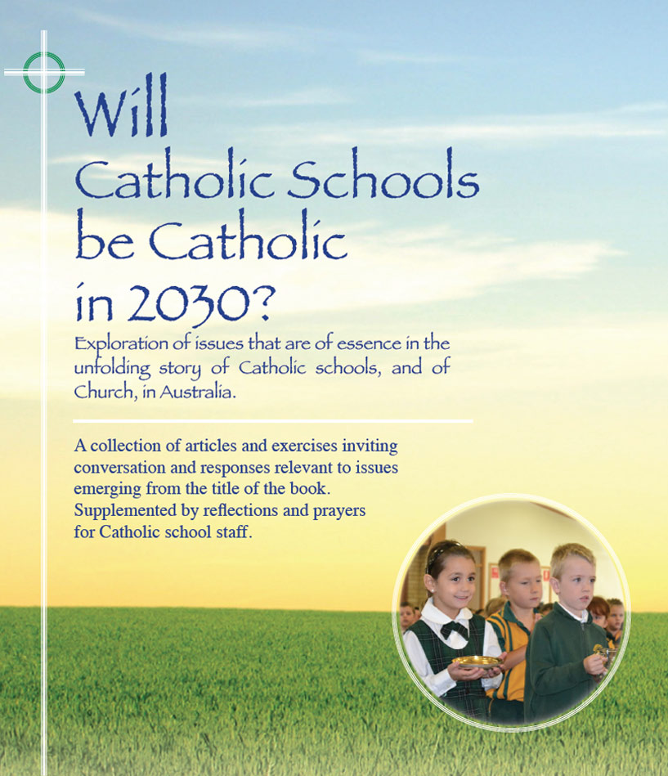
St Michael’s and St Gabriel’s are two all-boys Catholic secondary schools in suburban settings. The schools are not too far apart geographically. Each has a student population between 750 and 800 and each draws its students from a fairly similar SES background.

Snapshots of the Culture
in two Secondary schools

St Michael’s
St Michael’s is a newer school than St Gabriel’s. Nevertheless, the external condition of buildings and grounds is less than impressive. First-time visitors to the school often find it hard to locate the school office and the office waiting area is not all that attractive. Besides, front office reception of visitors is frequently below what might reasonably be expected and symbols to announce the distinctive character of the school are sparse and dated.

There are many diligent and professional teachers at St Michael’s. However, the spirit of collaboration within and across KLA’s is generally weak. There are several sub-culture pockets among staff which impact negatively on the dominant culture of the school. The morale and effectiveness of KLA ‘departments’ are determined more by the personality and enthusiasm of the coordinator than by enlightened and proactive policies and practices in leadership. Apart from mandated compliances, teaching remains largely a private practice. Student behaviour is a significant issue and there are inconsistencies in implementation of student management policies, causing angst among teachers and friction with parents. Generally a ‘them and us’ attitude characterises relationships with parents

NAPLAN and HSC results are mostly below state average. Planned ongoing professional learning for staff is not a priority. Staff absenteeism and turnover are problems and student enrolments are dropping.

The promotion of the religious dimension of the school devolves mainly to the REC and immediate assistants. A majority of the teachers are pretty open in their admission that they ‘don’t do God stuff’. Staff prayer together is usually restricted to a short, sharp rally to start meetings and, in the main, student experience of school prayer is haphazard and mechanical. With one or two exceptions relationships with clergy of the main feeder parishes are frosty. The annual ‘Staff Spirituality Day’ is commonly viewed as a compliance exercise to satisfy system requirements and relates only tangentially to the routine life of the school. The provision of opportunities for the religious and spiritual formation of staff is not included among leadership priorities.

It is probably true to say that St Michael’s is a school community where mediocrity dominates, a school community without much soul … a school in need of a ‘turned-around culture’.

St Gabriel’s
First-time visitors to St Gabriel’s are invariably impressed by the well-kept external state of buildings and grounds. Signage is clear and discreet. Office reception staff are attentive and welcoming.

The school staff comprises a good mix of ages, experience and gender. The principal, who is in his fifth year at St Gabriel’s is a dynamic and enlightened leader. He is supported by a committed and cohesive leadership team. There is a strong relational trust and a culture of mutual accountability among the staff generally. The best interest of all students is a guiding priority. A philosophy of ‘never turn a blind eye’ is embedded in the staff, inviting openness and honesty in naming and challenging staff attitudes and behaviours which are perceived to be at variance with the promotion of the greater good of students and staff alike. As well, there are policies and structures in place to enable student voice to be brought to the table of the common good.

Curriculum design and implementation are regularly reviewed to assure relevance and to maximise student engagement in learning. There is a lively professional spirit among staff generally, keeping teachers in touch with contemporary insights in best practice pedagogy as well as in enlightened policy and practice in the promotion of student wellbeing. Teachers are at ease with coordinators and colleagues occasionally dropping in on their classes with a view to subsequent dialogue about what works well and some areas of challenge.

Each year NAPLAN and HSC results are above State average and there is a pattern of student and team success across a range of sports. The school is also strong in its outreach in social justice initiatives and in engagement in wider community events.

Generally, there is a shared understanding amongst staff that St Gabriel’s as a Catholic school shares in the mission of the church and that as such, the integration and expression of religious faith and spiritual values within the total life of the school are parts of the package deal. Staff are happy to engage in conversation about this dimension of the school and many are proactive in their commitment to practices and projects which enhance the Catholic culture of the school. Besides, many cherish a hope that students may leave the school with an inclination to transform society, however little, in the spirit of the Gospel.

In its support for the mission of the school, the school leadership is to the fore in the provision of resources and opportunities to enable staff to grow in their own faith and spirituality. Clergy from the main feeder parishes meet as a group with the school leadership twice each year and the clergy draw up a roster of priests who will act as chaplains to Year groups. There is an active ‘Catholic Culture and Evangelisation’ team comprised of interested members from a cross-section of staff.

Partnership and good rapport with parents are valued aspirations of the school. There is an active parent liaison body whose ambit includes dialogue with the school leadership about learning and wellbeing policies.

St Gabriel’s presents a good model of a modern Catholic school honouring education with a moral purpose and true to its founding legacy.

For reflection and discussion

- List and rank the main factors or variables impacting on each of the contrasting school cultures.
- Compare and contrast these factors
- Supposing it was your responsibility to ‘raise the bar’ at St Michael’s, what immediate and longer term steps would you take?
- How would you seek to engage other school leaders and staff in this process? What support and resistance might you expect?

