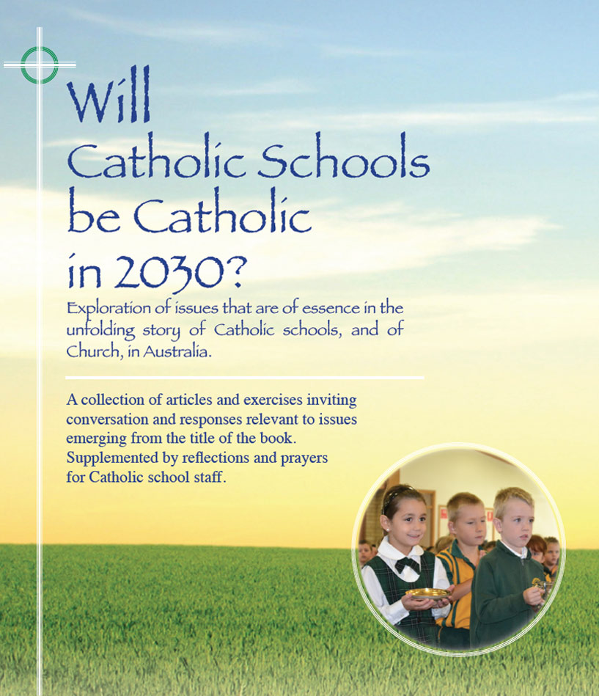
Themes
Chris Quinn, Gabrielle Doyle, Paul Hille - Pages 28-30

Future Challenges – Research Project

- From 2006 to 2012 the percentage of students in Catholic schools who are not of the Catholic faith rose from 24% to 29%.
- Accreditation to work in a Catholic school. Variation in requirements across dioceses.
- Research included interviews with senior secondary students, parents and teachers of Religious Education, RECs, Principals, Parish Priests.
- See page 30 for themes in Responses … note especially No 7 - Need for better understanding of the role of the Catholic school in to-day’s society, the inter-dependence of school and church, the role of the school in the wider society.
- See page 30 for Research Team recommendations. Note especially recommendation 2 : The development of policies, frameworks, and strategies at system and school levels to support and enhance opportunities for staff to grow in their own faith and spirituality to be maintained as a priority.
- Also note recommendation 4: it is imperative that Catholic school systems plan strategically for the formation and ongoing support of leaders in their role of maintaining in the schools a culture and an identity that are authentically Catholic.

For discussion

- What are possible reasons for the increasing percentage of enrolments from students who are not of the Catholic faith? What adjustments have we as system/school made to enable these students to be at ease with the religious dimension of schools?
- To what extent are the recommendations on page 30 already operative in our school? Any gaps?
- Does this research prompt thoughts of a possible research project that would provide us with data to review and renew the faith life of our own school community?

Click on icon for PowerPoint

