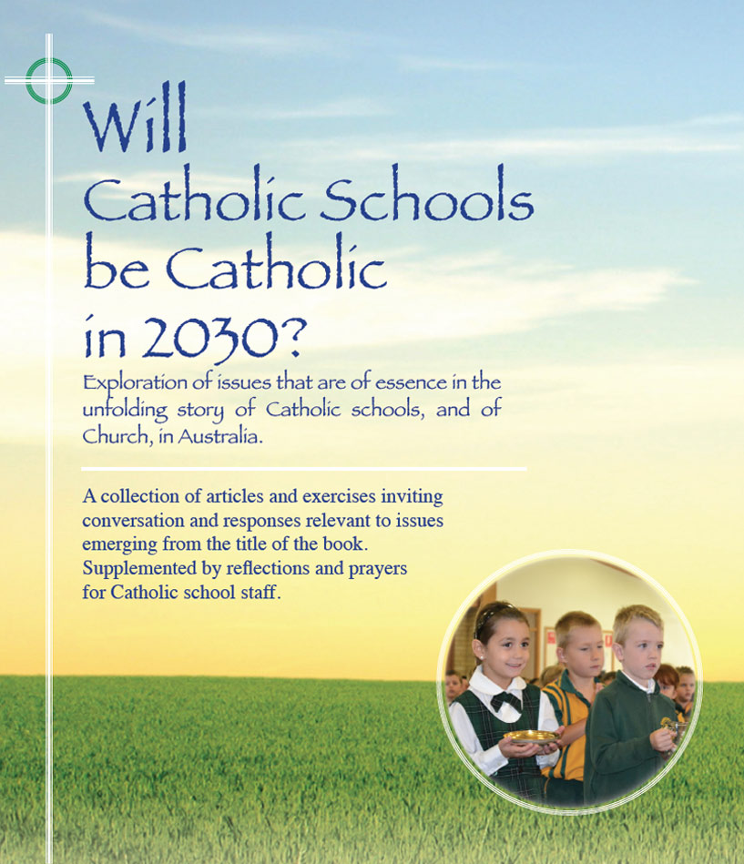
Themes

Paying it Forward –
Growing the story

- It’s OK to be Catholic and the possible need to give students a basis for sharing this conviction in a time when religious faith is on the outer and in a time when fixation on the shadows of religion, and of Catholicism, can mask the force for good in society the church has been, and continues to be.
- Maybe helpful to be explicit in naming the ways and the agencies through which the church shows the face of Christ the Good Shepherd to millions –across continents, across cultures, across creeds, in spiritual and pastoral ministry, and through material support.
- Important to acknowledge the work of the Royal Commission into sexual abuse and the grace it presents in its identification of the huge betrayal of trust by some clergy and religious causing terrible suffering and debilitation for the victims. Painful though the disclosures, the process enables the Church to embrace a new era of transparency, accountability, humility, reconciliation and compassion.

- Cantate Dominum Canticum Novum - Sing a New Song To The Lord.
This ancient exhortation of the Psalmist is ever more relevant now in a society riddled with symptoms of loss of soul. Trust in systems and in political leaders is at an all time low. Morality and ethics have entitlement and expediency as their main foundation. Our world cries out for the elevation and sanctification of the human condition in the transforming spirit of the Gospel.
- In a sense, the Catholic school is a microcosm of Church which, because of its structure and culture has great potential to be a truly Gospel community wherein the integration of faith and life may be normalised.
- Pope Francis wants a church that is more listening than telling, more pastoral than dogmatic, more compassionate than righteous, more inclusive than elitist, more loving than judgemental. The Catholic school is favourably placed to model such an image of church in the modern world.
- At no time in the history of Catholic schools in Australia have school leaders and teachers been so professionally qualified. In truth however, a majority lack the cultural Catholicity of earlier generations of Catholic school teachers. Catholic schools will be Catholic in 2030 only if there is increased priority at system and school level for the provision of a range of opportunities for growth in religious literacy, and formation in faith and spirituality.
- In his Apostolic Exhortation – Evangelii Gaudium, the Joy of the Gospel, Pope Francis issued a plea for joy in proclaiming and in living the Gospel. In a world grown weary with religious rhetoric there is a need for Catholics to be seen as ordinary and good human beings whose living life to the full is enriched by their faith.
- The story of Catholic schools in Australia is a proud one. Present generations of Catholic educators -Bearers of the Flame, are now challenged to grow what is best in that story.
For reflection and discussion
- What are some policies and strategies that might be helpful in counteracting the negative stereotyping of religion and Church that are common in the popular media?

- How can the Royal Commission into sexual abuse be an opportunity for reform in the Catholic Church? What are some emerging policies and attitudes with potential to prevent past abuses in Catholic institutions in the future?

- How may Catholic schools increase their capacity to be an influence for good in society?

- There is a perception that many who have had a Catholic school education and who have risen to prominence in society do not reflect Catholic values in their leadership roles. Do you agree with this perception, and if you do, what are some possible reasons for this apparent separation of soul and role ?

- ‘The Catholic school has great potential to be a truly Gospel community wherein the integration of faith and life may be normalised’ (See Themes above)
Can you name instances in which such ‘normalisation’ happens in your school? Are there further attitudes and practices that might strengthen the integration of faith and life?

- In the public discourse there is sometimes a suspicion towards one who is known to be a ‘practising Christian’. What might be a basis for such misgivings? How can schools promote an appreciation of a truly practising Catholic as a real asset to society?

- How may present generations of Catholic educators best grow the story of Catholic schools so that the schools may more authentically reflect the face of Christ in a changing world, in a changing Church?

