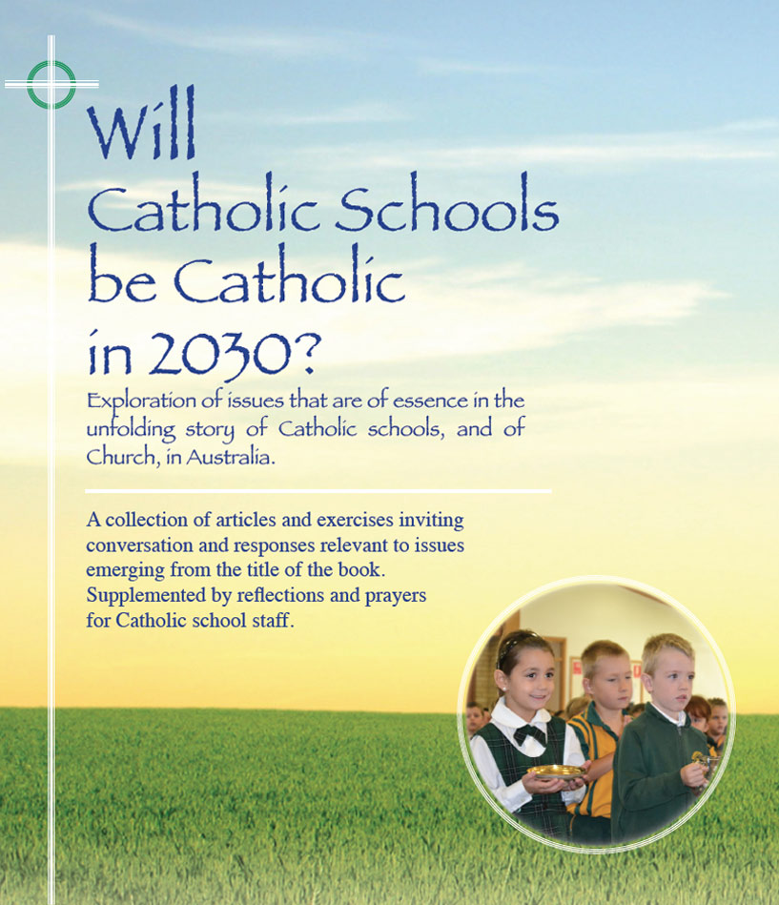
Pages 122-128
Themes

21st Century Catholic Schools:
At a ‘crossroads’ or on the ‘frontier’?

- In August 2007 the Catholic Bishops of NSW and ACT issued a pastoral letter entitled, Catholic Schools at a Crossroads. A motivation for this document was the realisation that increasing numbers of students not of the Catholic faith were seeking enrolment in Catholic schools. Additionally, a majority of families of students who were baptised Catholics no longer seemed to be ‘practising their faith’.
- In Catholic Schools at a Crossroads the bishops identified two possible future directions:
  - Direction 1: Continue as is, accepting all-comers with priority extended to baptised Catholics
  - Direction 2: Restrict enrolment to students from families where at least one parent/guardian is ‘practising’ and where the student is practising
The Bishops opted for Direction 1 and in so doing outlined a framework setting out standards and expectations to enhance the Catholicity of the schools in the changed and changing circumstances of society and church.
- To some extent it is a paradox that in an era of major alienation from the Church by Catholics, Catholic school enrolments are at an all-time high. It is likewise of interest that almost 30% of students in Catholic schools generally are not of the Catholic faith.
- The truth is that the Catholic school provides the only significant experience of Church that a majority of emerging Catholics may ever have. This is both a privilege and challenge for each Catholic school.
- In this context the Catholic school may be more appropriately viewed as being at the ‘frontier’ rather than at a ‘crossroads’ in the mission of the church. The Catholic school is in close touch with a whole ‘constituency’, the majority of whose members have no ongoing religious affiliation with their parishes.
- Most Catholic schools take seriously their reason for existence as a separate sector on the education landscape, i.e. that they are places where there is intentional integration of life, culture, and faith. Hence, the following are the norm in Catholic schools:
  - formal religious education program with Scripture and Tradition as a basis;
  - embedded practice of prayer;
  - special liturgies linked with the Church’s liturgical year;
  - sacred spaces and display of religious symbols;
  - social justice outreach.
In other words, the living of the Catholic life is normalised in such schools.
- The hope is that students leave Catholic schools with a heightened sense of the sacred along with an understanding of the mission of Jesus to the world and a commitment to having Jesus as a guide in their lives.
- It is the earnest wish of Pope Paul that the mission of the church be expanded beyond a focus on ‘the faithful remnant’, seeking to meet people wherever they may be in their life and faith journeys. A frontier mindset is a helpful and exciting one for all Catholic educators.

For discussion

- What are your thoughts and feelings about images such as ‘crossroads’ and ‘frontiers’ as they apply to the Catholic school sharing in the mission of the Church? Can you think of other images/metaphors that might suitably apply?
- How effective is our school in meeting students, staff, and parents ‘where they are at’ in their faith journeys, inviting/nudging them forward, while respecting their personal choices?

- What are some present school initiatives that include most families to some degree in the faith life of the school? Are there other possible avenues?

- Are there policies and practices we need to renew to ensure that, in as far as is possible, the experience of life in the school is a ‘good experience of church’ for both staff and students?

- Have a look at the Mass attendance graph on page 128. What are some issues arising, especially around challenges to broaden the umbrella of inclusion for many in the ‘green zone’?

Click here for PowerPoint

