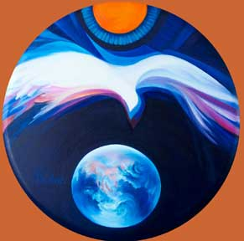
Celebrating the Spirit Among Us…
Mary Southard CSJ
Bright Wings
www.MarySouthardArt.Org ;
and www.MinistryOfTheArts.Org

HOLY SACRED SPIRIT
Holy Sacred Spirit
breathe your breath on us
Holy Sacred Spirit
breathe your life in us.
© 2000 Monica Brown & Emmaus Productions
http://au.emmausproductions.com/
"Used with permission from
Monica Brown & Emmaus Productions".

A reading from the Acts of the Apostles
When Pentecost day came round, they had all met in one room, when suddenly they heard what sounded like a powerful wind from heaven, the noise of which filled the entire house in which they were sitting; and something appeared to them that seemed like tongues of fire; these separated and came to rest on the head of each of them. They were all filled with the Holy Spirit and began to speak foreign languages as the Spirit gave them the gift of speech.
Now there were devout men and women living in Jerusalem from every nation under heaven, and at this sound they all assembled, each one bewildered to hear these men speaking their own language. They were amazed and astonished. ‘Surely’ they said ‘all these speaking are Galileans? How does it happen that each of us hears them in their own native language? Parthians, Medes and Elamites; people from Mesopotamia, Judaea and Cappadocia, Pontus and Asia, Phrygia and Pamphylia, Egypt and parts of Libya round Cyrene; as well as visitors from Rome – Jews and proselytes alike – Cretans and Arabs; we hear them preaching in our own language about the marvels of God.
Acts 2:1-11
Was Love the language of the Spirit, the universal language they all understood?

Let us ponder our world today and the many places where there is conflict, violence and oppression…..

Let us name some of these people and situations….

Let us bring them to prayer

TOUCH ME WITH TRUTH THAT BURNS LIKE FIRE
Lord,
send the gift of your Spirit
to fill this place
and myself
and the world.

Touch me
with truth
that burns like fire,
with beauty
that moves me like the wind;
and set me free, Lord,
free to try new ways of living;
free to forgive myself and others;
free to love and laugh and sing;
free to lay aside my burden of security;
free to join the battle for justice and peace;
free to see and listen and wonder again
at the gracious mystery of thing and persons;
free to be,
to give,
to receive,
to rejoice as a child of your Spirit.

And, Lord,
teach me how to dance
to turn around
and come down where I want to be,
in the arms and heart of your people
and in you,
that I may praise and enjoy you forever.
From Guerrillas of Grace
Ted Loder copyright © 1984, 2005 Ted Loder, admin. Augsburg Fortress. Reproduced with permission
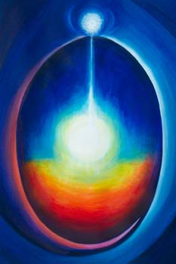
Mary Southard
Meditation
www.MarySouthardArt.Org ;
and www.MinistryOfTheArts.Org

Let us pray that the fire
of bombs and guns is replaced
by the fire of love…..

SETTING HEARTS ON FIRE
We come from ancient Dreamtime,
From the bush, or by the sea.
We come from a thousand city streets.
We are the rich and we are lowly,
We are the poor and the strong.
We come to share this moment,
Gathering here, singing one song.

With our hearts on fire with the love of Jesus.
Hearts on fire, let’s spread the Word.
Hearts on fire, feel the Spirit blazing.
Hearts on fire,
Called to live the Good News in this land.
Setting hearts on fire, with our hearts on fire,
Setting hearts on fire.

We long to live in freedom, we yearn for unity.
We dream of justice, joy and peace.
We are the voice of Jesus,
We are his heart and hands.
We are his body in our land.
Stand up! Live the story.
To all the world proclaim.
Lighting the fire, fanning the flames.
Michael Mangan
- Setting hearts on Fire
© 2001 Litmus Productions.
Used with permission.
www.litmusproductions.com

Spirit fill us with your power.
Jesus help us live your call.
O Creator give us wisdom,
So we will be Good News for all.

Thoughts and suggestions:
As a way of focussing on where the Spirit’s love and healing are most needed in our country and world you could ask staff to bring a newspaper article or a photo of some current situation where human rights are being abused. As educators we have the future leaders of all areas of life in our classrooms, in our care. The world that emerges in the next 40 years will be a reflection of the education we provide. So let us stir the minds, the hearts and the imagination of our young people to look at what is and imagine what might be. And nurture the confidence they will need to act courageously for a better world. Remember the prayer of St Teresa – Christ has no body now but ours.

