An Encounter that Questions and Heals

Let us begin this time of prayer conscious that Jesus is always present waiting for us to stop and listen to the whisperings of the Spirit…

WOMAN

Woman! Woman!
When will you soar on the wings of your longing
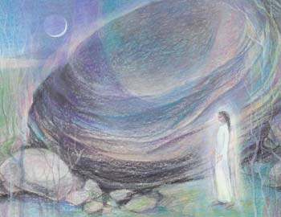
To the blissful heights
Where I await your love?
And if you meet me with all your desire,
I will touch you with my presence divine.
And you shall delight,
In body and in soul,
In my love.

Woman! Woman!
Come now to me in your sighings,
In your heart’s desire,
For I am the one you seek.
Since I am in you and you are in me,
We are one
Mary Southard CSJ
Ancient Presence
www.MarySouthardArt.Org ;
and www.MinistryOfTheArts.Org

And forever shall remain.
And you shall delight,
In body and in soul,
In my love.

Woman! Woman! Woman!
Briege O’Hare – Woman’s Song of God

A reading from the gospel according to John (8:1-11)
At daybreak, after spending the night at the Mount of Olives, Jesus appeared in the Temple again; and as all the people came to him, he sat down and began to teach them.

The scribes and Pharisees brought a woman along who had been caught in committing adultery; and making her stand there in front in full view of everybody, they said to Jesus,
‘Master, this woman was caught in the very act of committing adultery, and Moses has ordered us in the Law to condemn women like this to death by stoning. What have you to say?’

They asked him this as a test, looking for something to use against him. But Jesus bent down and started writing on the ground with his finger. As they persisted with their question, he looked up and said,
‘If there is one of you who has not sinned, let him be the first to throw a stone at her.’

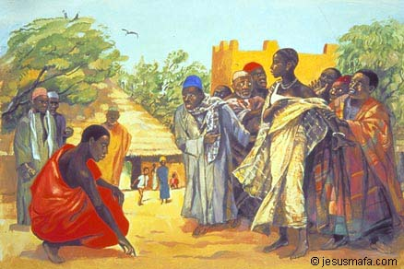
Then he bent down and wrote on the ground again. When they heard this they went away one by one, beginning with the eldest, until Jesus was left alone with the woman, who remained standing there. He looked up and said,
Jesus Mafa
‘Woman, where are they? Has no one condemned you?’

She replied,
‘No one, sir.’

Jesus said,
‘Neither do I condemn you. Go away, and don’t sin any more.’
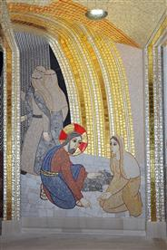
Spend some time walking in the shoes of:
The scribes and Pharisees
The Woman
Jesus
What do you see, hear, feel? Is there an invitation for you?
Are there still laws and behaviours in our society, in our Church which discriminate against women? Against the weak?
Share some of your ponderings with your neighbour….
Fr. Marko I. Rupnik & Atelier of Centro Aletti

He bends,
Scribbles slowly in the sand.

And then in a voice of tender authority:
‘If there is one among you without sin,
be the first to throw the stone.’

Quiet followed.
He did not hold them in his gaze.
Allowed them to ponder
in the quiet of their heart.

One by one stones placed
slowly on the ground.
In silence they left…
pondering the law?
Wondering if something new
was being asked of them?
Law must lead to love.

Now I am alone with him.
I am held once more in that gaze of love.
He does not deny my wrongdoing.
But forgives, and in those words
I find the courage to step
into another way of loving.
Leone Pallisier

I AM FREE
Alone I stood.
Men holding stones.
Many
Holy men,
Scribes and Pharisees
Some women too.
Wives of men who sought my body.

‘Caught in the act of adultery,
Death by stoning, says the law.’

Why only the woman guilty?
Both caught in the act.

A man stands there.
Gentle. Hands empty.
His eyes meet mine.
They are soft, inviting.
No lust there.
Lust and love different.
I know the difference.

He looks at the men, the court.
Holds them in his gaze.
I sense discomfort -
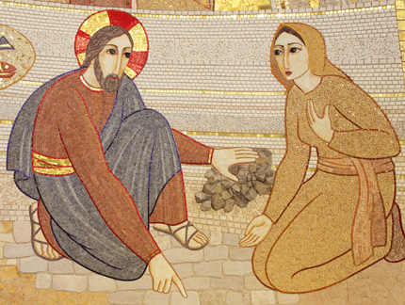
their body language changes.

HEAL ME
I will live for You alone, for you alone I’ll live.
Heal me, heal me, heal me and let me live.

Trisha Watts & Monica O’Brien
(c) 1992, Trisha Watts & Monica O’Brien (McInerney),
published by Willow Publishing Pty Ltd,
PO Box 1061 Dee Why NSW 2099.
All rights reserved. www.willowpublishing.com.au

