An unexpected encounter heals a man,
…..calls others to question the comfort of the law
Mary Southard CSJ
Listening to earth’s heartbeat
www.MarySouthardArt.Org ;
and www.MinistryOfTheArts.Org

LISTEN
Listen, the voice of Your God is calling.
Listen, the voice of Your God is calling,
Listen with the ear of your heart,
The voice of Your God is calling.
Monica Brown

Each day we are invited anew to listen to the voice of God echoing in the daily. In the scripture that follows we see a man engaged in the weekly ritual of visiting the synagogue who in obeying a command is healed. In contrast ‘they’ who were there watching to see were unable to hear or respond to the invitation to see differently. Let us listen to this reading twice. In the first reading enter into the text as the man with the withered hand…. In the second be the Pharisees……

A reading from the gospel according to Mark
Jesus went into the synagogue, and there was a man present whose hand was withered. And they were watching him to see if he would cure him on the Sabbath day, hoping for something to charge him with.

Jesus said to the man with the withered hand,
‘Get up and stand in the middle!’

Then he said to them,
‘Is it permitted on the Sabbath day to do good, or to do evil; to save life or to kill?’

But they said nothing.

Then he looked angrily round at them, grieved to find them so obstinate, and said to the man,
‘Stretch out your hand.’
He stretched it out and his hand was restored.

The Pharisees went out and began at once to plot with the Herodians against him, discussing how to destroy him.
Mark 3:1-6

What did you see, hear, feel, learn, when you were the man with the withered hand?

…..when you were the Pharisees?

Share something of this with the person next to you……

Daily we have the opportunity to come to quiet and seek wholeness and healing from the one who desires each of us to live fully….

COME TO ME
Come to me all you who are burdened and weary
And I shall give you rest.
Come to me as you are and I shall tend to you.
Listen – Come to Me
© 1997 Monica Brown & Emmaus Productions
http://au.emmausproductions.com/
"Used with permission from
Monica Brown & Emmaus Productions".

LOVE NOT LAW
My capacity to serve diminished.
A withered hand no blessing.
Sabbath duty finds me in the synagogue.

The mood is different.
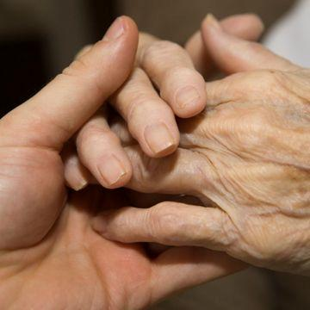
More 'holy' men than usual.
Why?
An itinerant man arrives.
I think he's called Jesus.

The mood tenses.
Pharisees' eyes icy, hard, judging.
The itinerant's soft, warm, inviting.

What is happening?

Attention turns to me.
Uncomfortable.

He speaks of law and love.

'Stretch out your hand.'
I stretch; released!

I'm cured.
How will they respond?

Plot to confine Jesus, love?
And keep the people bound?

Just enforce the law!
Withering a community, a people.

Jesus offers a different way.
A community bonded in love.
Leone Pallisier

Love softens, nurtures, blesses.
Share such love I must.

Law, without compassion,
often blinds, binds, paralyses.

Pharisees paralysed?
Hardened hearts -
can't accept love's freeing.

Is there something ‘withered’ within you, your family, your school community that you would like to be healed?

The law is there to protect people’s rights and responsibilities. As a society changes laws may no longer serve the life of the community. In the scripture we just heard, Jesus is trying to challenge the Pharisees, the religious leaders, to question their law, a law that in some instances kept people on the margins of the community. The same is true of a school. Are there laws, rules, routines that you need to revisit or rules you need to design, as the wider culture within which the school is now embedded has changed? Eg. In the early 1990’s social media did not exist as it does today. This has changed our schools and our culture considerably.

Francis, Bishop of Rome, reminds us…..
True faith in the incarnate Son of God is inseparable from self-giving, from membership in the community, from service, from reconciliation with others. The Son of God, by becoming flesh, summoned us to the revolution of tenderness.
Evangelium Gaudium 88

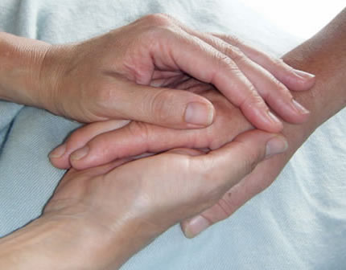
HEALING IS YOUR TOUCH
Healing is your touch, O God,
Renewing the Spirit of the broken.
Healing is your touch, O God,
Renewing the spirit of the broken.

© 1991 Monica Brown & Emmaus Productions
http://au.emmausproductions.com/
"Used with permission from
Monica Brown & Emmaus Productions".

Let us participate in the revolution of tenderness….

