The School Community – An Art Gallery

Each day thousands of children enter school grounds around the country. Each brings her or his gifts, hopes, dreams, secrets, worries, frustrations… In this prayer we will look at each child, adolescent or young adult as a work of art in the making… who is relying on the staff to participate in this creative activity….. Let us gather, open to the Spirit who connects us to this art of becoming…..
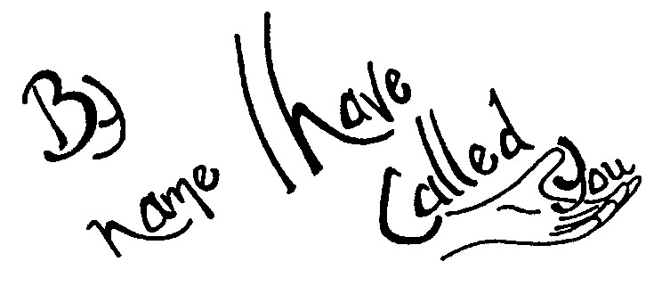
SPEAK LORD
Speak Lord I am listening,
Let your Word be done unto me,
May it find a home in me.
© 1991 Monica Brown & Emmaus Productions
http://au.emmausproductions.com/
"Used with permission from
Monica Brown & Emmaus Productions".

Let us listen to Paul as he helps us explore the power of the Spirit in our lives…

A reading from Paul’s letter to the Corinthians
There are many different gifts, but always the same Spirit; there are many different ways of serving, but always the same Lord. There are many different forms of activity, but in everybody it is the same God who is at work in them all. The particular manifestation of the Spirit granted to each one is to be used for the general good. To one is given from the Spirit, the gift of wisdom, to another the gift of knowledge, to another faith; and to another the gifts of healing, through this one Spirit; to another the working of miracles; to another, prophecy….. But at work in all of these is one and the same Spirit, distributing them at will to each other.
I Corinthians 12: 4-11 (adapted)

It is the Spirit who is active in nurturing our Art Gallery… an Art Gallery that is forever being created as students live and learn in their school community throughout the school day. Let us listen to some wisdom from Kevin O’Shea about God as Artist

Sometimes I like to imagine God as an Artist. The First Artist. And I like to imagine us as God’s unfinished art-works. Yes, unfinished. God actually doesn’t do more than sketches, never completed ‘works’. God does first drafts. God does that so we can pick up what God has started and be creators ourselves, indeed creators of ourselves……

You are meant to recognise the unfinished areas in your self and your life, and listen to the music in the silences there. You are meant to see what could be there in the blanks, if you, not God, did something to put it there. The gaps are there, intentionally, for you to play with. They are to awaken our freedom and responsibility. God gave us freedom… he wanted us to become creative like our Creator. So we are called to be creative co-creators with God and finish the ‘work of art’ God wanted us to be from the beginning.

Ponder this wisdom…. How is it echoing in your being as you listen and reflect. Share one idea with the person next to you….

One Art Work in the School Gallery



Into this empty frame place one of your students……try to imagine what he or she might be longing for…. What are your longings for him or her? How well do you know this student…. What are some ways you might reach out ….

Let this music speak.. Hold the chosen student as you pray this song….

THE FULLNESS OF GOD
Deep in Christ I pray you know the power He can give.
May your hidden self grow strong and may you live
The Fullness of God:
love, joy, peace, patience, kindness, goodness, faithfulness, gentleness and self-control.
Galatians 5:22

strong in faith and built on love until you know
how high and long, how wide and deep the fullness of God.

May the God of Jesus Christ, the Father we serve
Fill you hearts that you may see, deep in your heart
What hope his call now holds for you, His promise true:
To fill your heart with power to live the fullness of God.

Know the way you learnt from Christ to live life anew!
Let you heart by drawn to him, let Christ renew
The hope in you to grow into Goodness and Truth.
And living so you’ll come to know the fullness of God.
Frank Andersen – Eagles Wings

Often it is the small gestures of love, a sincere comment, that changes a child’s life…. Listen to this story…..

THE FREEDOM OF OUR DEEPEST SELF
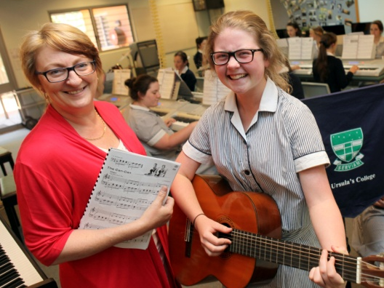
I was a junior in high school, student of a beloved English teacher who was fair, but tough. If Mrs. Allen gave a good grade you knew you had earned it. She did not grade out of kindness, nor did she reward ‘potential’. One weekend she asked our class to write a paper from the point of view of the King of England who had abdicated his throne for love.

A week later she walked between the rows putting the graded essays face down on each desk. As she laid my paper in front of me she paused and said, “Your essay made me cry”. It wasn’t much. Five words. I know I am a writer today because of that moment. I knew that her evaluation meant something.

In some respect we are always hoping for someone to see not only our talents, but our deepest self and the power it embodies. There are so many polite ‘no’s’ and ‘yes’s’ in our lives. In many ways we avoid the heart of things, and shy from what lies beneath the surface. Lending our lives to a deeper meaning and the emergence of truth is very different. It demands vigilance and commitment. It may involve choices that set us apart.

This is what’s required to be ‘born again in the spirit’. From the heart of all things the Greater Soul asks us to pull our boats up on the beach, nets and all. Put those things aside. Follow me.
Paula D’Arcy – Daybreaks 2007

Think of a student in your care…. Write a tribute you would like them to be able to write at the end of the school year……

Nurturing our Deepest Self and the Power it Embodies…
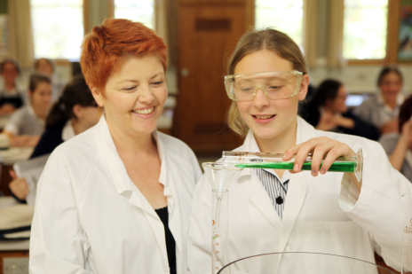

Teacher as Midwife

That child before me
Spirit filled
What gestures ignite life?
A listening heart
Genuine interest
Beckoning horizons
Curiosity aroused
Imagination kindled...

Different children, different needs.
Know your students.
Build trust.

Trust.....
An accumulation
of small, almost unnoticed gestures
Heartfelt gestures
Heart speaking to heart

Trust enables boldness
A courage to step through fear
to a new horizon, beckoning.

Creator and Creating God
nurture the midwife in me
to work with you
to enable our school community
to be a living gallery of masterpieces
breathing life and Spirit
into each of us.
AMEN
Leone Pallisier
Gifted uniquely
Yearning for life....

So much dormant within....
Wisdom, generosity, boldness, curiosity..
questions, longings...

In addition to artists
Students need midwives.
Artist's imagination
Gives form to something
Coming to birth within them.

Midwives coax into life
A talent dormant
A dream yearning
to be born within the other.

So let us be midwives.
Sensitive
Encouraging
Affirming
Challenging
those before us
to become the master piece,
the work of art
the creator and creating God
has etched in the depths
of their being.

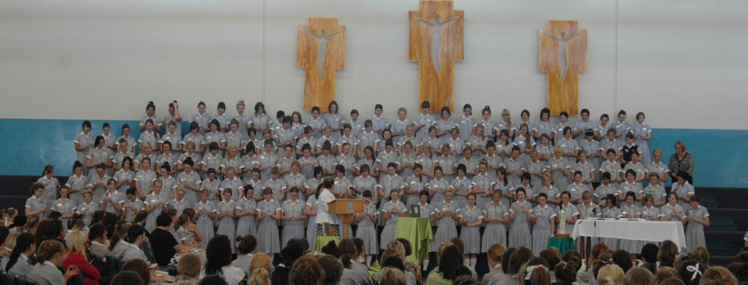

The strength of a community is its diversity of gifts and talents… Let us pray with Paul for a vibrant life-giving community….

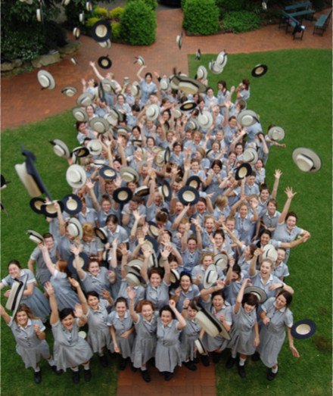
This is what I pray, kneeling before the Father, from whom every family, whether spiritual or natural takes its name:

Out of his infinite glory, may God give you the power through the Spirit for your hidden self to grow strong, so that Christ may dwell in your hearts through faith, and then, planted in love and built on love, you will with all the saints have strength to grasp the breadth and the length, the height and the depth; until knowing the love of Christ, which is beyond all knowledge, you are filled with the utter fullness of God.

Glory be to God, whose power, working in us, can do infinitely more than we can ask or imagine; glory be to God from generation to generation in the Church and in Christ Jesus for ever and ever. Amen.
Ephesians 3:14-21

GOD’S WORK OF ART
You are God’s work of art
Keep the flame of faith in your heart
And then you meet him when he comes.

Blessed be our God
Who chose you in the light of Christ
David Haas
www.giamusic.com
Printed with permission

Created in Jesus the Christ

You have been enlightened by the Lord,
Walk as children of the light.
The image of Midwife highlights the interdependence of the student teacher relationship…

Students are also Midwives to our being and becoming….

Teachers are also masterpieces in the Art Gallery

