Spring – the Season of Coming to Birth
In her book, Mystic Garden, Gunilla Norris has this to say of spring: ‘Spring is an ache. Buds swell on their branches. Bulbs cannot stay in their casings. There is the breaking out of one state into another. This is true in inner development as well. We are both the ones giving birth and the birthed. We are incredibly vulnerable, beautiful, dependent, dynamic, needy, and bursting at the seams.
The spring of the soul hums and aches. Birthing is full of pain, full of fear, full of exquisite excitement. It must be carefully attended. It must also be left well enough alone. Whatever has the dynamism to develop cannot be stopped. It will grow. It will grow.’ (Page 25)

Could spring be seen as a dance….
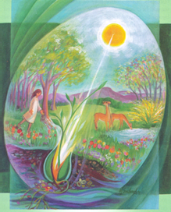
BORN TO DANCE
Unless we are broken
woken
we have yet to experience
the dance of new life
within
our unlived lives
for so long restless, persistent, aching
breaking into Dance.
Noel Davis
– The Heart Waking

Mary Southard CSJ
Awakening Dawn
www.MarySouthardArt.Org ;
and www.MinistryOfTheArts.Org

DANCING WITH GOD
Mechtild of Magdeburg - God is the source of all energy for living. To fully open ourselves to this energy is to dance with the Divine Life. Mechtilde, however, knows that she can only enter this dance when Divine Love gives the lead.

I cannot dance, O Lord, unless you lead me
And if you want me to leap for joy,
Then you must be the first to dance and to sing
And I will follow you; in your echo I will ring.
Then, only then,
Then, only then,
Then, only then, will I leap for joy!
Then, only then,
Then, only then,
Then, only then, will I sing for joy!

Lead me Lord in your joyful dancing.
I will follow in your dance of life.
Then all my living will be true to you,
My loving God.

Breige O’Hare –
Woman’s Song of God

I cannot sing, O Lord, unless you lead me
And if you want me to sing for joy,
Then you must be the first to sing out your song
And I will follow you and sing right along,
Then, only then,
Then, only then,
Then, only then, will I sing for joy!
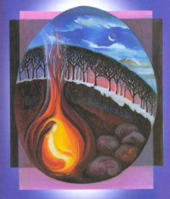
O ANTIPONS FOR SPRING
O Midwife of Spring,
Come! Come encourage what needs to be born in us.
Draw us out of winter’s nurturing womb.
Teach us to believe in our unopened buds.
Accompany us into a world starved for new life.
O Come!

O Seed Buried in the Soil,
Come! Come die to your seed-like condition.
Break through the darkness that has cradled your life.
Pierce the hard husk of all that we cling to.
Urge us to listen to the quiet sound of growing.
O Come!

O Hidden Life Now Unveiled,
Mary Southard CSJ
Holy Waiting
www.MarySouthardArt.Org ;
and www.MinistryOfTheArts.Org
Come! Come, welcome guest.
Set free our reluctance to live fully and deeply.
Awaken us to the beauty that holds and enfolds us.
Open our eyes to all we can become.
O Come!
Choose one or two of the O Antiphons and let them speak to you…..

Is there an invitation to birth something new, allow a flowering of something slumbering within awaiting birth…..
O Spring Rising Out of Winter’s Arms,
Come! Come melt what is frozen in us.
Open the buds of our longing with your gentle breezes.
Soften the hard earth of our hearts with your rains.
Breathe warmth upon the cold places in us.
O Come!

O Green Mantle of Creation,
Come! Come clothe us with the colours of spring.
Paint our fields and forests with your artist’s brush.
Leap into our lives with a lover’s enthusiasm.
Fill us with boundless energy and faithful hearts.
O Come!

O Child of Resurrection,
Come! Come dancing out of winter’s gloom.
Enliven us with your radiant hope.
Lure us through the closed doors of doubt.
Celebrate with us the wonder of risen life.
O Come!

O Laughter of the Earth,
Come! Come laugh us out of our rigidity.
Lighten hearts grown weary with anxiety.
O Awakening Dawn,
Come! Come like the day star rising out of the east.
Come bearing the sparkling rays of your sunbeams.
Come carrying baskets of flowers and green-laced leaves.
Call forth blossoms sleeping in the garden of our lives.
O Come!
Macrina Wiederkehr and Joyce Rupp
- Circle of Life 2005 Ave Maria Press

Send us out to the meadows to play
like a child.
Rise up in our souls with lighthearted joy.
O Come!

DANCE OF THE UNIVERSE
Dancing, spinning, leaping, twirling;
dance of the universe dance in me.
Twisting, turning, skipping, whirling;
dance of the universe dance in me.
Dance of love and harmony,
dance of the universe dance in me.
Dance of light and unity,
dance of the universe dance in me.
Kathy Sherman
– Song of the Universe
Courtesy of www.ministryofthearts.org
Congregation of St. Joseph

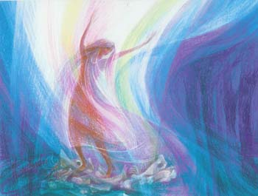
Let us Pray
Mary Southard CSJ
Strand Gatherer
www.MarySouthardArt.Org ;
and www.MinistryOfTheArts.Org
Flame –Dancing Spirit, come
Sweep us off our feet and
Dance us through our days.
Surprise us with your rhythms;
Dare us to try new steps, explore
New patterns and new partnerships;
Release us from old routines
To swing in abandoned joy and
Fearful adventure. And
In the intervals,
Rest us
In your still centre.
Amen.
From Women Included
–The St Hilda Community

I said to the almond tree,
‘Speak to me of God.’
And the almond tree blossomed
Nikos Kazantzakis
