Nurturing Communities of Abundance

THE SOUP STONE
Narrator
Woman
Neighbour
Stranger
Omit black

A woman in a village was surprised to find a fairly well-dressed stranger at her doorway asking for something to eat.

‘I’m sorry, I have nothing in the house right now.’

‘Not to worry”, said the amiable stranger. “I have a soup stone in this satchel of mine; if you will let me put it in a pot of boiling water I’ll make the most delicious soup in the world. A very large pot, please.’

The woman was curious. She put the pot on the fire and whispered the secret of the soup stone to a neighbour. By the time the water began to boil all the neighbours had gathered to see the stranger and her soup stone. The stranger dropped the stone into the water then tasted a teaspoonful with relish and exclaimed, ‘Ah, delicious. All it needs is some potatoes.”

‘I have potatoes in my kitchen,’ shouted one woman. In a few minutes she was back with a large quantity of sliced potatoes that were thrown into the pot. Then the stranger tasted the brew again. ‘Excellent!’ she said, but added wistfully, ‘If we only had some meat, this would become a tasty stew.”

Another housewife rushed home to bring some meat that the stranger accepted graciously and flung into the pot. When she tasted the broth again she rolled her eyes heavenward and said, ‘Ah tasty! If we had some vegetables it would be perfect, absolutely perfect.’

One of the neighbours rushed off home and returned with a basketful of carrots and onions. After these had been thrown in too and the stranger tasted the mixture, she said in a voice of command, ‘Salt and sauce.’ ‘Right here,’ said the housewife. Then came another command, ‘Bowls for everyone.’ People rushed to their homes in search of bowls. Some even brought back bread and fruit.

Then they all sat down to a delicious meal while the stranger handed out large helpings of her incredible soup. Everyone felt strangely happy as they laughed and talked and shared their very first common meal. In the middle of the merriment the stranger quietly slipped away, leaving behind the miraculous soup stone that they could use any time they wanted to make the loveliest soup in the world.

What does this story tell us about:
Leadership

Community

What gifts do I have to nourish a community?

HERE IS MY LIFE
Refrain:
Here is my life, myself the bread that I bring.
Here is my soul, my wine the song that I sing.
take it for gift and take it for granted,
sprung from the seeds that I’ve washed and I’ve planted
so long ago, and even ‘till now, and even ‘till now.

Bread from the fields, from my friends and bread from the lean years.
Bread from my youth and my loves and bread from the green years.
This much is ready now, this much is ready now,
Bake it as your own.
Wine of my joys and my dreams and wine of my good times,
wine of my won’t and my will, my did and my should times.
This much is ready now, this much is ready now.
Pour it as your own.

Bread from the highlands of life and bread from the valleys,
bread from the good things we’ve done that nobody tallies.
Now we are ready Lord. Now we are ready, Lord.
Bake us as your own.

Joe Wise.
©GIA:www.giamusic.com

A Similar Story from our Faith Tradition…
Narrator
Jesus
Disciples

THE FEEDING OF THE FIVE THOUSAND

A reading from the Gospel according to Mark

The apostles returned to Jesus and told him all that they had done and taught. And he said to them,
‘Come away by yourselves to a lonely place and rest a while.’

For many were coming and going, and they had no leisure even to eat. And they went away in the boat to a lonely place by themselves.

Now many saw them going, and knew them, and they ran there on foot from all the towns, and got there ahead of them. As he landed he saw a great throng, and he had compassion on them, because they were like sheep without a shepherd; and he began to teach them many things.

And when it grew late, his disciples came to him and said,
‘This is a lonely place, and the hour is now late; send them away, to go into the country and villages round about and buy themselves something to eat.’

But he answered them,
‘You give them something to eat.’

And they said to him,
‘Shall we go and buy two hundred denarii worth of bread and give it to them to eat?’

And he said to them,
‘How many loaves have you? Go and see.’

And when they found out, they said,
‘Five, and two fish.’

Then he commanded them all to sit down by companies upon the green grass. So they sat down in groups, by the hundreds and fifties. And taking the five loaves and the two fish he looked up to heaven, and blessed, and broke the loaves, and gave them to the disciples to set before the people; and he divided the two fish among them all. And they all ate and were satisfied. And they took up twelve baskets full of the broken pieces. And those who ate the loaves were five thousand people.
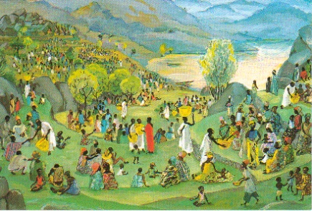
(Mark 6:30-44)
Jesus Mafa

LEADERSHIP FOR COMMUNITY
IN
THE FEEDING OF THE FIVE THOUSAND
THE LEADER IN THIS STORY…..

- Acts responsively, informed… by a framework of faith and hope…..

- Looks, listens, and discerns

- Keeps ‘reframing’ reality…

- Deflects, redirects, and ‘hands off’ initiatives and actions…

- Issues invitations and permissions and simple challenges…

- Deals with what is available…

- Models the desired action…

- Risks waiting for reality to emerge, whatever it may be….

BUT DOES NOT….

…get obsessed with goals that become binding, and blinding.

…press a pre-planned agenda.

…accept other’s definition of the situation.

…embrace other people’s projections about his/her responsibilities

…issue detailed orders or coercive commands.

…become obsessed with what is lacking.

…merely exhorts others to act

…force results, or the illusion of results
Parker J Palmer

What can I learn about leadership from the feeding of the five thousand and Parker’s reflection?

BREAD FOR THE HUNGRY
Refrain:
If you pour out your bread for the hungry,
The poor in your midst you will always have,
as close as your own heart if you can see
the poverty that lives down deep inside us all,
the quiet thirst that keeps us on our way,
the quiet thirst that keeps us on our way.

Silver or gold have I none to give,
but what I have I offer unto you.
Arise and be healed in the name of Jesus Christ
for all the world to see, like a city on a hill,
like a candle raging quiet in the night.
-Joe Wise
Songs for the Journey
©GIA:www.giamusic.com

if you bind up the ©GIA:www.giamusic.com
wounds of the soul,
then will your true light shine,
then will your true light shine
for all the world to see,
like a city on a hill,
like a candle raging quiet in the night.

A man sits alone by a prison wall;
a woman lays in pain upon her bed;
a young child walks the alleys with a muffled cry;
and who will give them comfort in my name,
and who will give them comfort in my name?

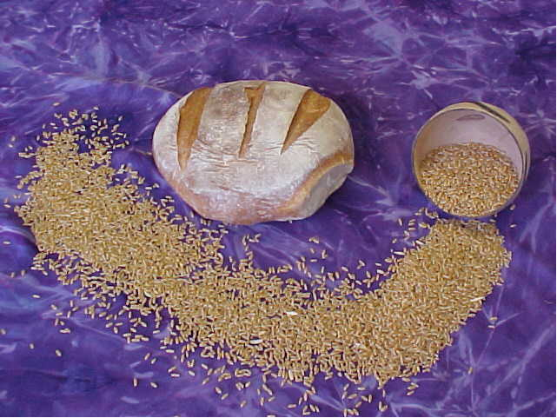

One Bread…
…..Many Grains

Thoughts and Suggestions:
Each one of us is born gifted with the potential to enrich the community. However life often intervenes and through circumstances we often do not recognise the gifts we have. Schools and faith communities have the opportunity to nurture communities of life where people flourish. The Soup Stone is a story that has been told through many cultures. This means that the story is crafted around universal principles. I suggest that you search The Soup Stone on Amazon and you will be amazed at how many versions of this story are there. In our own faith tradition the story echoes in the Feeding of the Five thousand. Pete Seeger and Paul DuBois Jacob’s Some Friends to Feed is a wonderful version for children. When the stranger arrives at the village the adults do not receive him. But the children do and through them a community, scarred by war and famine, is brought together for a meal. There is a song flowing through the story and in a CD accompanying the book Pete Seeger tells the story and sings the song. Leadership resides in all of us. Good leadership both recognises the gifts in others and invites them to be shared for the life of the community. The promise of the gospel is fullness of life and this is nurtured in communities of home, school, church and various other groups to which we belong..

As a way of ritualising this you could have stones in the sacred space and during either of the songs you could invite participants to pick up a stone as a symbol of claiming their gifts and their responsibility to share for the well-being of all.
This prayer could be introduced with some quiet, reflective music to invite people into a story telling and listening space.

