Listening to my Story

LISTEN
Listen, the voice of Your God is calling.
Listen, the voice of Your God is calling,
Listen with the ear of your heart,
The voice of Your God is calling.
Monica Brown

TREASURE IN THE FIELD OF OUR STORY
Slow a while.
Pause if you will.
Take time to listen to your story.
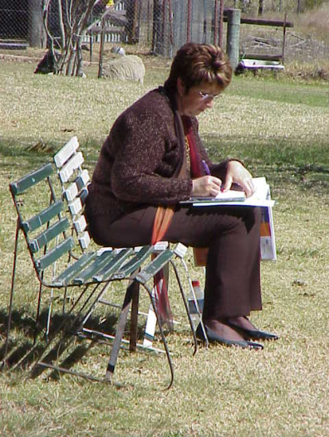Let your heart savour the folk
who have made you feel good
to be yourself.

Treasure them anew and give thanks.
Pray to be open to that spirit in you.

Discern for yourself
as you pan for gold.
It is the Beloved of Life
the Divine in our midst
the Beauty of Spirit alive in us
who keeps affirming our self worth
stripping away the overburden
uncovering the treasure in the field of our story.
Noel Davis
– Together at the Edge: Trust Me
COME TO ME
Come to me all you who are burdened and weary
And I shall give you rest.
Come to me as you are and I shall tend to you.
Listen - Come to me
© 1997 Monica Brown & Emmaus Productions
http://au.emmausproductions.com/
"Used with permission from
Monica Brown & Emmaus Productions".

In the poem we are encouraged to ‘Take time to listen to your story’….
In recent times when have I listened to my story?

Do I have regular moments of quiet in my life when I ‘listen with the ear of my heart’ to the relationships in my life, the ‘work’ entrusted to me …. to sense the holy in the daily?

Are there decisions I could make that would enable me to live with greater awareness and intention? E.G. 10 minutes of quiet before retiring each night; or 10 minutes of quiet upon rising in the morning…

God can only be present and active in the world today if we allow the Spirit to work through us…..

St Teresa’s prayer captures this simply and powerfully…
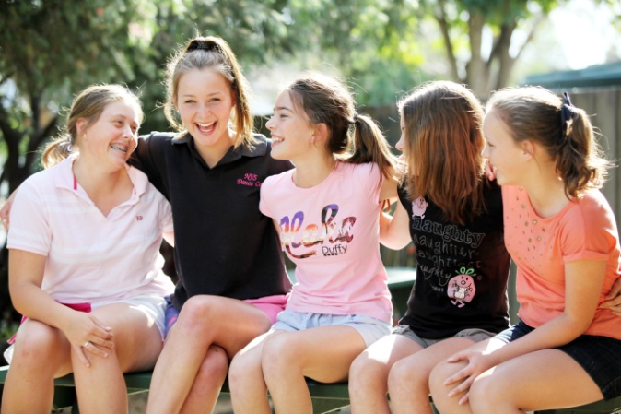Christ has no body but yours,
No hands, no feet on earth but yours,
Yours are the eyes with which he looks
Compassion on this world,
Yours are the feet with which he walks to do good,
Yours are the hands, with which he blesses all the world.
Yours are the hands, yours are the feet,
Yours are the eyes, you are his body.
Christ has no body now but yours,
No hands, no feet on earth but yours,
Yours are the eyes with which he looks
compassion on this world.
Christ has no body now on earth but yours.
An invitation to live and share the story…..
THE STORY WE SHARE
It’s a story that’s older than you or me,
deep as a well in the desert must be,
a journey begun in that far off time
when Abraham believed the sign God gave.

And the story is mine, the story is ours,
if we open our ears, we can hear;
a story that grows with the passing of years;
made of our laughter, struggle and fears.
The story we share, the journey to there
is happening here.

It’s a story the child and the grandmother share;
a mystery to ponder, a journey to make.
If we dare, a story to help us grow tall.
A tale of love, the story of us all

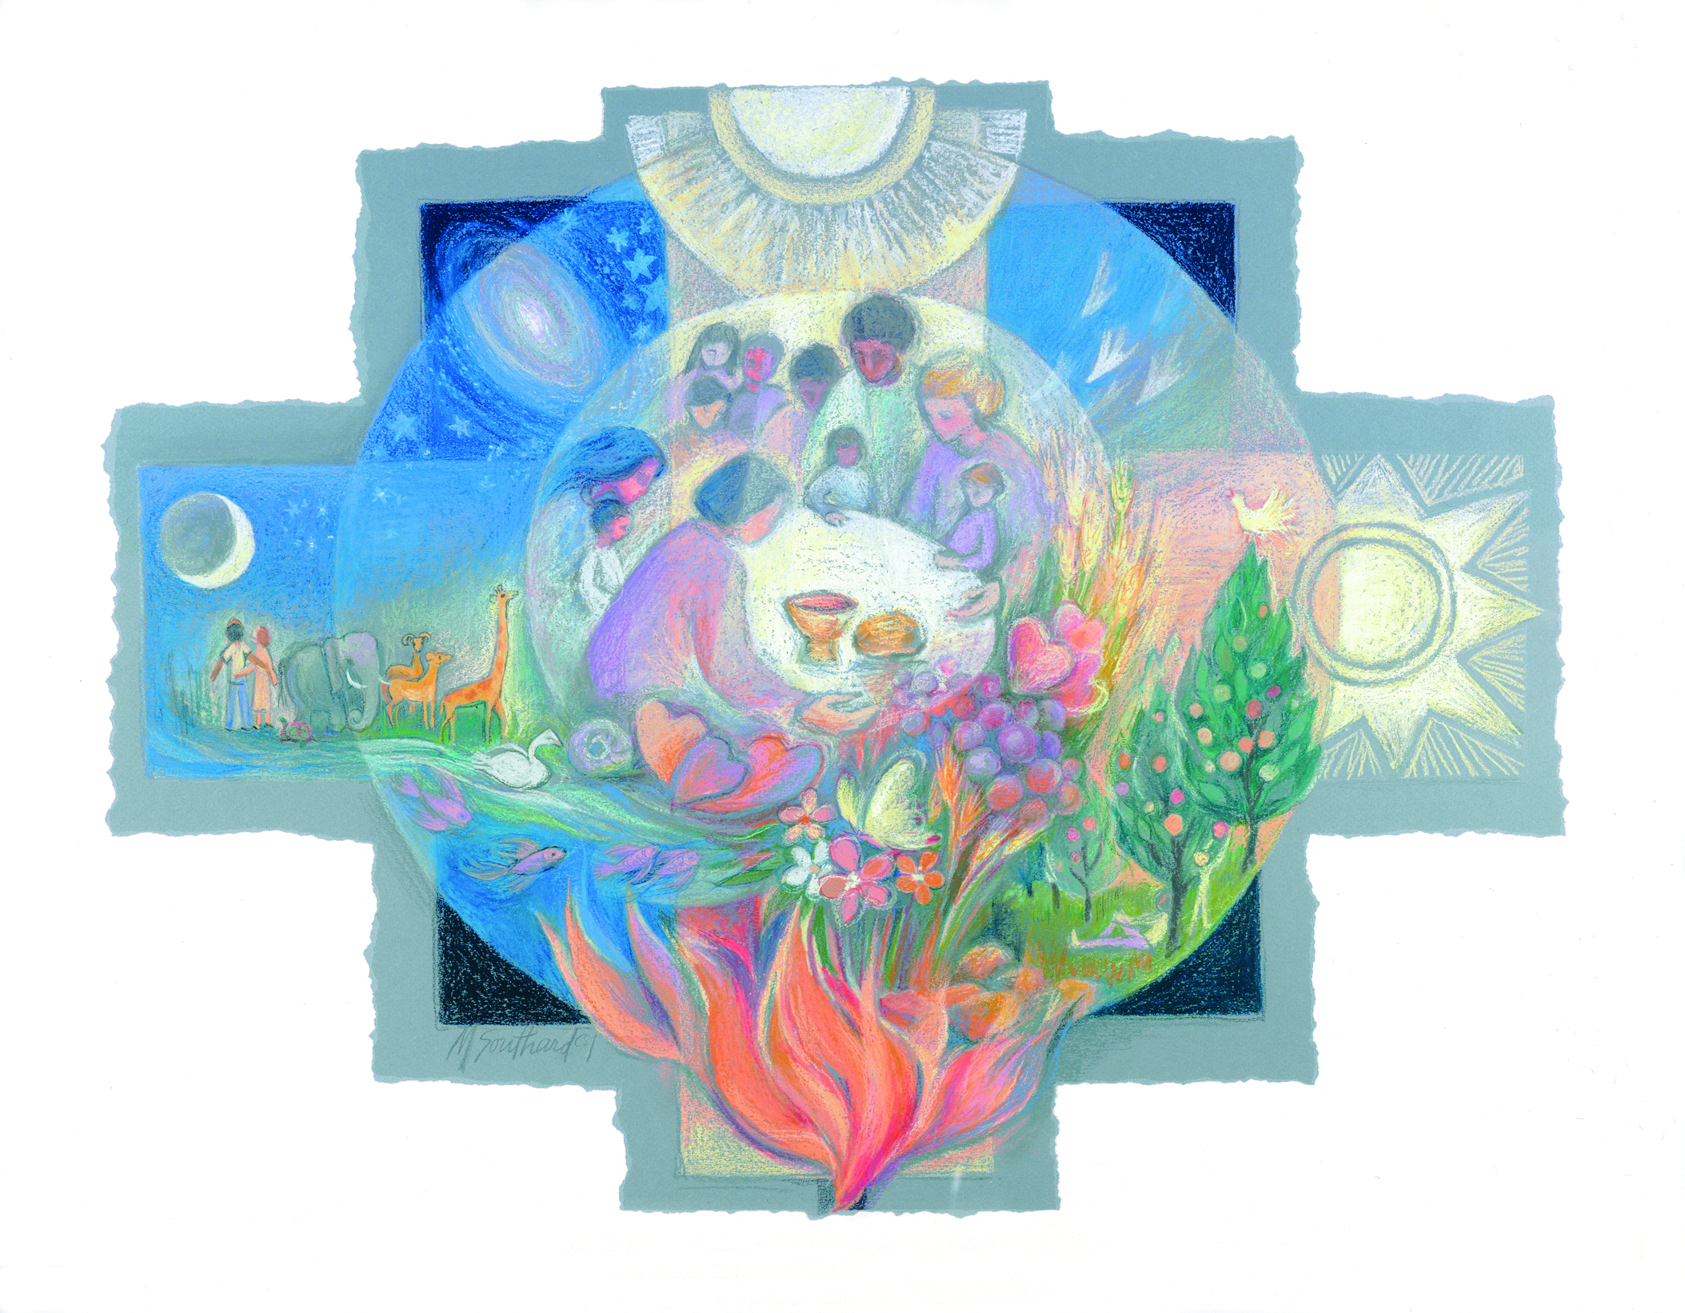
It’s the story of dying and rising again;
friendship found in the wine and the bread.
Round a fire that glows at the end of the day
we share the news and sing the blues away.

It’s a story that’s woven strand by strand;
the weaving of lives and the linking of hands;
no need to be lonely, the story we share
is drawing us, calling us to care.

It’s the story of God, concerned for the small,
providing the earth as a mother for all;
giving power to build and power to burn.
‘Where to now?’ Is surely our concern.
Peter Kearney –
Mary Southard CSJ
Sacred Community
www.MarySouthardArt.Org ;
and www.MinistryOfTheArts.Org

Growing in God
www.peterkearneysongs.aradium.com/

