Encounter, Decision, Mission….
….The Essence of Discipleship
DEEP WATERS
Empty me O God
that I may be filled.

Lead me
Lead me down
Lead me down into the depth of You.

Stay with me
Stay with me and speak to me
Stay with me and speak to me in silence

Deep waters flowing calling all to follow;
Watching, listening, waiting silence finds a home.

Deep waters flowing calling all to follow;
Watching, listening, waiting silence finds a home.
Trisha Watts & Monica O’Brien
(c) 1992, Trisha Watts & Monica O’Brien (McInerney),
published by Willow Publishing Pty Ltd,
PO Box 1061 Dee Why NSW 2099.
All rights reserved.www.willowpublishing.com.au
A reflection on John 4
Open to encounter, conversion…
INSIGHT
Staring into the depths,
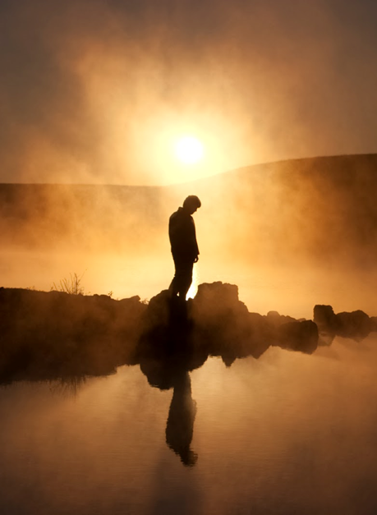
what do we see?

The journey inward is the hardest of all.
Over the years we build the walls of self-protection,
blocking out light and truth.

It’s too far to go down.
too deep to delve.
Yet we are drawn to the inner well,
our thirst for truth longing to be quenched.

This journey needs companions,
faces and voices reflecting back our own,
Loneliness aches,
emptiness rings hollow.

A voice breaks through the silence:
“I’m thirsty – will you give me a drink?”

What do I have that another could want?
Openness to possibilities,
a heart ready to receive.

“If you only knew the gift of God,
and who is it that is speaking to you”….

Can we recognize the one
whose invitation echoes in our hearts?

Can we share the gift?
Gemma Simmons IBVM

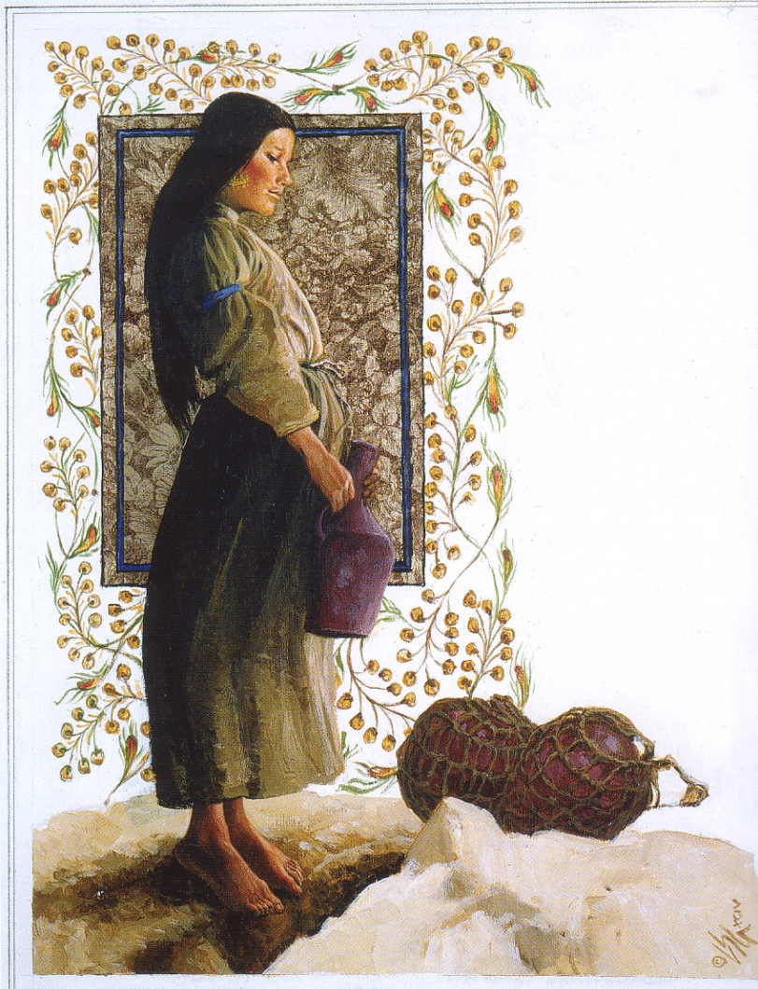
Louis Glanzmann

Pondering the choice…

I was on edge –
precipitous –
balancing my weight
before the dream of flowing water
that would never end …

Ah, I am so thirsty,
so deeply thirsty as I dare,
with mystic smile,
to imagine cleansing, freeing water
pouring over me …
Me?

Ah, give it to me!
I cry aloud,
from my deep dark place of longing.

Claiming the freedom to respond…

I am swelling with a joy and freedom
I am no longer afraid and shamed.
I am your soul sister.
Honoured, blessed
bearer of new life,
First witness of the Christ among us
Who broke the rules of exclusion,
Who dared to speak to a woman,
Who asked a favour from such as I,
then chose me
the rejected one,
chose me
the sinner,
chose me
the woman
to run, oh so filled up,
with such Good News.

Excerpts from
Edwina Gateley
– Soul Sisters

I have never known!
There is a rush like cleansing water
running through me,
leaving me light as air.
I have no need now for my jar of clay.

I run with the Living Water!
I run with the Good News entrusted to me –
to me –
by the Christ who waited for me,
received and filled me at the well
where women gather.

Ponder the wisdom articulated in these poems…. What is speaking to you now?

Let the art draw you into the encounter…. What do you see, feel, hear?

CHRIST, BE OUR LIGHT
Bernadette Farrell
Lyrics
http://www.spiritandsong.com/compositions/10415

Thoughts and suggestions:
This reflection centres on the woman at the well. In the Encounters section the text is explored more fully, and it would be helpful to have looked at this prior to engaging in this one. Sometimes we become so familiar with a text that it ceases to speak. Poetry and art can bring the text alive once again. Hopefully the art and poetry here will do that.

Discipleship is a life long journey. Engaging in conversation and dialogue and sharing insights can deepen our understanding and our response.

