The Journey Continues….
…..They Tell their Story

LEAD ME, GUIDE ME
Lead me, guide me in your way
Lead me, guide me in your way
Lead me, guide me in your way
Your holy way, O my God.
© 2003 Monica Brown & Emmaus Productions
http://au.emmausproductions.com/
"Used with permission from
Monica Brown & Emmaus Productions".

Narrator Jesus Disciple 1 Disciple 2 Disciples Omit Black

A reading from the gospel according to Luke
Now on that very same day (the Sunday after the crucifixion), two of the disciples were on their way to a village called Emmaus, seven miles from Jerusalem, and they were talking together about all that had happened. And it happened that as they were talking together and discussing it, Jesus himself came up and walked by their side; but their eyes were prevented from recognising him. And he said to them,
‘What are all these things that you are discussing as you walk along?’

They stopped, their faces downcast.

One of them called Cleopas, answered him,
‘You must be the only person staying in Jerusalem who does not know the things that have been happening there these last few days.’
He asked,
‘What things?’

They answered,
‘All about Jesus of Nazareth, who showed himself a prophet powerful in action and speech before God and the whole people; and how our chief priests and our leaders handed him over to be sentenced to death, and had him crucified. Our own hope had been that he would be the one to set Israel free. And this is not all: two whole days have now gone by since it all happened; and some women from our group have astounded us: they went to the tomb in the early morning, and when they could not find the body they came back to tell us they had seen a vision of angels who declared he was alive. Some of our friends went to the tomb and found everything exactly as the women had reported, but of him they saw nothing.’

Then he said to them,
‘You foolish people! So slow to believe all that the prophets have said! Was it not necessary that the Christ should suffer before entering into his glory?’

Then, starting with Moses and going through all the prophets, he explained to them the
passages throughout the scriptures that were about himself.

When they drew near to the village to which they were going, he made as if to go on; but they pressed him to stay with them saying,
‘It is nearly evening, and the day is almost over.’

So he went in to stay with them. Now while he was with them at table, he took the bread and said the blessing; then he broke it and handed it to them. And their eyes were opened and they recognized him; but he had vanished from their sight.

Then they said to each other,
‘Did not our hearts burn within us as he talked to us on the road and explained the scriptures to us?’

They set out that instant and returned to Jerusalem. There they found the eleven assembled together with their companions, who said to them,
‘The Lord has indeed risen and has appeared to Simon.’

Then they told their story of what had happened on the road and how they had recognized him at the breaking of bread.
Luke 24:13-35

EMMAUS—A MODEL FOR MINISTRY:

1. Tell your story … it is your history of becoming who you are..

2. Bring it into dialogue with the Gospel: See the meaning of it all….

3. Celebrate what happened—offer hospitality

4. Sent on Mission—invited to share your experience

STAY ON THE ROAD TO EMMAUS.
Every generation of Christians must fight its own demons, struggle with its own sadness. Today we live in that particular sadness between Good Friday and Easter Sunday. We are walking on the road to Emmaus. The God, the Church, and the dreams we had as children have died and we are trying to console each other for our crucified dreams.

Yet the old words, the old creeds, the ancient alleluias, still burn holes in us and when we hear the words of Jesus, as we gather for Eucharist, it is still easy enough to sing: “Are not our hearts burning within us?”

We need to remain on the road to Emmaus. The resurrected Christ is there to be met. In his company we need to spill out our sadness, mourn our disappointments, and stir our old hopes. At some moment our eyes will open and we will recognize the crucified Lord in the Risen Christ who is actually walking with us now. Our dreams will explode anew, like a flower bursting into bloom after a long winter, and we will be filled with a new innocence as Easter Sunday happens again.
Ronald Rolheiser
Daybreaks

There are two stages in this event:
The Journey and The Meal….
Let the artists speak to each of these stages….
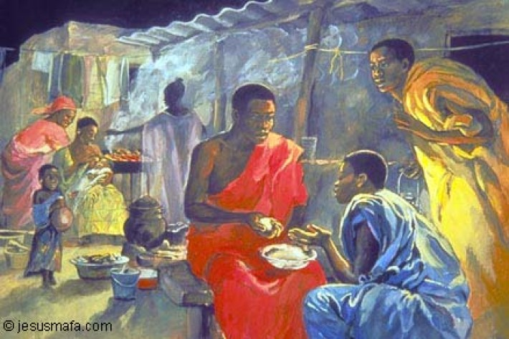
JANET BROOKS GERLOFF - EMMAUS

https://alexandrarossworks.files.wordpress.com/2013/11/emmaus_janetbrooks-gerloff.jpg
Jesus Mafa
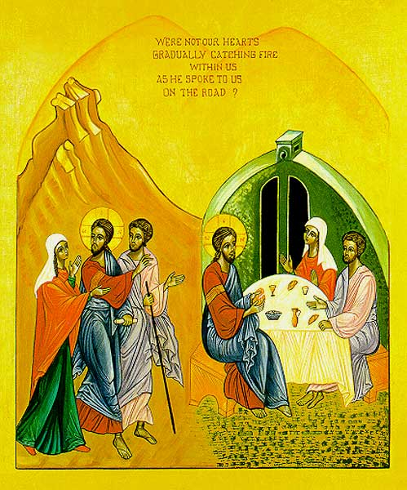
The two stages of the Emmaus event are depicted in this icon…

What do you see, hear, feel….

Sister Marie-Paul Farran OSB

SERVANT GIRL AT EMMAUS - VELAZQUEZ

https://shepaintsred.files.wordpress.com/2013/04/velazquez-ashx.jpg
Jesus
can be recognised and
encountered
from the margins…

The Servant-Girl at Emmaus
(a painting by Velazquez)

She listens, listens, holding
her breath. Surely that voice
is his – the one
who had looked at her, once, across the crowd,
as no one ever had looked?
Had seen her? Had spoken as if to her?

Surely those hands were his,
taking the platter of bread from hers just now?
Hands he’d laid on the dying and made them well?

Surely that face - ?

The man they’d crucified for sedition and blasphemy.
The man whose body disappeared from its tomb.
The man it was rumored now some women had seen this morning, alive?

Those who had brought this stranger home to their table
don’t recognise yet with whom they sit.
But she in the kitchen, absently touching the wine jug she’s to take in,
a young Black servant intently listening,

swings round and sees
the light around him
and is sure.
- Denise Levertov

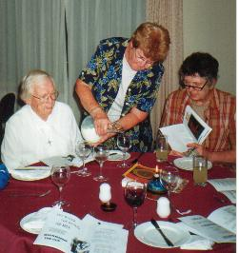EMMAUS
“Then came the journey to Emmaus,
two of us pouring out our heart’s confusion.
We were joined by a stranger
who seemed ignorant
of all that had happened.

He listened intently
as we poured out our story,
then gave it back to us,
It happens at tables the world over.
We sit down as strangers,
strangers in our own household.

Yet when we eat together
the possibility remains
some day we will leave as friend.
We will drop our masks of fear
and recognize each other
for the first time.
How can we hand bread to another
and remain the same?
.
Someday when our hands reach for the bread
our hearts will touch
And then we will know our foolishness.
We will recognize each other at last.
Our fears will flee away.
We will be scattered strangers no longer.

Anything can happen when you share a meal!”
Macrina Wiederkehr
– Seasons of your heart.

piece by piece
explaining every fear and pain.
We were awe-struck and amazed.

We pressed him to stay with us
to share our evening meal.
We weren’t ready to let this stranger go.
And then the unbelievable happened
as startling as the moment
when he washed our feet.
He took the bread and blessed it.
He broke it and handed it to us.

We recognised him then
as a stranger no longer
but he had vanished from our sight.
That was the moment of our understanding.

It was clear to us then
why our fear started crumbling
and why our love was returning.
Almost anything can happen at a table;
anything can happen when you share a meal.

And then the unbelievable happened
as startling as the moment
when he washed our feet.
He took the bread and blessed it.
He broke it and handed it to us.

We recognised him then
as a stranger no longer
but he had vanished from our sight.
That was the moment of our understanding.

It was clear to us then
why our fear started crumbling
and why our love was returning.
Almost anything can happen at a table;
anything can happen when you share a meal.

Time Alone…
If you were on a journey with a colleague at this time what ‘stories’ would you be sharing?

Name the hopes, the anxieties….

Talk about them as if there is ‘a stranger’ listening….. Then in the depth of your heart try to hear ‘the stranger’s’ conversation with you…

What are you hearing?

Emmaus Walk...
Share some of your reflection with a companion…..

EMMAUS SONG
Come journey with us walk with us, listen to our story.
Our hopes, our dreams, our struggles our joys, our story of life,
we share with you as we journey. Jesus, our God.

May our hearts be warmed and strengthened by your presence here.
In your holy word and bread of life in the love we share.
May we go forth on our journey with you.

Come journey with us, talk with us, tell us of your story.
Open our minds to understand the mystery of your life with us,
your risen life. Jesus, our God.

Come journey with us, stay with us, make us one with you.
In the blessing of bread, the breaking of bread may we truly know
your life in us, your love for us. Jesus, our God.

© 1993 Monica Brown & Emmaus Productions
http://au.emmausproductions.com/
"Used with permission from
Monica Brown & Emmaus Productions".

In the secret of my heart, teach me wisdom.
Psalm 50

Thoughts and suggestions:
There are many ways the resources here can be used. You could have the theme of Emmaus for a term and each time the staff meets take one of the resources. In that way the response to this event can be both expanded and deepened. When Cardinal Martini was here in Sydney he used this text for a reflection evening. He suggested that the disciples could be a man and a woman – that makes it a more inclusive text. He drew our attention that only Cleopas was named. If the other was a man why was he not named? It is not unusual for a woman to be unnamed in the scriptures. Sister Marie-Paul suggests this interpretation in her icon.

Emmaus brings together the themes of journey and meal – two themes central to our faith tradition. And in The Servant Girl we are reminded that those not at the centre of the action are often more attuned to situations as they watch from afar, perceiving body language, sensitive to the tone of conversation, able to ponder in the quiet of the kitchen awaiting the next task. Denise Levertov’s poem is a response to Velaquez’s art.

The resources could also be used for a staff reflection day. That would provide an ideal setting for an Emmaus walk.

