Teaching to honour the promise of the Gospel…
I have come that you might have life, life in abundance

In Richard Pring’s article Lessons from the Gas Chambers http://archive.thetablet.co.uk/article/10th-october-1992/19/blackboard he quotes a headmistress writing to new teachers in her school…

Dear Teacher,
I am the victim of a concentration camp. My eyes saw what no man should witness:
gas chambers built by learned engineers;
children poisoned by educated physicians;
infants killed by trained nurses;
women and babies shot and burned by high school and college graduates.

So, I am suspicious of education.

My request is: help your students become human. Your efforts must never produce learned monsters, skilled psychopaths, educated Eichmanns.

Let us gather in prayer and reflection on the invitation: help your students become human. Trisha Watts in her song Remember My Love reminds us that we are dealing with mystery, the mystery of God’s love, and God desire for each one of us to be loved into life…
Mary Southard CSJ
Child-of-the-Universe
www.MarySouthardArt.Org ;
and www.MinistryOfTheArts.Org

REMEMBER MY LOVE
Remember my love,
My love from age to age is timeless and new.
Remember my love, and how I’ve sheltered you.
Make your home in me as I make mine in you.

1.Tenderly I’ve watched and waited.
I have seen the sign of hope in your eyes.
Through the years love was created,
By the power of faithfulness.

2. Lovingly I’ve listened closely,
I have heard your tired voice in the night.
Through the years I’ve held you gently,
Like a mother who knows her own.
Trisha Watts & Monica O’Brien
(c) 1992, Trisha Watts & Monica O’Brien (McInerney),
published by Willow Publishing Pty Ltd,
PO Box 1061 Dee Why NSW 2099.
All rights reserved. www.willowpublishing.com.au

Let this song speak to you as teacher…..
Are there invitations to journey more deeply into the mystery of God for you personally?

Are there phrases or lines which could help you to tease open that invitation: help your students become more human?

Lift up the Souls of Students….

Parker Palmer has for many years focused his life’s work on nurturing the inner landscape of teachers’ lives. He believes strongly that we teach who we are. A retreat program has been developed by The Centre for Courage and Renewal to prepare facilitators to engage teachers and other professionals in this inner work. In his articles The Grace of Great Things written in 1997 he says:
I saw the other day a remarkable documentary called The Transformation of Allen School. Allen School is an inner-city school in Dayton, Ohio. It was for many years at the bottom of the list in that city by all measures. There were fifth graders who had parole officers. The dropout rate was incredible and saddening. The failure of those students in every aspect of their lives sickened the heart. And along came a new principal, a principal who—it’s relevant to note—came from the Philippines, a culture which has an inherent respect for things spiritual in a way American culture does not. And he brought the teachers together and said to them, in substance, as his very first proclamation as principal, that:
We have to start to understand that the young people we are working with have nothing of external substance or support. They have dangerous neighborhoods. They have poor places to live. They have little food to eat. They have parents who are on the ropes and barely able to pay attention to them. The externals with which American education is obsessed will not work in this situation.
But these students have one thing that no one can take away from them. They have their souls. And from this day forth in this school, we are going to lift those souls up. We are going to make those souls visible to the young people themselves and to their parents and to the community. We are going to celebrate their souls, and we are going to reground their lives in the power of their souls. And that will require this faculty recovering the power of their own souls, remembering that we, too, are soul-driven, soul-animated creatures.

And in a five-year period, that school, the Allen School in Dayton, Ohio, rose to the top of every dimension on which it had been at the bottom, through hard work, through disciplined work, but through attentiveness to the inward factors that we are here to explore. This is not romanticism. This is the real world.
The Grace of Great Things
www.couragerenewal.org/writings/grace-great-things for full article

Here is another principal new to a school offering a challenge to teachers……

In your experience who are the leaders with whom you have worked who have challenged you to think differently about the art and craft of teaching? About the way we relate with children?

Are there challenges we as a school community need to explore to enable our students and staff to live from within?

To lift up the souls of students we need to be in touch with our own souls…. The following poem invites us to reflect upon this important element of our lives…

THE WOODCARVER
Khing, the master carver, made a bell stand
Of precious wood. When it was finished,
All who saw it were astounded. They said it must be
The work of spirits.
The Prince of Lu said to the master carver:
“What is your secret?”

Khing replied: “I am only a workman:
I have no secret. There is only this:
When I began to think about the work you commanded
I guarded my spirit, did not expend it
On trifles, that were not to the point.
I fasted in order to set
My heart at rest.
After three days fasting,
I had forgotten gain and success.
After five days
I had forgotten praise or criticism.
After seven days
I had forgotten my body
With all its limbs.

“By this time all thought of your Highness
And of the court had faded away.
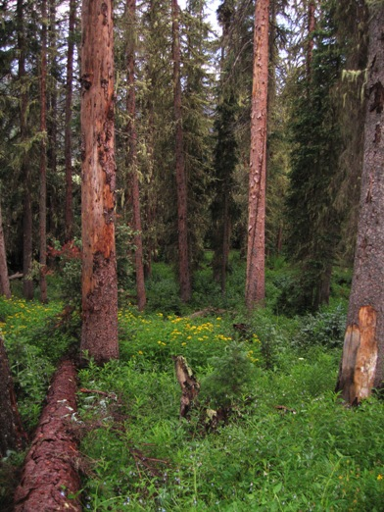All that might distract me from the work
Had vanished.
I was collected in the single thought
Of the bell stand.

“Then I went to the forest
To see the trees in their own natural state.
When the right tree appeared before my eyes,
The bell stand also appeared in it, clearly, beyond doubt.
All I had to do was to put forth my hand
And begin.

“If I had not met this particular tree
There would have been
No bell stand at all.

“What happened?
My own collected thought
Encountered the hidden potential in the wood;
From this live encounter came the work
Which you ascribe to the spirits.”

From The Way of Chuang Tzu, ed. and trans. By Thomas Merton

REFLECTING ON ‘THE WOODCARVER’

In the second stanza of his story, the Woodcarver speaks about guarding his spirit, setting his heart at rest, and ‘forgetting’ certain obstacles that would compromise the integrity of his work (attachment to gain and success, or to praise and criticism). Some of you may find it helpful to reflect on related needs and issues in your own active lives.

At the same time the story explores at least four other kinds of ‘soul and role’ issues on which some may find it helpful to reflect. In the course of his inner journey, the Woodcarver transforms his relationship to four elements that are key to work of every kind:

- The animating force behind my work.
Why am I doing this?

- The gifts and skills that carry my work forward.

3, The ‘other’ with whom/which I work?

4. The fruitfulness of my work.

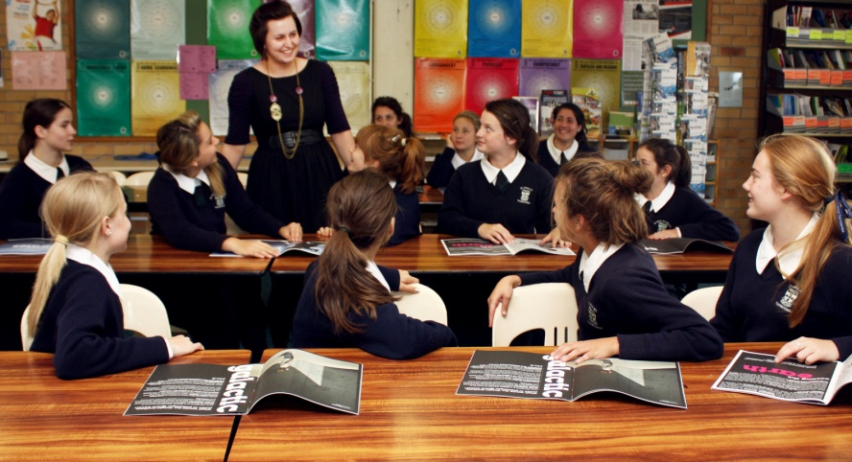

Adapted from the work of Parker Palmer

In the gospels Jesus shares the Beatitudes to help us understand what God is asking of us as a people….

Macrina Wiederkeher invites us to pray these blessings:
O Christ of the Merciful
Who are these people
wearing the robes of your mercy?
Have you returned again
in the person of their flesh?
Your love shines out in them
like a full moon.
O Christ of the Merciful
Dress me in the warm robes of your mercy.

O Christ of the Pure of Heart
Who are these fearless ones
seeing with their hearts
calling me to connect
with my own God-like heart?
In the centre of my being
dwells a heart that is one,
a stranger to division.
Forever it whispers,
I am already within you.
Believe in me! Believe in me!
O Christ of the Pure of Heart
Create in me a deep faith
in an undivided heart.

O Christ of the Peacemakers
Who are these dreaming dreams
carrying torches
building bridges?
They walk in peace
out where the wild things are.
They pitch their tents
in the fields of violence
And all of this
because they are at peace
within themselves.
O Christ of the Peacemakers
Create in me a peaceful heart
that cannot stay at home.

O Christ of the Persecuted
Twisted, broken
bent upon the cross
they proclaim all the truth they knew.
They died of truth, and
the Kingdom of Heaven became theirs.
O Christ of the Persecuted
Create in me a willingness
to die for the truth.
Macrina Wiederkehr
Seasons of Your Heart

THE PRAYER OF THE BEATITUDES
O Christ of the Poor in Spirit
They have no light of their own
no wealth of their own
Yet because of your glory
shining within them
they will be known in the Kingdom of God.
O Christ of the Poor in Spirit
Create in my crowded heart
a space for God.

O Christ of Those Who Mourn
A holy sorrow washes my soul
as the ache of others’ pain
threads its way through my being;
Sharing their sorrow
without trying to take it away
brings healing and comfort.
O Christ of Those Who Mourn
Create in me a new courage
to sit beside the sorrowing.

O Christ of the Lowly Ones
Possessing no power
save a truth deep within,
God’s anawim linger long
over that truth.
They receive
rather than take.
O Christ of the Lowly Ones
Create in me a gentle, open spirit.

O Christ of Those Who Hunger for Justice
What is this gnawing
in the center of their being?
Hunger-pains, refusing to be satisfied
with anything less than God.
In the deep caverns of their souls
lives a blazing zeal
that burns for righteousness.
O Christ, Sun of Justice
Burn your way into my soul
with the terrible gift
of this same blazing zeal.

SUMMONED BY LOVE
Mary Southard CSJ
Child of the Universe
www.MarySouthardArt.Org ;
and www.MinistryOfTheArts.Org

Be still and know I am God.
Listen to me and see
you’re not alone in your journey.
Trust in yourself and trust in me.

Be not afraid of the night.
Darkness shall not prevail.
My light will guide and make clear your way.
Tender and strong your heart will stay.

Summoned by you, summoned by love we come.
We are gathering to celebrate your word, O Lord.
Summoned by you, summoned by love we come.
Our lives we give in offering to you.

Go now in faith and in peace.
Your life will be my sign,
Know deep within I am with you now,
Now and until the end of time.
Trisha Watts & Monica O’Brien
(c) 1992, Trisha Watts & Monica O’Brien (McInerney),
published by Willow Publishing Pty Ltd,
PO Box 1061 Dee Why NSW 2099.
All rights reserved. www.willowpublishing.com.au

Thoughts and Suggestions:
I have included a variety of resources to engage teachers in reflecting upon their responsibility to nurture the faith of children. To make the gospel real to the lives of children today is a key responsibility. To do this, teachers need to be committed to their own inner journey. The Woodcarver is one resource through which to ponder our own centeredness. Those preparing a prayer will know which resources might best engage staff in conversation and reflection on this important element of Catholic education. The excerpts from Pring and Palmer invite us to look closely at what we do as educators. The music invites us to ponder the mystery of God in our own lives and invites to the respond to the summons of Love and allow our loves to become signs of God’s love in the world.…..The Prayer of the Beatitudes could be read by one person with the group praying together those parts on bold type.

