The Cycle of the Seasons – Pondering Winter
Winter is a lesson about the fine art of loss and growth. Its lesson is clear; there is only one way out of struggle and that is by going into the darkness, waiting for the light, and being open to new growth.
Joan Chittister
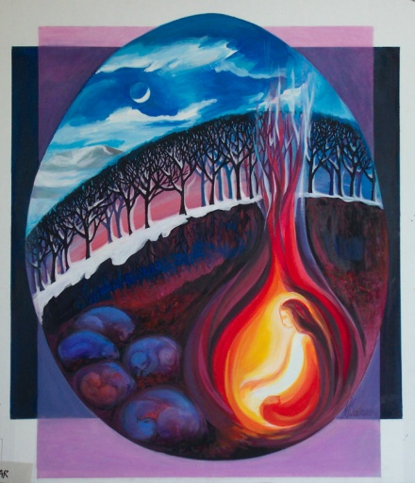
Winter a time to stop, to rest, to be…

KEEPING VIGIL WITH MYSTERY
My heart can see into the darkness.
And my prayer travels deep, where the Eternal One waits.
With love I listen, keeping vigil with the Mystery,
With the One who waits for me.
I am with the one who waits for me.
Velma Frye & Macrina Wiederkehr
– Seven Sacred Pauses
www.velmafrye.com

Mary Southard CSJ
Holy Waiting
www.MarySouthardArt.Org ;
and www.MinistryOfTheArts.Org

A reading from the gospel according to John
Jesus said,
‘I tell you most solemnly, unless a wheat grain falls on the ground and dies, it remains a single grain; but if it dies it yields a rich harvest. Those who love their life lose it; those who hate life in this world keep it for the eternal life.

Those who serve me, must follow me, for wherever I am, my servants will be there too. Those who serve me, my Father will honour.’
John 12:24-26

LISTENING TO WINTER
The trees have shed their colourful autumn robes.
Winter is raging through the dark, empty branches
and I am listening.
I am listening to the roar and to the quiet of winter.
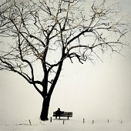
I am listening to a beauty
that sometimes remains unseen.
I am listening.

I am listening to the seed hidden in the earth.
I am listening to the dark swallowing up the light.
I am listening to faith rising out of doubt.
I am listening to the need to believe without seeing.
I am listening.

I am listening to the season of contemplation,
to the urgency of our world’s need for reflection.
I am listening to all that waits within the earth,
to bulbs and seeds,
to deep roots dreaming.
I am listening to the sacred, winter rest.
I am listening.
I am listening to long nights,
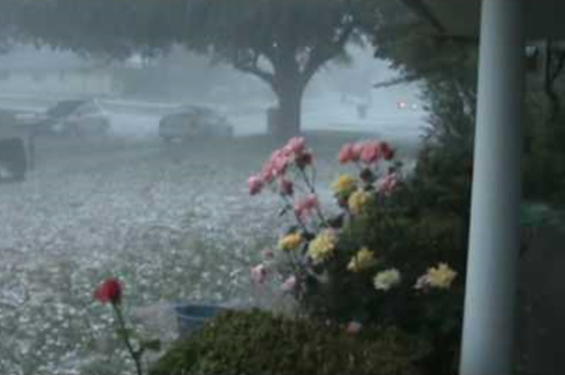
comforting darkness,
fruitful darkness,
beautiful darkness.
I am listening to the darkness of the winter season.
I am listening to the sparks of hope within the darkness.
I am listening.

I am listening to storms raging at my window,
to storms raging in my heart.
I am listening to all that makes me pull my cloak a little tighter
I am listening to trust buried deep in the ground of my being.
I am listening.

I am listening to the kind permission of the season
to rest more often,
to reflect more deeply,
to pray without words.
I am listening to the sacrament of non-doing.
Highlight the lines that are speaking to you…

Listen carefully….what are they asking of you?

How will you respond?
I am listening.

I am listening to my dreams and inner visions,
to the unknown wrapped in the mystery of my life,
to tears trapped in underground streams of my being,
to seeds watered daily by those tears.
I am listening.

I am listening to the quiet life in winter’s womb.
I am listening to the winter, nurturing spring.
I am listening to brilliant winter sunsets
and lovely frosty mornings.
I am listening to snowflakes flying through the air,
to the cold winds that often blow out there,
to bare trees, so lovely in their emptiness,
to one leaf that never did let go.
I am listening.

I am listening to winter
handing over spring.
I am listening to the poetry of winter.
I am listening.
Macrina Wiederkehr
The Circle of Life 2005
Joyce Rupp and Macrina Wiederkehr
Sorin Books – Ave Maria Press

Let us pray
We pray in thanks for those with hope around us, for eyes to see the ever-present hint of spring within our soul. Thanks be to you for the gentle, persistent power of your love that asserts itself within us, and will not be denied until it buds, then bursts, full-flower.

We praise you for your patience with our blindness and our short-lived memories, and stand dumbfounded that you accept us all and all within us and dare to take delight in us. This alone is a cause for hope – to know your ease with our dis-ease of self. We trust that what you know and love of us gives peace today and future promise. Amen
Janet Schaffran and Pat Kozak
More than Words
Repeat Mantra: KEEPING VIGIL WITH MYSTERY

