Leadership that both gives and receives
…..Jesus models this for us
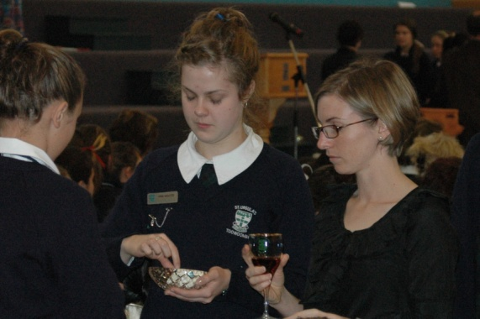
A NEW COMMANDMENT
A new commandment I give unto you
That you love one another as I have loved you
That you love one another as I have loved you.

By this the world will know you are my disciples
If you have love one for another.
By this the world will know you are my disciples
If you have love one for another.
Author Unknown

A reading from the gospel according to John
Now before the festival of the Passover, Jesus knew that his hour had come to depart from this world and go to the Father. Having loved his own who were in the world, he loved them to the end. The devil had already put it into the heart of Judas son of Simon Iscariot to betray him. And during supper Jesus, knowing that the Father had given all things into his hands, and that he had come from God and was going to God, got up from table, took off his outer robe, and tied a towel around himself. Then he poured water into a basin and began to wash the disciples’ feet and to wipe them with the towel that was tied around him.

He came to Simon Peter, who said to him,
“Lord, are you going to wash my feet?”
Jesus answered,
“Unless I wash you, you have no share with me.”
Simon Peter said to him,
“Lord, not my feet only but also my hands and my head!”
Jesus said to him
“One who has bathed does not need to wash, except for the feet, but is entirely clean. And you are clean, though not all of you.”
For he knew who was to betray him; for this reason he said, “Not all of you are clean.”

After he had washed their feet, had put on his robe, and had returned to the table, he said to them,
“Do you know what I have done to you? You call me Teacher and Lord – and you are right, for that is what I am. So if I, your Lord and Teacher, have washed your feet, you also ought wash one another’s feet. For I have set you an example, that you should do as I have done to you.
(John 13: 1-15)

In this text focus on Peter’s reaction to this gesture of Jesus….
What does it teach us about Peter?

In what ways does it speak to me and my response to various situations?

In the following reflection Macrina Wiederkehr enters the scene and imagines what it might have been like as a participant in this gesture of hospitality, love and service….

GOD IN AN APRON
Supper was special that night.
There was both a heaviness
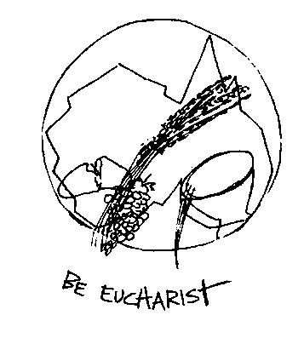
and a holiness hanging in the air.
We couldn’t explain the mood.
It was sacred, yet sorrowful.
Gathered around that table
eating that solemn, holy meal
seemed to us the most important meal
we had ever sat down to eat.

We were dwelling in the heart of mystery.
Though dark the night
Hope felt right
as if something evil
was about to be conquered.

And then suddenly
the One we loved startled us all.
He got up from the table
and put on an apron.
Can you imagine how we felt?

God in an apron!
Then he handed me the towel and said,
‘As I have done
so you must do.’
Learn to bow.
Learn to kneel.

Let your tenderness encircle everyone you meet.
Wash their feet not because you have to, because you want to.

It seems I’ve stood two thousand years holding the towel in my hands,
‘As I have done so you must do,’ keeps echoing in my heart.

‘There are so many feet to wash’, I keep saying.
‘No,’ I hear God’s voice resounding through the years,
‘there are only my feet.
What you do for them you do for me.’
Macrina Wiederkhr
Seasons of your Heart

Tenderness encircled us
as He bowed before us.
He knelt and said,
‘I choose to wash your feet
because I love you.’

God in an apron, kneeling.
I couldn’t believe my eyes.
I was embarrassed until his eyes met mine.
I sensed my value then.
He touched my feet.
He held them in his strong, brown hands.
He washed them.
I can still feel the water.
I can still feel the touch of his hands.
I can still see the look in his eyes.

Let this poem speak……….

Another person ponders this text

A BOWL OF DIRTY WATER
Feet are arguably one of the least attractive parts of the human anatomy. Often gnarled or knobbly, they can sprout fungi, calluses, bunions, and ingrown toenails. They ache when we’re dying to shop, get pinched and blistered by our favourite shoes, and trample on unsuspecting pets as they try to sleep. Feet are something only a mother could love. Yet at the heart of John’s account of Jesus’ words and deeds at the Last Supper what do we find? Feet, front and centre. John omits what the other Gospels record as Jesus’ Eucharistic words over bread and wine. Instead, he has Jesus rise from the table, strip, wrap himself in a towel, pick up a bowl, and – without a word, - begin washing his disciples’ feet, one by one.

Meditating on this scene, novelist Luigi Santucci once wrote that if he could have some relic of Christ’s passion, he’d choose a bowl of dirty water. He’d take it into the streets, he tells us, passing from person to person, looking only at their feet and never at their faces – so he couldn’t tell friend from foe. Popes and presidents, drug dealers and arms merchants, gurgling babies and adoring grandparents, petty thieves and scam artists, prom queens and disc jockeys: he’d wash the feet of every one – and keep on washing until they understood. Deciding who to save isn’t our job. Our job is choosing whom to serve. And Jesus’ example suggests we should be absolutely indiscriminate in our judgement. Look at feet, not faces. Serve all, because Christ died to save all. That, perhaps, is the ultimate meaning of Eucharist.
Come to the table where all are welcome.
Nathan Mitchell
– Daybreaks 2010
What is your response to this text…..

Our Final Song with an Invitation

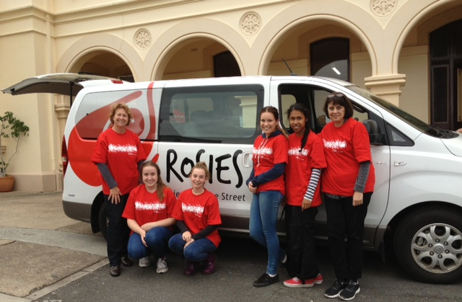
SO YOU MUST DO
Jesus our Teacher and Lord
stooped to wash the feet of his disciples
and he told them, “This is an example,
just as I have done so you must do”.

When Jesus had gathered with those he loved,
as a humble servant he knelt at their feet.

“If I, your teacher, have washed your feet,
so must you be willing to serve in my name.”

“A new commandment I give to you,
that you love each other as I have loved you.”
Marty Haugen
– Up from the Waters
©GIA:www.giamusic.com
Thinking and Suggestions:
For this prayer you could have a towel and a bowl of dirty water…. as the final song is sung people could be invited to stir the water as a gesture of willingness to respond to the invitation of Jesus: I have set you an example, that you should do as I have done to you….

This prayer could also focus on Peter. In the previous reflection on this text Peter’s reaction was omitted so we could focus on our response to Jesus’ invitation rather than on Peter’s. Here we can ponder how much of Peter resides in me! It can be comforting to know that Peter who was finally invited to lead the emerging community of Jesus’ disciples sometimes missed the point of Jesus’ words and actions. It is good to remember that we are always in the process of becoming disciples – it is a life long journey.

A New Commandment is available from iTunes by a number of artists.

