I have a Gospel to Proclaim ….
KEEPING VIGIL WITH MYSTERY
My heart can see into the darkness.
And my prayer travels deep, where the Eternal One waits.
With love I listen, keeping vigil with the Mystery,
With the One who waits for me.
I am with the one who waits for me.
Velma Frye & Macrina Wiederkehr
– Seven Sacred Pauses
www.velmafrye.com

A reading from the gospel according to John
It was very early on the first day of the week and still dark, when Mary of Magdala came to the tomb. She saw that the stone had been moved away from the tomb and came running to Simon Peter and the other disciple, the one Jesus loved.

Mary said:
‘They have taken the Lord out of the tomb, and we don’t know where they have put him.’

So Peter set out with the other disciple to go to the tomb. They ran together, but the other disciple, running faster than Peter, reached the tomb first; he bent down and saw the linen cloths lying on the ground, but did not go in. Simon Peter who was following now came up, went right into the tomb, saw the linen cloths on the ground, and also the cloth that had been over his head; this was not with the linen cloths but rolled up in a place by itself. Then the other disciple who had reached the tomb first also went in; he saw and he believed. Till this moment they had failed to understand the teaching of scripture, that he must rise from the dead. The disciples then went home again.

Meanwhile Mary stayed outside near the tomb, weeping. Then, still weeping, she stooped to look inside, and saw two angels in white sitting where the body of Jesus had been laid, one at the head, the other at the feet.

They said:
‘Woman why are you weeping?’

Mary replied,
‘They have taken my Lord away and I don’t know where they have put him.’

As she said this she turned around and saw Jesus standing there, though she did not recognize him.

Jesus said,
‘Woman, why are you weeping? Who are you looking for?’
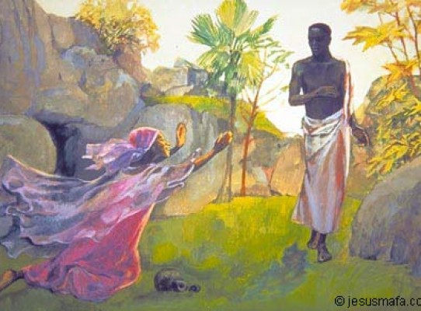
Jesus Mafa
Supposing him to be the gardener she said,
‘Sir, if you have taken him away, tell me where you have put him, and I will go and remove him.’

Jesus said:
‘Mary!’

She knew then and said to him in Hebrew,
‘Rabbuni!’ – which means Master.

Jesus said to her,
‘Do not cling to me, because I have not yet ascended to the Father. But you go and find the brothers, and tell them: I am ascending to my Father and your Father, to my God and your God.’

So Mary of Magdala went and told the disciples that she had seen the Lord and that he had said these things to her.
John 20:1-18

THEY HAVE TAKEN AWAY MY LORD.
(A reflection on John 20: 1-18)

It was unfinished.
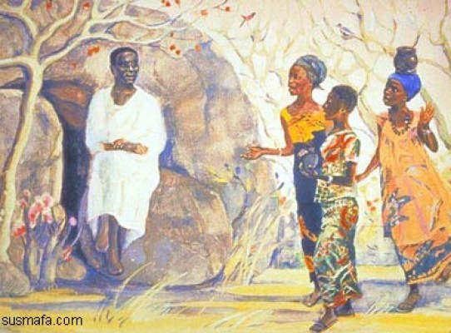We stayed there, fixed until the end.
Jesus Mafa
women waiting for the body that we loved;
and then it was unfinished.
There was no time to cherish, cleanse, anoint;
no time to handle him with love,
no farewell.

Since then, my hands have waited,
aching to touch even his deadness,
smooth oil into the bruises that no longer hurt,
offer his silent flesh my finished act of love.

I came early, as the darkness lifted,
to find the grave ripped open and his body gone;
container of my grief smashed, looted,
leaving my hands still empty.
I turned on the man who came:
‘They have taken away my Lord – where is his corpse?
Where is the body that is mine to greet?
As you listened to John’s gospel, pondered the poem or contemplated the Jesus Mafa art what are you learning?

‘I stood and grieved, and then departed.’ Have you had such an experience in your life? What did you learn from the experience?

‘I have a gospel to proclaim.” What does this mean in your life?

He is not gone
I am not ready yet, I am not finished –
I cannot let him go
I am not whole.”

And then he spoke, no corpse,
and breathed,
and offered me my name.
My hands rushed to grasp him;
to hold and hug and grip his body close;
to give myself again, to cling to him,
and lose myself in love.
‘Don’t touch me now.’

I stopped, and waited, my rejected passion
hovering between us like some dying thing.
I, Mary, stood and grieved, and then departed.

I have a gospel to proclaim.
Janet Morley
All Desires Known
Like Mary I have a Gospel to Proclaim …

Let us pray together this song of belief that invites participation and action.

I BELIEVE
What do I believe?
What do I believe?

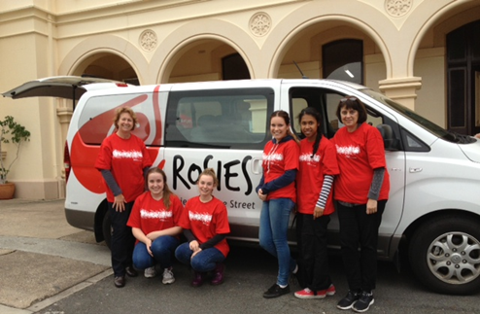I believe we can say the words that need to be said.
I believe we can be a voice for the voiceless.
I believe in a world of hurt we can be peace.
I believe we can keep hope, hope alive.
Oh, I believe! I believe!
I believe we can turn indifference into love.
I believe that we can uninvite bitterness. (Bye, bye!)
I believe in the healing power of a song.
I believe in the wisdom of a child.

Oh, I believe! I believe!
We have just the right amount of holy anger
to make positive changes in an unjust world.
We have just the right amount of holy passion
to make positive changes in an unjust world.
And we hold these truths to be self-evident,
no matter how beautiful they are.
Oh, I believe! I believe!
(*Macrina Wiederkehr, Velma Frye)
www.velmafrye.com

An Invitation from Francis, our leader, in this year of Mercy….
In this Holy Year, we look forward to the experience of opening our hearts to those living on the outermost fringes of society: fringes modern society itself creates. How many uncertain and painful situations there are in the world today! How many are the wounds borne by the flesh of those who have no voice because their cry is muffled and drowned out by the indifference of the rich! During this Jubilee, the Church will be called even more to heal these wounds, to assuage them with the oil of consolation, to bind them with mercy and cure them with solidarity and vigilant care. Let us not fall into humiliating indifference or a monotonous routine that prevents us from discovering what is new! Let us ward off destructive cynicism! Let us open our eyes and see the misery of the world, the wounds of our brothers and sisters who are denied their dignity, and let us recognize that we are compelled to heed their cry for help! May we reach out to them and support them so they can feel the warmth of our presence, our friendship, and our fraternity! May their cry become our own, and together may we break down the barriers of indifference that too often reign supreme and mask our hypocrisy and egoism!( MV 15)

* Music available velmafrye.com or iTunes

