Discipleship – the Call to Integrate Martha and Mary

LOVE, SERVE AND REMEMBER
Why have we come to earth,
Do you remember?
Why have we taken birth,
Do you remember?

To love, serve and remember
To love, serve and remember
To love, serve and remember
Lyrics and music – John Astin
Kathy Zavada – In Love Divine

A reading from the gospel according to Luke
In the course of their journey Jesus and the disciples came to a village, and a woman named Martha welcomed Jesus into her house. She had a sister called Mary, who sat down at the Lord’s feet and listened to him speaking.

Now Martha who was distracted with all the serving said,

‘Lord, do you not care that my sister is leaving me to do the serving all by myself? Please tell her to help me.’

But the Lord answered:

‘Martha, Martha, you worry and fret about so many things, and yet few are needed, indeed only one. It is Mary who has chosen the better part; it is not to be taken from her.

Luke 10:38-42
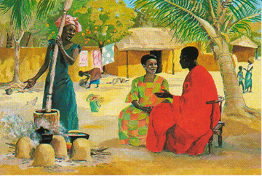
With whom do you identify most in this text?

Do you have feelings as you ponder this character?

Name them….
Jesus Mafa

Before this encounter at the house of Martha as portrayed in Luke’s gospel, we have Jesus teaching through story. He has just told the parable of the Good Samaritan, a story in which the religious leaders and educated Jews did not respond to a person in need. It was a foreigner, an outsider from Samaria, who was filled with compassion for the stranger and responded in the manner in which Jesus was endeavouring to form his disciples…

We now move to another domestic scene in the home of Martha and Mary as recounted in John’s gospel. Martha welcomes him… she is a woman of hospitality…. Mary chooses to sit and listen…. Both prayer and service are essential for us to engage fruitfully in mission… the challenge for us is to integrate Mary and Martha in our lives…
Let us explore the dynamic within the family from what John tells us…..
A reading from the gospel according to John
Six days before the Passover, Jesus went to Bethany, where Lazarus was, whom he had raised from the dead. They gave a dinner for him there; Martha waited on them and Lazarus was among those at table. Mary brought in a pound of very costly ointment, pure nard, and with it anointed the feet of Jesus, wiping them with her hair; the house was full of the scent of the ointment.
John 12:1-3
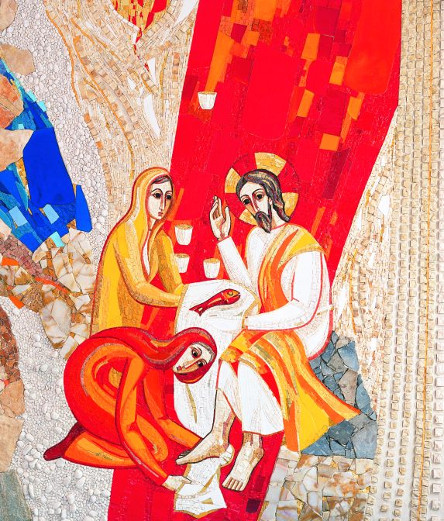
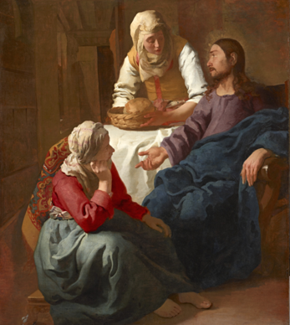
Fr. Marko I. Rupnik & Atelier of Centro Aletti

Johannes Vermeer

Art is full of symbolism… look how artists, three and a half centuries apart, have captured Martha, Mary and Jesus as portrayed in the gospels… Look at the placement of characters, the colours, the gestures, what is central….
Let them draw you into the heart of the encounters depicted here…..

Capture what you see, hear, feel in a poem, prayer, art…

Share your musings with the person next to you….
At a later time you might search the web for various interpretations of this art….

Let us pray with each of these women
Ah Mary,
you confront us with the challenge
to take time, to sit quietly,
to listen to the voice of the Spirit
deep within,
and allow our work to be transformed
from duty to service ...
from job to vocation, ….

Then and only then
can we sacralise our call
so whatever we do
becomes an expression of love ….
Then we truly will be able to say:
‘This is my body given for you.’
Leone Pallisier
Ah, Martha,
you confront us
with the task of sacralizing our call,
with making holy our work
of home-making and mothering.
Your voice awakens us
from complacency and submission
to claim the dignity of baking our bread
for the hungry of the world.

Your voice urges us to claim the right
to bless and break our bread
and offer to all who come to our table, saying:
Take this,
All of you and eat it,
This is My Body,
Soul Sister.
Soul Sisters—Edwina Gateley

Let us anoint each other for mission….

Anoint me with the oil of blessing, O God,
And the touch of your enlivening Spirit

Anoint my HEAD so that your thoughts and dreams draw me into your presence among us.

Anoint my EYES so that I might recognise you in those around me.

Anoint my EARS that I might listen with a heart ready to hear and respond.

Anoint my LIPS that I might speak your word without fear.

Anoint my HANDS to touch with tenderness those longing for the warmth of human contact.

Anoint my FEET to walk in courageously to those places where you are calling for presence.

Anoint my HEART with integrity so that I may respond to Francis, our leader’s invitation to begin a revolution of tenderness.

Anoint my spirit for mission, that I might reach out and into the heart of the whole hurting world.

Anoint my soul for ministry, that I might have the courage to respond with the whole of my being to the daily demands of grace.

Anoint me to remember that I am never alone.
Leone Pallisier

Send forth singing the song: LOVE, SERVE AND REMEMBER

