A Furtive Encounter and a Touch that Heals….

WILL YOU LOVE ME
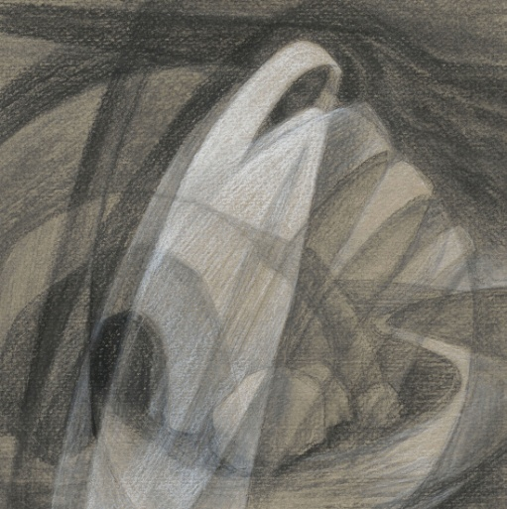Will you give me your life forever?
Will you carry my cross every day?
Will you walk in the light of my presence?
Will you follow the truth of my ways?

Will you love me as I have loved you?
Will you live with me the darkness as I die?
For the moon and the stars will be gone like the night,
and the sun will be shining on you.

Like the purest of gold in the furnace,
is your love strong enough to endure?
Does your faith carry on through the shadows?
Does it shine in the night for the world?
Mary Southard CSJ
Even the rocks will cry out
www.MarySouthardArt.Org ;
and www.MinistryOfTheArts.Org

Can you walk in the footprints of silence,
through the wilderness sands in the sun,
from the desert of doubt and temptation,
to the glorious mountain of fire?
Brian Boniwell
– The Lord Delights

Let us ponder a woman who ‘had carried her cross’ for many years, who had walked in the ‘footprints of silence’…

A reading from the gospel according to Mark
Now there was a woman who had been suffering from haemorrhages for twelve years. She had endured much under many physicians, and had spent all she had; and she was no better, but rather grew worse.

She had heard about Jesus, and came up behind him in the crowd and touched his cloak, for she said,
‘If I but touch his clothes I will be made well.’

Immediately her haemorrhage stopped; and she felt in her body that she was healed of the disease. Immediately aware that power had gone forth from him, Jesus turned about in the crowd and said,
‘Who touched my clothes?’

And his disciples said to him,
‘You can see the crowd pressing in on you; how can you say, “Who touched me?”’

He looked all around to see who had done it. But the woman knowing what had happened to her came in fear and trembling, fell down before him and told him the whole truth. He said to her,
‘Daughter, your faith has made you well; go in peace, and be healed of your disease.’
Mark 5:25-34

Ponder the woman…..
what do you
Mary SouthardCSJ
Healing Touch
www.MarySouthardArt.Org ;
and www.MinistryOfTheArts.Org

see,
feel,
hear…..

HEALING IS YOUR TOUCH
Healing is your touch, O God,
Renewing the Spirit of the broken.
Healing is your touch, O God,
Renewing the spirit of the broken.
© 1991 Monica Brown & Emmaus Productions
http://au.emmausproductions.com/
"Used with permission from
Monica Brown & Emmaus Productions".

Let us listen to how this text touches Janet Morley

O MY GOD TURN TO ME
O my God, turn to me;
answer my pain and my pleading,
for I am heavy with fear.
My fear has been my garment day and night;
anxiety clings to me like a shadow,
faithful and pitiless.

My blood flows like tears,
Louis Glanzmann
like weeping that will not end;
like grief that cannot be healed,
my body is drained of strength,
and I cannot contain myself.

Many draw back from me;
my friends withhold their touch,
Like a body that is untouched,
I have no substance;
like a dead thing that may not be touched,
I have become unclean.

But you have seen my reproach;
you comprehend my shame,
You alone are my helper,
in the shadow of your cloak I shall be healed.
I will not let you pass,
but I shall be comforted;
my soul clings to you,
and my affliction shall cease.

For I will touch you, and you shall know me;
you shall be moved by me.
In the flood of your power I shall be changed,
for you cannot withhold your love.
Every part of my being
reaches out for your touch;
and I shall know in my body
that I have been made whole.

Then shall my terror and trembling
be turned to the fear of God;
then shall my blood be the blood of life,
and my tears not grief, but grace.
Janet Morley
– All Desires Known.

What are your fears, your anxieties, your weakness that you would like to reach through to touch the healing garment of Jesus?

Name them, open them to the healing touch of God…. This may come through the touch of a child, a spouse, a parent, a colleague, a student….

To whom do you need to reach out…… to touch with tenderness….

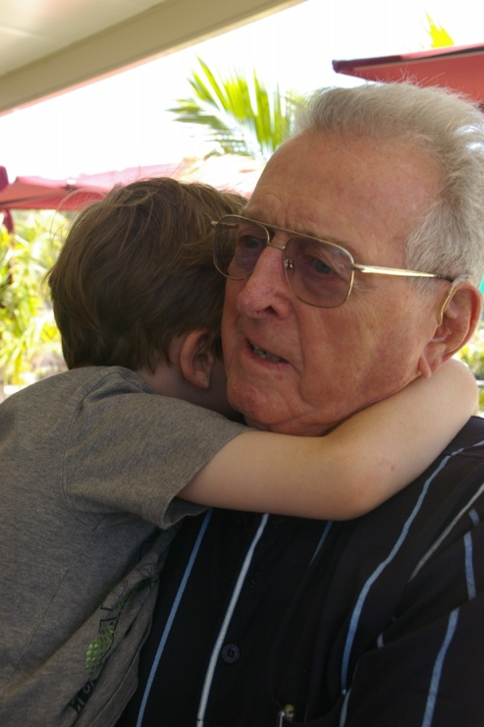

ENFOLD ME IN YOUR LOVE
Enfold me in your love,
Enfold me in your love,
Encircle me O God, surround me with your love,
Come fill me with your love.

Enfold me with your peace..

Enfold me with your grace…

Enfold me in your love

© 1997 Monica Brown & Emmaus Productions
http://au.emmausproductions.com/
"Used with permission from
Monica Brown & Emmaus Productions".

