This is My Body Given for You
One of the soldiers pierced Jesus’ side with a lance; and immediately there came out blood and water. John 19:34
SO GREAT A LOVE
Oh what do we do with so great a love
so great a love
Oh what do we do with so great a love
so great a love
so great a love
so great a love
so great a love
Oh what do we do with so great a love
so great a love…..
Carolyn McDade – O Beautiful Gaia
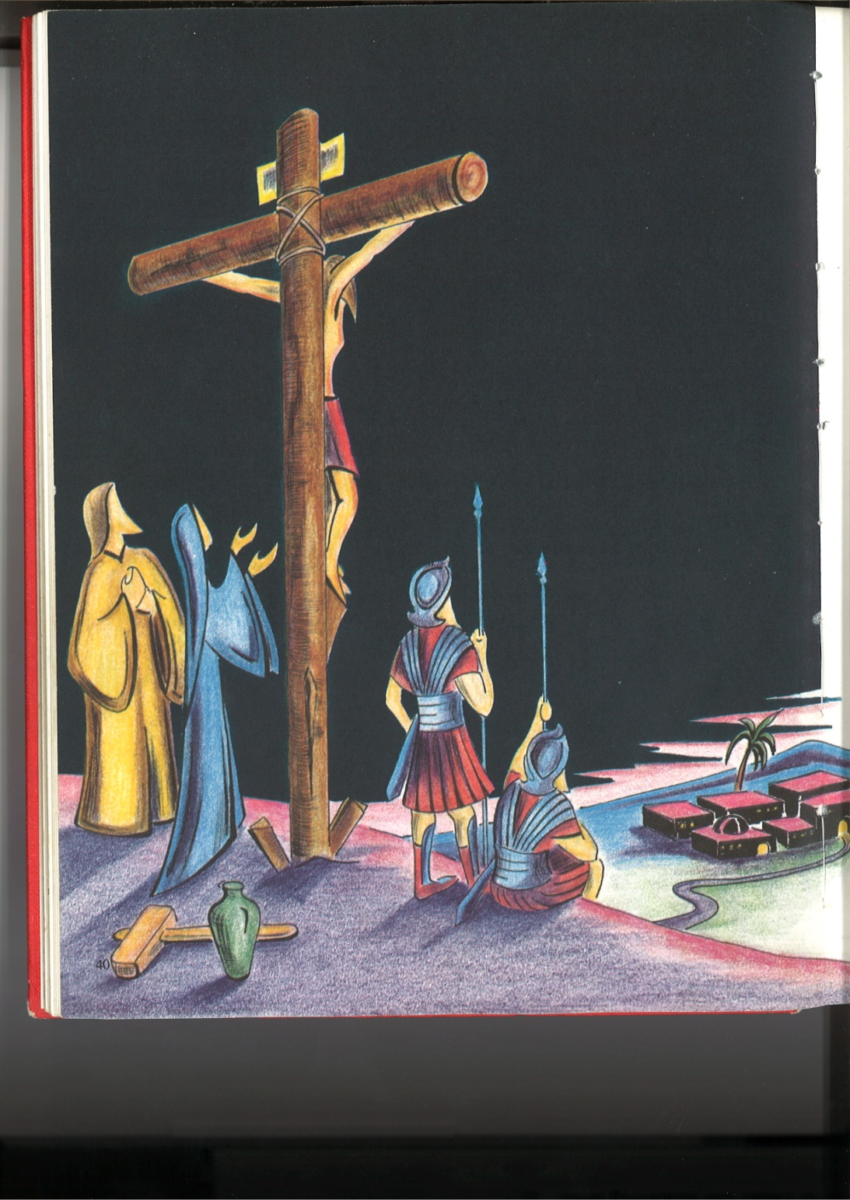
Kien Be OSU

MY HEART
My heart is fixed upon you God,
My heart is steadfast in your love,
My heart at peace within your gaze,
My heart at home in your embrace.

© 1991 Monica Brown & Emmaus Productions
http://au.emmausproductions.com/
"Used with permission from
Monica Brown & Emmaus Productions".

Let this moment speak in the quiet of your heart

