The Cycle of the Seasons…. Pondering Autumn
Autumn is that transition time when we leave the extravagant growth of summer and prepare to embrace the solitude of winter. It is a time to celebrate the wonders of summer as we allow its fruitfulness to surrender once again to the earth so that the ongoing cycle of life continues. After the vibrancy of summer it gives us time to stop, to ponder and to plan the next cycle of growth. What seeds need to be replanted, that served the summer well? Are there new seeds I wish to plant? Are there others I need to set aside as they have given all the life they can? What pruning might be needed? Autumn is the season of paradox – in order to grow we may need to let go of work, attitudes, beliefs, relationships which are not nurturing the promise of the Gospel: I have come that you might have life and have it to the full. (John 10:10). It is time to discern who we want to be and what ‘seeds’ will assist in that process of becoming.

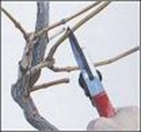
Autumn – The Season of Surrender
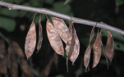
LET GO AND MOVE
With all that has been, take lessons,
take lessons and be grateful.
Let go! Let go! Let go! Let go!
Let go and move! Move on! Move on!
Velma Frye & Macrina Wiederkehr
– Seven Sacred Pauses
www.velmafrye.com

AN AUTUMN BLESSING
Blessed are you, autumn,
season of so much bounty.
You invite us to imitate your generosity
in giving freely from the goodness of our lives,
holding nothing back.

Blessed are you, autumn,
your harvesting time has come.
As we gather your riches into our barns,
reveal to us our own inner riches
waiting to be harvested.

Blessed are you, autumn,
season of surrender,
you teach us the wisdom of letting go
as you draw us into new ways of living.

Blessed are you, autumn,
season of unpredictability.
You inspire us to be flexible
to learn from our shifting moods.

Blessed are you, autumn,
feast of thanksgiving.
You change our hearts into fountains of gratitude
as we receive your gracious gifts.
Joyce Rupp & Macrina Wiederkehr
The Circle of Life 2005
Ave Maria Press
Blessed are you, autumn,
chalice of transformation,
you lift a cup of death to our lips
and we taste new life.

Blessed are you, autumn,
season of the heart’s yearning,
you usher us into places of mystery
and, like the leaves, we fall trustingly
into eternal, unseen hands.

Blessed are you, autumn,
with your flair for drama
you call to the poet in our hearts,
“return to the earth, become good soil;
wait for new seeds.’

Blessed are you autumn,
you turn our faces toward the west.
Prayerfully reflecting on life’s transitory nature
we sense all things moving toward life-giving death.

Blessed are you autumn,
you draw us away from summer’s hot breath.
As your air becomes frosty and cool
you lead us to inner reflection.

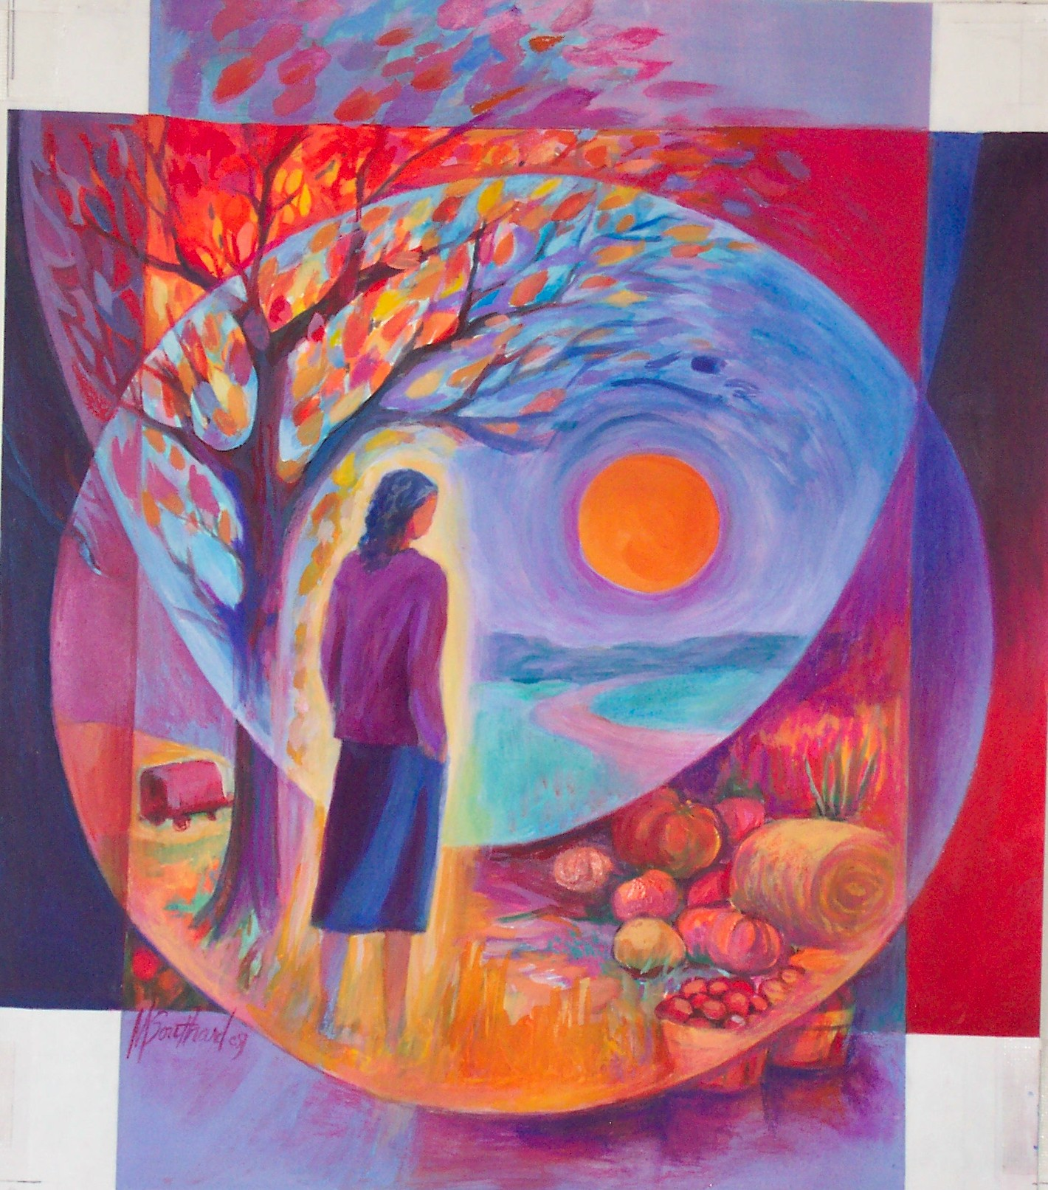
Is there something in the above poem which speaks to your life at this moment in history?

Autumn invites us to ‘fallow time’… do you have ‘fallow’ moments in the day, the week, the month, the term?

How might you arrange your life so that there are times of quiet when you can listen to the echoes of God within your being calling you to deeper attentiveness to his love and the work he has entrusted to you?
Mary Southard CSJ
Abundant Autumn
www.MarySouthardArt.Org ;
and www.MinistryOfTheArts.Org

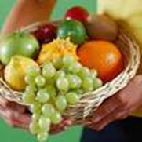
From Autumn Sonnets
If I can let you go as trees let go
Their leaves, so casually, one by one;
If I can come to know what they do know,
That fall is the release, the consummation,
Then fear of time and the uncertain fruit
Would not distemper the great lucid skies
This strangest autumn, mellow and acute.
If I can take the dark with open eyes
And call it seasonal, not harsh or strange
(For love itself may need a time of sleep),
And, treelike, stand unmoved before the change,
Lose what I lose to keep what I can keep,
The strong root still alive under the snow,
Love will endure - if I can let you go.
May Sarton

HERE IS MY LIFE
Here is my life, myself the bread that I bring.
Here is my soul, my wine the song that I sing.
take it for gift and take it for granted,
sprung from the seeds that I’ve washed and I’ve planted
so long ago, and even ‘till now, and even ‘till now.

Bread from the fields, from my friends and bread from the lean years.
Bread from my youth and my loves and bread from the green years.
This much is ready now, this much is ready now,
Bake it as your own.

Wine of my joys and my dreams and wine of my good times,
wine of my won’t and my will, my did and my should times.
This much is ready now, this much is ready now.
Pour it as your own.

Bread from the highlands of life and bread from the valleys,
bread from the good things we’ve done that nobody tallies.
Now we are ready Lord. Now we are ready, Lord.
Bake us as your own.
Joe Wise
Most Requested
©GIA:www.giamusic.com

