Mary – A Jewish Peasant Woman
In partnership with God she gifted the world with Jesus
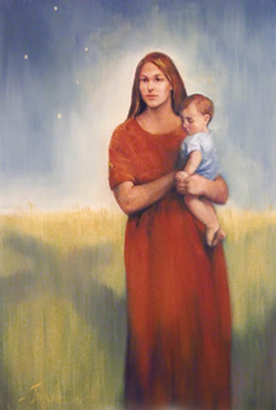
LEAD ME, GUIDE ME
Lead me, guide me in your way
Lead me, guide me in your way
Lead me, guide me in your way
Your holy way, O my God.

© 1993 Monica Brown & Emmaus Productions
http://au.emmausproductions.com/
"Used with permission from
Monica Brown & Emmaus Productions".

A reading from the gospel according to Luke
‘Mary treasured all these things and pondered them in her heart.’
Luke 2:20

Imagine Mary as….

Child Daughter Friend
Mary of the Southern Cross
Jan Williamson
Niece Jewish peasant

Sibling Betrothed Teenage mother

Wife Refugee

Neighbour Nurse Cook

Hostess Gardener Homemaker

Going to the market Collecting water from the well
Chatting with the women
Woman of faith Leader of prayer in family
Prophet

Are these the roles and daily tasks during which ‘she treasured and pondered’ what had been told to her at the birth of Jesus and the unfolding of her own life as his mother?

How else might you imagine Mary?

We, like Mary, are invited to leave the familiar behind…. to step into the unknown
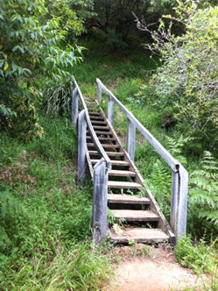O God,
who am I now?
Once, I was secure
in familiar territory
in my sense of belonging
unquestioning of
the norms of my culture
the assumptions built into my language
the values shared by my society.

But now you have called me out and away from home
and I do not know where you are leading.
I am empty, unsure, uncomfortable.
I have only a beckoning star to follow.

Journeying God,
pitch your tent with mine
so that I may not become deterred
by hardship, strangeness, doubt.
Show me the movement I must make
toward a wealth not dependent on possessions
toward a wisdom not based on books
toward a strength not bolstered by might
toward a God not confined to heaven
but scandalously earthed, poor, unrecognised…

Help me to find myself
as I walk in others’ shoes.
Kate Compston
John 1:14; Hebrews 13:13-14
Bread of Tomorrow

Is there an invitation here for me?

How might I respond?

MARY A PARTNER IN HOPE –

Elizabeth Johnson challenges us:
… what would be a theologically sound, spiritually empowering and ethically challenging view of Mary, mother of Jesus Christ, for the 21st century? My answer has been to suggest that we remember Mary as a friend of God and prophet in the communion of saints. Let her dangerous memory inspire and encourage our own witness.
We ought to relate to Miriam of Nazareth as a partner in hope, in the company of all the holy women and men who have gone before us. This can help us reclaim the power of her memory for the flourishing of women, for the poor and all suffering people. It can help us to draw on the energy of her example for a deeper relationship with the living God and stronger care for the world.
When the Christian community does Marian theology this way, our eyes are opened to sacred visions for a different future. We become empowered to be voices of hope in this difficult world. Like Mary, we will be rejoicing in God our savior and announcing the justice that is to come.

Sent forth in the company of Mary…
Mary in her time and in her place opened herself to bring to birth the Word of Life. That is our mission as disciples, a responsibility of our Baptismal commitment. Let us pray in song for the courage to listen to the Word whispering within me and for the courage to go where it is leading…

GALILEE SONG
Deep within my heart I feel
Voices whispering to me.
Words that I can’t understand
Meanings I must clearly hear!
Calling me to follow close
Lest I leave myself behind!
Calling me to walk into
Evening shadows one more time!

So I leave my boats behind!
Leave then on familiar shores!
Set my heart upon the deep!
Follow you again, my Lord!
As I gaze into the night
down the future of my years,
I’m not sure I want to walk
past horizons that I know!
But I feel my spirit called
Like a stirring deep within
restless ‘till I live again
beyond the fears that close me in!
Frank Andersen
– Everything I Possess

In my memories I know
how you send familiar rains;
falling gently on my days
dancing patterns on my pain!
And I need to learn once more
in the fortress of my mind
to believe in falling rain
as I travel deserts dry!

Thoughts and suggestions:
For many older Catholics this image of Mary so often shaped the understanding and imagination of the mother of God. Can you imagine a woman dressed like this engaging in the tasks and roles named in this reflection? In some ways this depiction put Mary ‘on a pedestal’ remote from us and from the daily. The gift of recent scholars, especially women theologians and scripture scholars, is their portrayal of Mary as a Jewish peasant woman invited to participate in God’s mission in our world. Paul VI in his apostolic exhortation Marialis Cultus (1975) suggested that one of the main reasons for the wane in devotion to Mary was that our approach to Mary reflected outdated ideas of the Middle Ages and the Counter-Reformation period of the Church, views of Mary that had little appeal to contemporary people. For an article titled: In Search of the Real Mary by Elizabeth Johnson C.S.J. visit http://www.americancatholic.org/newsletters/cu/ac0501.asp. It is in accessible language and really expands our imagination and understanding of Mary in the culture of her time and as a model for us today. The paragraph by Elizabeth in this reflection is from the document.

MARY OF THE SOUTHERN CROSS
A Word from the Artist: Jan Williamson's life sized portrait in oils depicts Mary as a rural woman standing with the child Jesus in what might be considered a wheat field. The infant Jesus is dressed in a romper suit, as any child today might be. Mary is wearing a simple brown dress.

Mary's face is serene, yet possessing of a great strength. It could be the face of an Aboriginal woman, or even the face of a European migrant. It is a face that might be described as universal.

Behind the picture of Mary the shadow of the cross can be seen. It is as if her shadow and the shadow of the cross are one. The colours of the painting are reminiscent of the outback — olive greens and ochre reds.
Copyright: Diocese of Toowoomba

