**Jesus Models Servant Leadership….**

**I am among you as one who serves…**

**KEEPING VIGIL WITH MYSTERY**

My heart can see into the darkness.

And my prayer travels deep, where the Eternal One waits.

With love I listen, keeping vigil with the Mystery,

With the One who waits for me.

I am with the one who waits for me.

Velma Frye & Macrina Wiederkehr

– *Seven Sacred Pauses*

www.velmafrye.com

**Jesus’ last gathering with the disciples…**

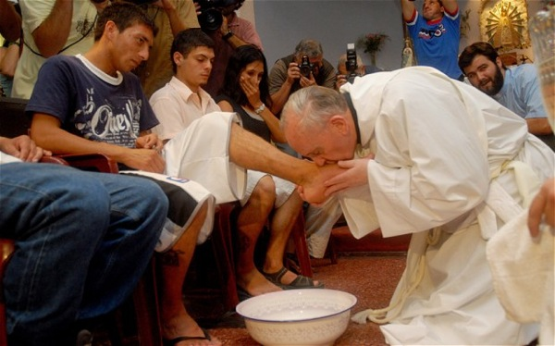**THE BASIN AND THE TOWEL**

**Francis, Bishop of Rome**

**Models**

**Servant Leadership….**

**Washing feet**

**in a juvenile prison in Rome**

A reading from the gospel according to John

**Now before the festival of the Passover, Jesus knew that his hour had come to depart from this world and go to the Father. Having loved his own who were in the world, he loved them to the end. The devil had already put it into the heart of Judas son of Simon Iscariot to betray him. And during supper Jesus, knowing that the Father had given all things into his hands, and that he had come from God and was going to God, got up from table, took off his outer robe, and tied a towel around himself. Then he poured water into a basin and began to wash the disciples’ feet and to wipe them with the towel that was tied around him. ….**

**After he had washed their feet, had put on his robe, and had returned to the table, he said to them,**

**“Do you know what I have done to you? You call me Teacher and Lord – and you are right, for that is what I am. So if I, your Lord and Teacher, have washed your feet, you also ought wash one another’s feet. For I have set you an example, that you should do as I have done to you.**

**I tell you most solemnly, no servant is greater than his master, no messenger greater than the man who sent him.**

**Now that you know this, happiness will be yours if you behave accordingly.”**

(John 13: 1-5, 12-17)

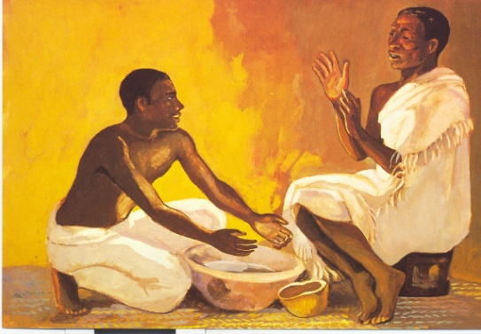

*Jesus Mafa*

*He got up from the supper and took off his outer garment and wrapped a towel around himself* – **John 13:4**

John records none of Jesus’ parables because for him Jesus’ life was a parable. The footwashing was just such a moment of meaning.

In an upstairs room

A parable is just about to come alive

And while they bicker about who’s best

With a painful glance He’ll silently rise

Their Saviour Servant must show them how

Through the will of the water

And the tenderness of the towel

***CHORUS: And the call is to community***

***The impoverished power that sets the soul free***

***In humility to take the vow***

***That day after day we must take up***

***The basin and the towel***

In any ordinary place

On any ordinary day

The parable can live again

When one will kneel and one will yield

Our Savior Servant must show us how

Through the will of the water

And the tenderness of the towel

***BRIDGE: And the space between ourselves sometimes***

***Is more than the distance between the stars***

***By the fragile bridge of the servant’s bow***

***We take up the basin and the towel***

***CHORUS: And the call is to community***

***The impoverished power that sets the soul free***

***In humility to take the vow***

***That day after day we must take up the basin and the towel***

And the call is to the community

The impoverished power that sets the soul free

In humility to take the vow

That day after day we must take up the basin

And day after day we must take up the basin

And day after day we must take up

The basin and the towel.

Michael Card © 1994 Birdwing Music

http://store.michaelcard.com/

What am I hearing, seeing, feeling in John’s text and Michael Card’s music?

Is there an invitation as teacher, leader, parent, companion…..

Share a little of your reflection with the person next to you….

**A TOWEL AND A BASIN**

From *A Radical Guide for Catholics* by Huebsch

It is our tools that determine our trade in life and the tools of the Eucharist are a towel and a basin. In the gospel of John the bread, if there was any, is not mentioned at all. The writer of that Gospel was able to sum up all that the Eucharist means without the food; and all that was needed to tell the story was that towel and basin.

We read this story at Mass only on one evening of the entire year: Holy Thursday, when very few people are present. I think that’s a great shame because it is really the charter document of the church, of our households, and of our small communities.

The point made here is that if we have not washed one another’s feet with a life of service to the body of Christ, the community present and absent, then we really haven’t *received* communion.

But it isn’t easy to be so intimate and to risk this much faith. It’s much easier to just go to Mass on Sunday which involves almost no risk at all in much of the modern world. (P 201)

It is a terrible risk to look across the table at someone and say to him or her, or to them: “Do we want Jesus at the centre with the solidarity that implies?” “Do we or can we come to love each other this much?” “Will we really receive the Body of Christ, with all its bruises and imperfections and needs? All its unwanted, unwashed and unhealed?” “Are we really ready for this?”

These are very intimate questions because they put us on the line with people at our own table, the one with whom we break bread, our “Companions”. (P.200)

**If we take seriously the many lessons from Jesus’ final meal with his disciples how might our living, leading and loving change?**

**Let us pray…**

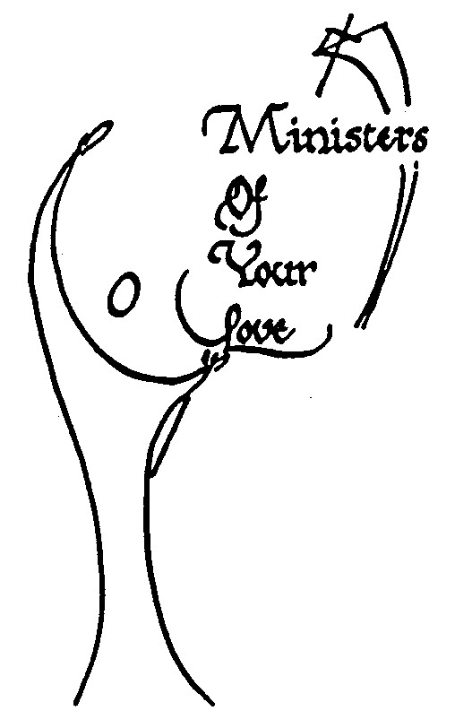

Let’s wash the feet of the world,

the tired aching feet of the Guatemalan Mayans,

the nomadic feet of the Australian aborigines,

the trimmed and pedicured feet of Madison Avenue,

the feet of refugees with no land to call home,

the busy feet of parents,

the tiny feet of children around the world,

the determined feet of women today,

the feet in army boots carrying guns and bombs,

those in the shoes of priests,

neighbours,

homeless,

or hopeless people everywhere.

Let’s make a pact with each other,

a covenant,

that we will stay together

until the feet of the world

march together on the Mountain of Justice.

We make this prayer in Jesus name.

AMEN Huebsch page 205

**Some suggestions and commentary**

In our culture the washing of feet is a rather dramatic gesture. In the time of Jesus it was an ordinary daily ritual after walking, sandaled or bare footed, on dusty tracks and roads. It was a practise that offered hospitality - the comfort of clean feet, of resting tired feet in cool water, the touch of the other who wiped the feet. It was in many households the task of the servant.

In this text Jesus takes on the role of servant and asks the disciples to do the same. In *Evangeli Gaudium* Francis, invitesus **‘***constantly to run the risk of a face-to-face encounter with others, with their physical presence which challenges us, with their pain and their pleas, with their joy which infects us in our close and continuous interaction. True faith in the incarnate Son of God is inseparable from self-giving, from membership in the community, from service, from reconciliation with others. The Son of God, by becoming flesh, summoned us to the revolution of tenderness.’ (88)*

Are we as leaders, parents, teachers willing to participate in this revolution of tenderness?

Depending upon the time available, the summary of Regina Bechtle’s article: *Spirit-Led Leadership* could be read and discussed in the context of this prayer. This appears in the introduction to the section on Leadership.