Teachers… Students
Gifted for the Life of the Community…
DIFFERENT GIFTS
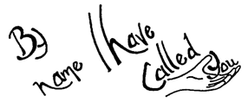
A reading from Paul’s letter to the Corinthians
There are many different gifts, but always the same Spirit; there are many different ways of serving, but always the same Lord. There are many different forms of activity, but in everybody it is the same God who is at work in them all. The particular manifestation of the Spirit granted to each one is to be used for the general good. To one is given from the Spirit, the gift of wisdom, to another the gift of knowledge, to another faith; and to another the gifts of healing, through this one Spirit; to another the working of miracles; to another, prophecy….. But at work in all of these is one and the same Spirit, distributing them at will to each other.
I Corinthians 12: 4-11 (adapted)
HOLY GROUND
You are here, so this is holy ground.
In all that is, You are here.
This is holy ground, the ground of my being now.
My spirit bows to you upon this holy ground.
© 2000 Monica Brown & Emmaus Productions
http://au.emmausproductions.com/
"Used with permission from
Monica Brown & Emmaus Productions".

DIFFERENT WORK
A reading from Paul’s letter to the Ephesians
Each one of us, however, has been given his own share of grace, given as Christ allotted it… And to some, his gift was that they should be apostles; to some, prophets; to some evangelists, to some pastors and teachers; so that the saints together make a unity in the work of service, building up the body of Christ. In this way we are all to come to unity in our faith and in our knowledge of the Son of God, until we become the perfect One, fully mature with the fullness of Christ himself.
Ephesians:11-13.

Watch this YouTube clip It’s in Everyone of Us. This is a song by David Pomeranz accompanied by people from throughout the globe
http://m.youtube.com/watch?v=op9sUiANKiE&feature=kp

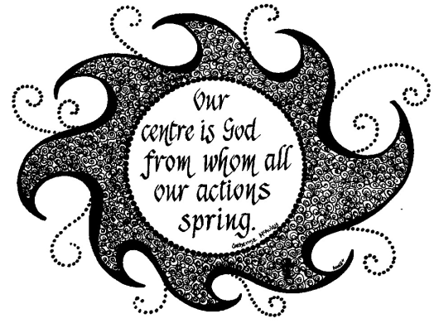

IGNITING THE FIRE WITHIN
From Like Water for Chocolate
What follows is an incident in the novel when Doctor John shows Tita an experiment…
“While phosphorous doesn’t combine with oxygen to burn at ordinary temperatures, it does burst into flame very rapidly at an elevated temperature; Watch…..”

The doctor placed a small amount of phosphorous in a tube that was closed at one end and full of mercury. He melted the phosphorus by holding the tube over the flame of a candle. Then using a small bell jar containing oxygen, he transferred the gas to the jar, very, very, slowly. When the oxygen reached the top of the jar, where it encountered the melted phosphorus, an explosion occurred, brilliant, instantaneous, like a flash of lightning.
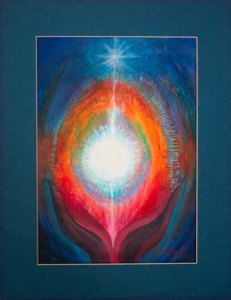
Mary Southard
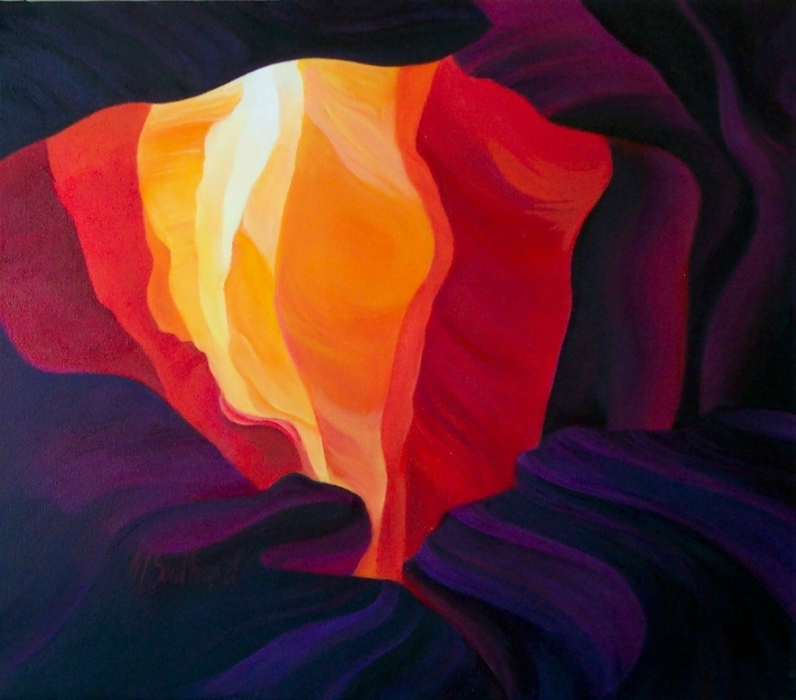
‘”As you see, within our bodies each of us has the elements needed to produce phosphorus. And let me tell you something I’ve never told a soul. My grandmother had a very interesting theory; she said that each of us is born with a box of matches inside us but we can’t strike them all by ourselves; just as in the experiment we need oxygen and a candle to help. In this case the oxygen, for example could come from the breath of the person you love; the candle could be any kind of food, music, caress, word or sound that engenders the explosion that lights some of the matches. For a moment we are dazzled by an intense emotion. A pleasant warmth grows within us, fading slowly as time goes by, until a new explosion comes along to revive it. Each person has to discover what will set off these explosions in order to live, since the combustion that occurs when one of them is ignited is what nourishes the soul.
Mary Southard CSJ
Inner Fire
www.MarySouthardArt.Org ;
and www.MinistryOfTheArts.Org

That fire, in short, is its food. If one doesn’t
find out in time what will set off these explosions,
the box of matches dampens, and not
a single match will ever be lit.”
Laura Esquivel
Can you name your particular gifts?
who helped you to recognise them….
who encouraged you to nurture them….

Name some of the choices you have made that have ignited the fire within…..

How are you enriching the various communities in which you live and work through continuing to nurture these gifts and sharing them for the life and enrichment of the community?
Remember the more diverse the gifts of the community the richer the community.

HOLY SPIRIT OF FIRE
Holy Spirit of Fire,
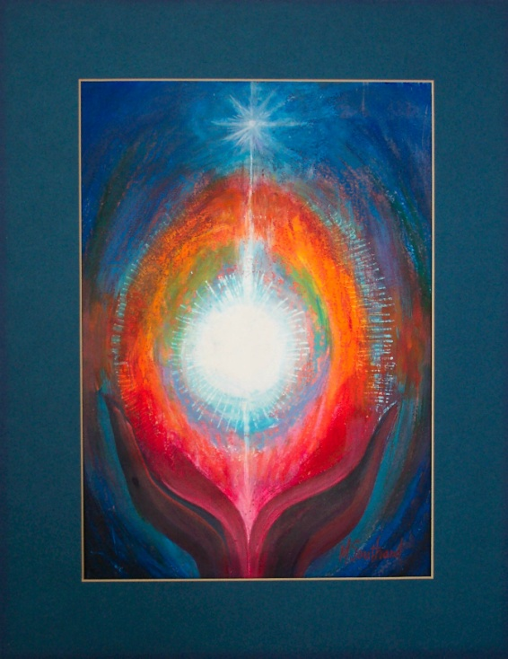
Open our hearts, set us ablaze.
Mary Southard CSJ
Meditation 2
www.MarySouthardArt.Org ;
and www.MinistryOfTheArts.Org

Holy Spirit of Fire,
Help us know the mystery of God’s ways.

Keep us blazing, keep us burning,
Open up our hearts
To fan your flames of love,
Holy Spirit of Fire.

Holy Spirit of Fire,
Fill us with a passion for Your life.
Holy Spirit of Fire,
Help us show the world your shining light.

Holy Spirit of Fire,
Fan the flame of courage in our hearts.
Holy Spirit of Fire,
Help us live the Good News where we are.

Holy Spirit of Fire,
Breathe your fire of love into our lives.
Holy Spirit of Fire,
Keep the embers glowing through the night.
Michael Mangan
– Setting Hearts on Fire
© 2001 Litmus Productions.
Used with permission.
www.litmusproductions.com

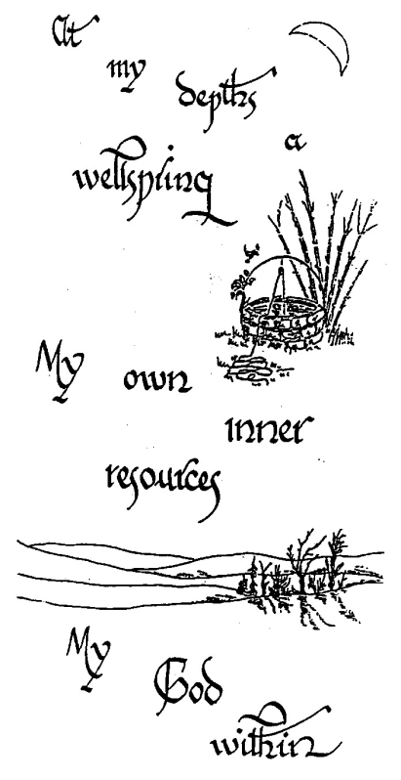
NURTURING THE INNER SELF
Paul prays for the people of Ephesus; we pray for those gathered:
This is what I pray, kneeling before the Father, from whom every family, whether spiritual or natural takes its name:

Out of his infinite glory, may God give us the power through the Spirit for our hidden self to grow strong, so that Christ may dwell in our hearts through faith, and then, planted in love and built on love, we will with all the saints have strength to grasp the breadth and the length, the height and the depth; until knowing the love of Christ, which is beyond all knowledge, we are filled with the utter fullness of God.

Glory be to God, whose power, working in us, can do infinitely more than we can ask or imagine; glory be to God from generation to generation in the Church and in Christ Jesus for ever and ever. Amen.
Ephesians 3:14-21 – adapted for prayer

The fruit of the Spirit is love, joy, peace, patience, kindness,
goodness, faithfulness, gentleness and self-control.
Galatians 5:22

