A Blind Man Initiates an Encounter with Jesus

LISTEN
Listen, the voice of Your God is calling.
Listen, the voice of Your God is calling,
Listen with the ear of your heart,
The voice of Your God is calling.
Monica Brown
Narrator Blind Man Jesus Crowd

A reading from the gospel according to Mark
They reached Jericho; and as Jesus left there with his disciples and a large crowd, Bartimaeus, (that is, the son of Timaeus), a blind beggar, was sitting at the side of the road. When he heard that it was Jesus of Nazareth, he began to shout and to say,
‘Son of David, Jesus, have pity on me’.

And many of them scolded him and told him to keep quiet, but he only shouted all the louder,
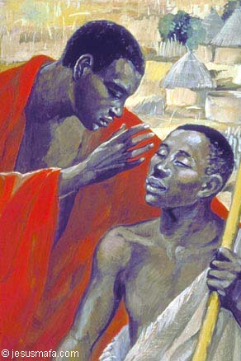
‘Son of David, have pity on me.’
Jesus Mafa

Jesus stopped and said,
‘Call him here.’

So they called the blind man.
‘Courage, get up; he is calling you.’

So throwing off his cloak, he jumped up and went to Jesus.

Then Jesus spoke,
‘What do you want me to do for you?’

‘Rabbuni, Master let me see again.’

Jesus said to him,
‘Go; your faith has saved you.’

And immediately his sight returned and he followed him along the road.
Mark 10:46-52
. COME TO ME
Come to me all you who are burdened and weary
And I shall give you rest.
Come to me as you are and I shall tend to you.
Listen – Come to Me
© 1997 Monica Brown & Emmaus Productions
http://au.emmausproductions.com/
"Used with permission from
Monica Brown & Emmaus Productions".

MICHAEL FALLON MSC REFLECTS…..
Bartimaeus knows what he wants. He calls out and he won’t let anyone talk him out of it. Jesus stops. Of course he stops. This is God who hears the cry of the poor. He wants to respond to the blind man’s call. But notice that Jesus does not call the man himself. He does it through others. That is the way it happens. Jesus hears our call and he answers it through those who listen to him and learn to love as he loves. He needs us to love for him.

Now comes the important part. The man throws off his cloak. It is all he has but it is enough to hold him back. In fact one gets the impression that it is the cloak that is making him unable to see. A bird cannot fly if you tie its leg with a piece of string. But even if you tie it with the thinnest gossamer thread, it cannot fly unless it can break the thread. There is nothing much holding this man back, but he has to throw it off or he will never be able to run to Jesus. He has to cast off the cloak or he will never be free to see. What am I hiding behind? What am I holding on to, however insignificant, that is keeping my hands clasped and so unable to receive God’s gift. What is stopping me going to Jesus with open hands?

Jesus, with typical respect, does not presume to know what the man wants, but asks him: ‘What do you want me to do for you?’ Let that be Jesus’ question to each of us today. Jesus loves us. He doesn’t make decisions for us. He doesn’t control us or lock us into a cage, however safe it might appear. He doesn’t constrain us. he wants us to be free, really free. So he asks us to ask ourselves what it is that we really want. Why are we unsatisfied, off the road and blind? What do I want Jesus to do for me?

The blind beggar asks to see again. And it is his ‘faith’ that makes it possible for him to be healed and so to see. The sight we are talking of here is not the sight of the eye, or even the sight of the mind. It is the seeing of the heart that knows it is made for love and that recognises in Jesus the God who is the answer to its longing. It is the sight of one who knows its own powerlessness, and who cries out for grace, trusting in the mercy of God revealed in Jesus. It is this faith, and nothing else, that makes it possible for the disciple to ‘follow Jesus on the way’ — the way to Jerusalem, and so to death: the way through death to the resurrection and fullness of life as God’s beloved.

In the silence of prayer, let us contemplate this scene, and be the blind beggar. Let us taste our experience of being blind, of being alone, by the side of the road, missing out on life. Let us cry out for help. Let us anticipate a response, and listen for it. Let us be willing to cast off whatever it is that gives us our security, little though it may be, and let us run to him.

Time to ponder quietly on Jesus’ question to the blind man and his response:

What do you want me to do for you?
Master, let me see again…

Poetry is the language of the soul… You might like to capture in a poem the experience of Jesus or the Blind Man in this encounter.

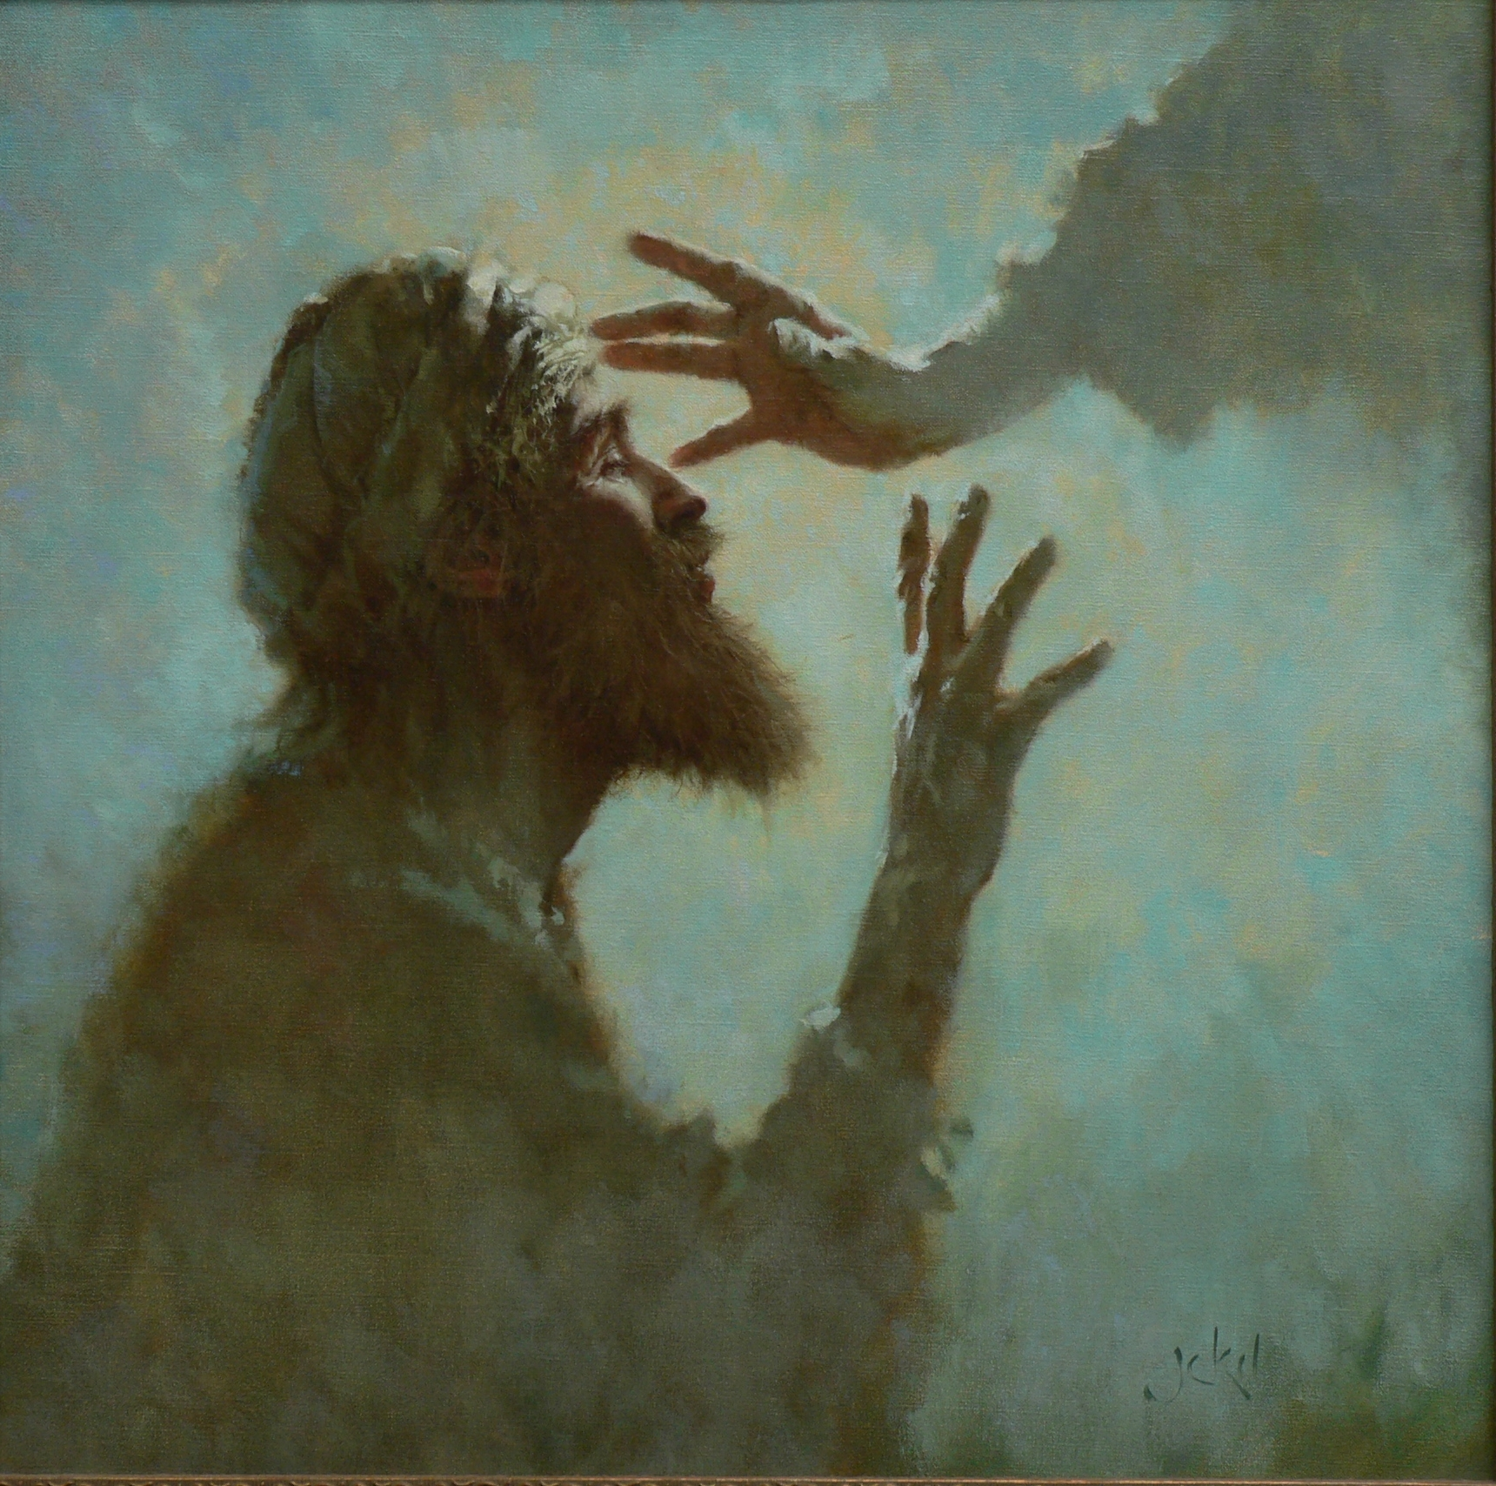
OPEN MY EYES
Brian Jekel
Open my eyes, Lord, Help me to see your face.
Open my eyes, Lord, Help me to see.

Open my ears, Lord, Help me to hear your voice.
Open my ears, Lord, Help me to hear.

Open my heart, Lord, Help me to love like you.
Open my heart, Lord, Help me to love.

I live within you, Deep in your heart, O love,
I live within you, Rest now in me.
Jesse Manibusan
.

