The Heart of Holy week
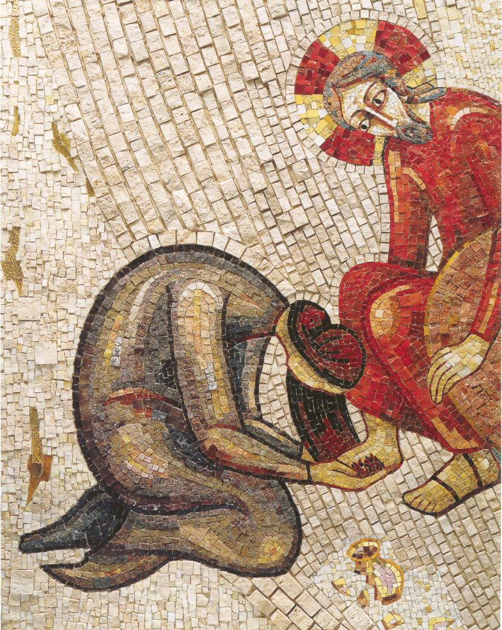
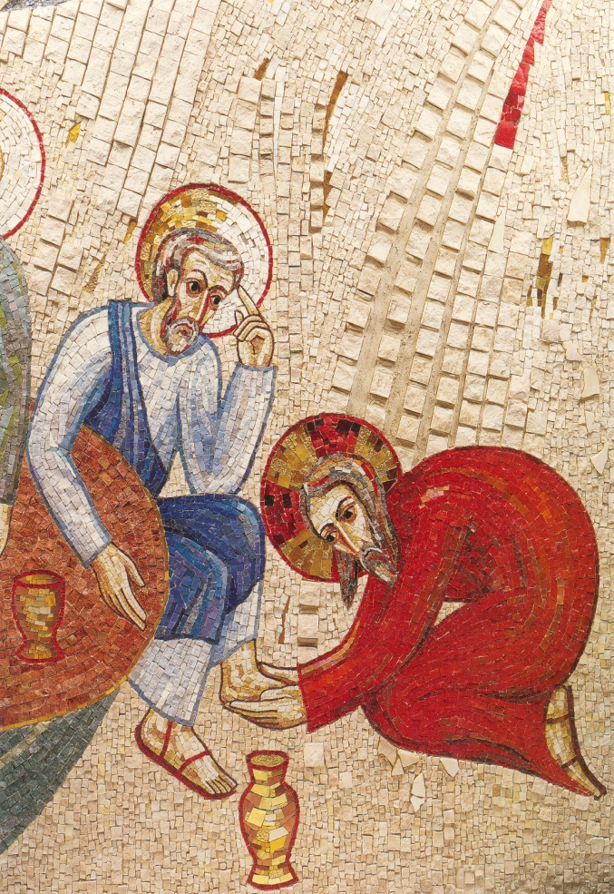
Touching with Tenderness…..

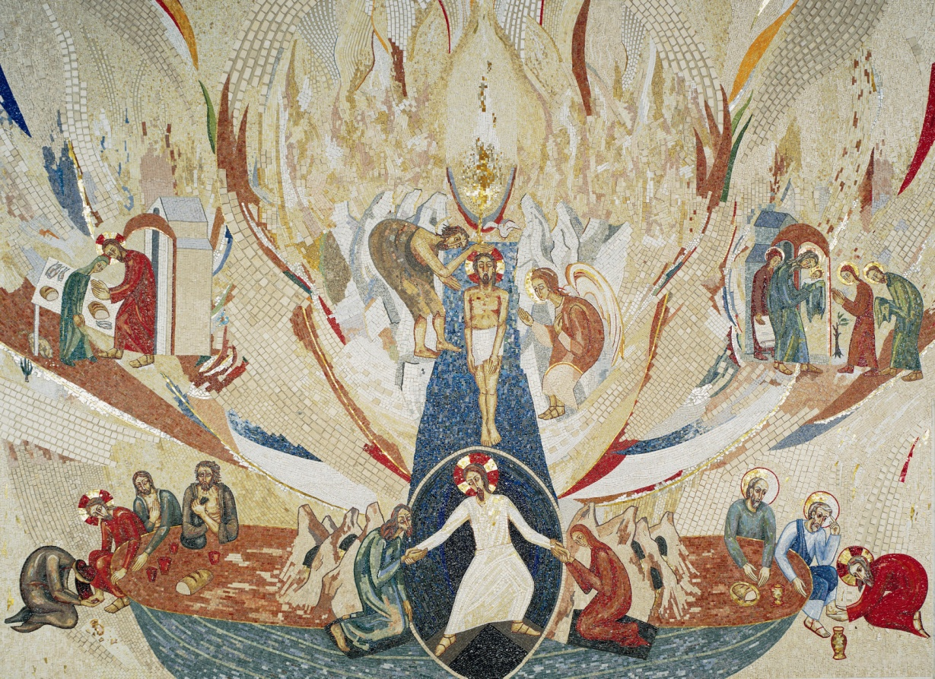

Fr. Marko I. Rupnik & Atelier of Centro Aletti
A WOMAN PONDERS THE MOOD OF THE CITY
Natasa, am wondering if we could have the full mosaic where these two appear?

Marko Rupnik SJ
Something is happening.
I can feel it…
There’s tension in the Temple,
comings and goings around Pilate’s place.
What can I do?
I have that jar of nard….
So often have I held it wondering …
when I would soothe my body
with its oil and sweetness?

How often have I opened it
just to enjoy its aroma.

Now I know for what I have been keeping it.
To anoint the one I love.
At this time of deepening gloom
what could be nicer than feet
massaged and anointed
for the unknown journey that lies ahead.

He is gathering for a meal tonight.
At our home.
Martha has invited him.
I cannot delay.
We know not the time the leaders will act,
but act they will…
The whisperings are becoming more urgent….

Tonight I’ll slip in quietly,
sit at the feet of the one I love,
and pour out my love
as I let my precious nard
anoint the feet of the one
who embraced me as disciple.

O what that will be for me…
To touch with tenderness
the one who loved me into life.
Reflection on John 12:1-11
Leone Pallisier

Could it be that Jesus has returned?
I saw him in passing.
With his disciples,
those men and women who are close to him,
keep him company, provide for his needs,
listen to his stories.

And some of these stories
are being whispered about, questioned.
That one about the Pharisee and the publican–
That’s really upset our holy men –
The tax collector got it – what Jesus was about.
The Pharisee didn’t!!!

True to form the holy men cannot listen,
cannot open to another experience of God.
Set in their old ways,
their minds closed,
their hearts cold,
their spirits calculating.

I know they are planning action.
To do something to the one I love.

What can I do to embrace this one I love.
The one who changed my life
by noticing women,
speaking with them,
staying with them,
listening to them,
encouraging them.
And I was one of them….

HEALING IS YOUR TOUCH
Healing is your touch, O God,
Renewing the Spirit of the broken.
Healing is your touch, O God,
Renewing the spirit of the broken.

© 1991 Monica Brown & Emmaus Productions
http://au.emmausproductions.com/
"Used with permission from
Monica Brown & Emmaus Productions".

JESUS PONDERS THE MOOD OF THE CITY…
…AND HIS LIFE’S WORK

The mood in Jerusalem is different.
Last night when fear was stirring deep within –
I knew something was afoot –
there was furtive activity among religious leaders.
I sensed it might be me.
They could not listen to my message –
what authority or position did I have?
The son of a carpenter, from Nazareth.

At times like this
friends and companions, blessing.
Martha, Mary, Lazarus
– their home my home..
Gathered for a meal.
All of us, the twelve.

Mary so often at my feet listening,
was there.

This was not unusual.
Suddenly, the room was filled with perfume.
What was happening?

And then I felt her touch.
With tenderness and care she anointed my feet.
Massaged and softened them.
I was caressed, cradled in the intimacy of touch.
No words were spoken by the woman.
Women can speak wordlessly.
Hands and hair enough….

An intimate moment broken.
A scolding comment about extravagance.
And one of mine too, Judas….
Why can’t men sense mood?
Break a sacred moment…

Tonight we gather again….
Maybe for the last time.
Disciples so slow to understand,
to grasp my message is love,
only love.
Have I failed as teacher?

The touch of last night still held
in my body,
my soul,
my spirit.

A surge of courage stirred within,
she had encouraged me.
Filled me with hope that I would not be left alone.

How can I leave such a legacy?
A legacy of tenderness and love…
….that we do not walk alone
How can I do the same?
Leave a gesture that will always speak.
Speak of what God’s mission is…
To love the world into fullness of life.

Tonight I’ll wash their feet!
That will surprise them,
and surprise might be remembered.

Some are slow, so words are necessary.
My words will be:
‘As I have done, so you must do.
Wash each other’s feet….
….and allow others to do the same to you.’
Leone Pallisier

Furtive glances make me wonder….
Wonder why the change…

Why are we afraid of love?
Afraid to love?
That is the essence of my message:
All are equal in God’s eyes.
All are held in God’s embrace.
The embrace, love.

And yet we are free to shun this love.
And how we value freedom.

Freedom for what?
To command and control?
Or to love and empower?

How did I learn about this love
while others failed to see?

Was it those times of quiet,
alone among the hills,
by the lake,
at night when all were resting.

There I heard the Father
whispering in the silence,
in the quiet of my heart.

I was drawn to ponder the people all around.
My mother had encouraged that.
Some were visible, others invisible
– people without a place.
It was those without a place
those whisperings kept urging me towards

the shepherds, the lepers, the sinners -
these were the ones open to my message.
The smallest gesture of hospitality
was received with gratitude.
Sensing something deeper in life
they keep returning to listen, to see….

Some became friends, others disciples.
The women were such a source of hope.
They were eager to be drawn to the mystery within.
They were open to love, eager to share this love.

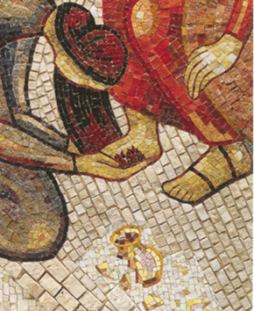

Let us accept this invitation

A NEW COMMANDMENT
A new commandment I give unto you
As you pray this song hold a person who needs to experience love, God’s love, through your hands, your words, your touch, your smile, your embrace.
That you love one another as I have loved you
That you love one another as I have loved you.

By this the world will know you are my disciples
If you have love one for another.
By this the world will know you are my disciple
If you have love one for another.
Author Unknown

Thoughts and Suggestions:
The art work is part of the mosaics in Redemptoris Mater, the chapel in the Vatican adjacent to the papal apartments. The two depicted here – the woman who anointed Jesus, and Jesus washing the feet of the disciples are on the back wall of the sanctuary and from the body of the church appear at either end of the altar. It was this art which provoked the two reflections above. The entire mosaic in the sanctuary depicts various events in the life of Jesus from the Annunciation until his death. Are these two placed where they are to emphasise their connection to living Eucharist in the daily events of our lives?

I suggest this be a quiet meditative prayer. First you could invite those present to ponder the art, let it speak and after some time invite a sharing of insight and response with the next person. Then have a reading either aloud or in silence of the poems.

If you have room for sacred space, oil, a bowl of water and a towel could focus the group on the simplicity of what is needed to touch someone deeply. There could even be an anointing of each other during the final song if it seemed appropriate.

The woman who anointed Jesus is not included in the holy week liturgy so this is one way of drawing attention to the role of women in the final days of Jesus’ life.

In the section on discipleship there is another reflection on the woman who anointed Jesus; the washing of the feet is included in the section on leadership.

