Teaching – Calling another to life….
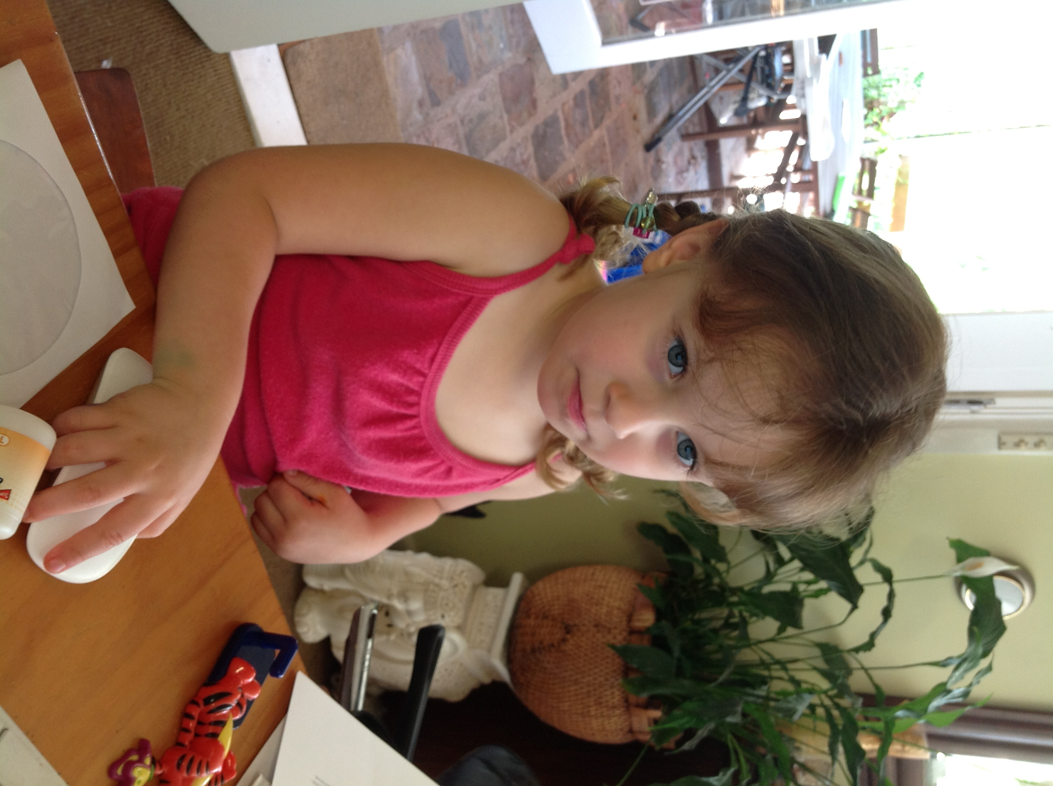
Close your eyes and imagine yourself in front of your class. Let your eyes roam around … where do your eyes rest? Why there? Is there a child you rarely notice? Focus on that person….Listen to your heart… try to attune yourself to the mind, heart and spirit of that person…

LISTEN
Listen, the voice of Your God is calling.
Listen, the voice of Your God is calling,
Listen with the ear of your heart,
The voice of Your God is calling.
Monica Brown

THE AVERAGE CHILD
I don’t cause teachers trouble
My grades have been OK
I listen in my classes
I’d like to build a rocket
I’ve a book that shows you how
Or start a stamp collection
Well no use starting now.
Cause since I’ve found I’m average
I’m just smart enough to see
To know there’s nothing special
That I should expect from me.

I’m part of the majority
That hump part of the bell
Who spends his life unnoticed
In an average kind of hell.
Michael Buscemi
And I’m in class every day.
My parents think I’m average
My teachers think so too
I wish I didn’t know that
Cause there’s lots I’d like to do.

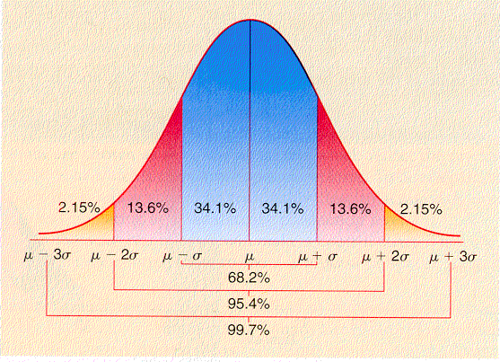

Let this poem speak to you……

Have some conversation with another teacher….

Come to me all you who are burdened and weary
And I shall give you rest.
Come to me as you are and I shall tend to you.
Listen – Come to Me
© 1997 Monica Brown & Emmaus Productions
http://au.emmausproductions.com/
"Used with permission from
Monica Brown & Emmaus Productions".
RECEIVING A BLESSING
Ronald Rolheiser speaks:
Several years ago, I preached a sermon on the baptism of Christ within which I remarked that the words that God speaks over Jesus at his baptism – “This is my beloved child in whom I take delight” – are words that God daily speaks over us. Some hours later my doorbell rang and I was approached by a young man who had heard my sermon and who was both moved and distraught by it.

He had not been to church for some time but had gone on this particular Sunday because he had, just that week, pleaded guilty to a crime and was awaiting sentence. He was soon to go to prison. The sermon had struck a painful chord inside him because, first of all, he had trouble believing that God, or anyone else, loved him; yet he wanted to believe it. Secondly, and even more painful, he believed that nobody had ever been pleased or delighted with him: “Father, I know that in my whole life nobody has ever been pleased with me. I was never good enough! Nobody has ever taken delight in anything I’ve ever done!” This man had never been blessed. Small wonder he was about to go to prison.
What does it mean to be blessed? What is a blessing?
The word “blessing” takes it root in the Latin verb benedicere, to speak well of ( bene well, dicereto speak). Therefore to bless someone is to speak well of him or her. But this implies a special form of “speaking well”. To bless someone is, through some word, gesture, or ritual, to make that person aware of three things:
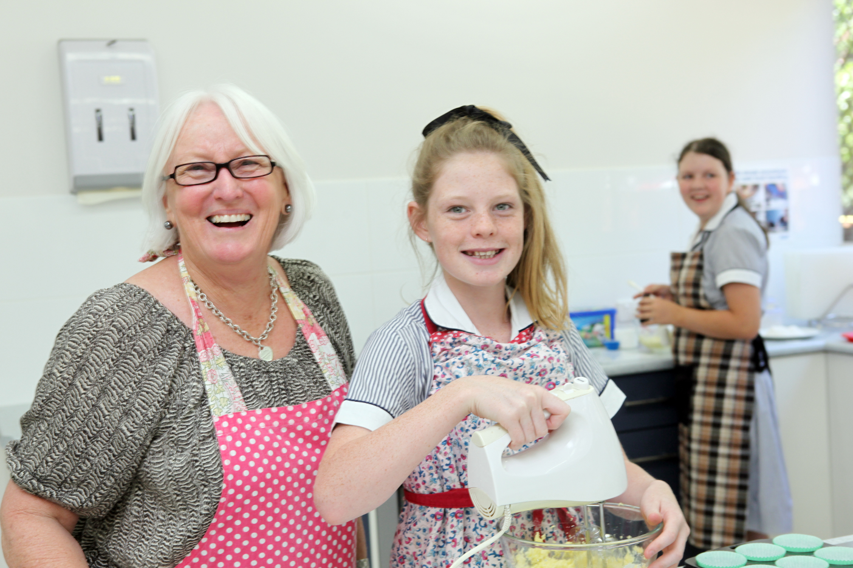
- the goodness of the original creation when, after making the earth and humans, God said that it was “good, very good”;

- that God experiences the same delight and pleasure in him or her that God experienced in Jesus at his baptism when he said: “This is my beloved child in whom I take delight”;

- that we, who are giving the blessing, recognize that goodness and take that delight to the other person.

Rolheiser – Against an Infinite Horizon p33
Crossroads
Which child in your class is in need of a blessing?

In what ways could you be the one to bless this child?

You are invited to hold this student or these students in your healing hands as you pray this Prayer of Blessing….

PRAYER OF BLESSING
.May the blessing of light be on you,
light without and light within.
May the blessed sunlight shine upon you
and warm your heart
till it glows like a great fire
and strangers may warm themselves
as well as friends.

And may the light shine out of the eyes of you,
like a candle set
in the window of a house,
bidding the wanderer to come in
out of the storm.

May the blessing of rain be on you;
the soft sweet rain.
May it fall upon your spirit
so that little flowers may spring up
and shed their sweetness on the air.
May the blessing of the earth be on you,
the great round earth.
May you ever have a kindly greeting for people
as you’re going along the roads.

And now may the Lord bless you,
and bless you kindly, Amen.
Irish Blessing

And may the blessing of the great rains be on you,
to beat upon your spirit
and wash it fair and clean;
and leave there may a shining pool
where the blue of heaven shines,
and sometimes a star.

THERE WHERE YOU ARE
‘There where you are, you will find God’
Mary MacKillop 1874

God in the ordinary moments each day.
The breath of our living and the dying we face.
God in our dreaming the light ever near,
The hope in our brokenness, hardness and fear.
God in the rising from every pain,
There in the arms that reach out to embrace.

God in our footsteps when we dance with the lame.
The voice in the stillness and the giver of grace.
God in our blindness when we wake and we see,
Christ in the face of the lost and the weak.
Jen Charadia
– In God and for God
www.renewalproductions.com.au

There where you are you will find God.
There where you are you will find God.
There where you are you will find God.
Right there where you are you will find God.
Our good God.

