Seeking Solitude …. Coming to Quiet…
….Nurturing a Discerning Heart

Very early in the morning, while it was still dark, Jesus got up, left the house and went off to a solitary place, where he prayed.
Mark 1:35
In Jesus’ life there was a rhythm of engagement and solitude. In the quiet of the morning, the solitude of a mountain, the desert, these were the places to which Jesus constantly withdrew to be in communion with Abba. In such moments he was discerning, discerning the will of the Father, always conscious of the needs of the people to whom he was sent.

O LIVING BREATH OF GOD
O living breath of God awaken us this day.
O living breath of God awaken us this day.
Open the windows of our souls.
Open the walls of our minds.
Open the doors of our hearts.
Awaken us to hope. Awaken us to joy.
Awaken us to the coming of the light.
Velma Frye, Macrina Wiederkehr
– The Seven Pauses
www.velmafrye.com

AS SILENCE GROWS
There is the silence that leads us out into the desert
of our solitude
and the silence that divines the flow of the Divine
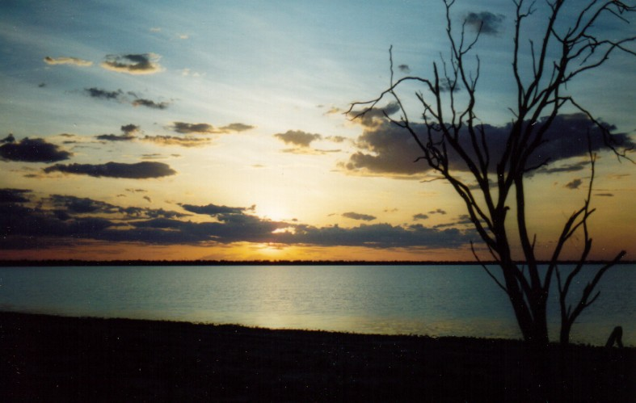within our world.

There is the silence that eludes us
when we try too hard
and the silence that opens up inside of us
when we give it time.

There is the silence that is deeper
than the ocean depths
and the silence that is lapping
around our feet.

There is the silence that is deafened
by the noise of haste
Lake Gregory in the Australian Desert
and the silence that signs the presence of the One
who hears us as we are.

There is the silence that is pushed and shoved
by our crowded way of life
and the silence that opens up our eyes
to where true contentment lies.

There is the silence that empties us of all
we have gathered up along the way
and the silence that eases the pain of letting go
that becomes the joy dancing in us down the road.

There is the silence of the wilds
beyond the enclosures of our minds
and the silence of the heart’s home paddock
where we can rest a while.
Noel Davis
Heart Gone Walkabout

Let this poem speak to your experience ….Is there an invitation for you at this time in your life? How might you respond to that invitation?

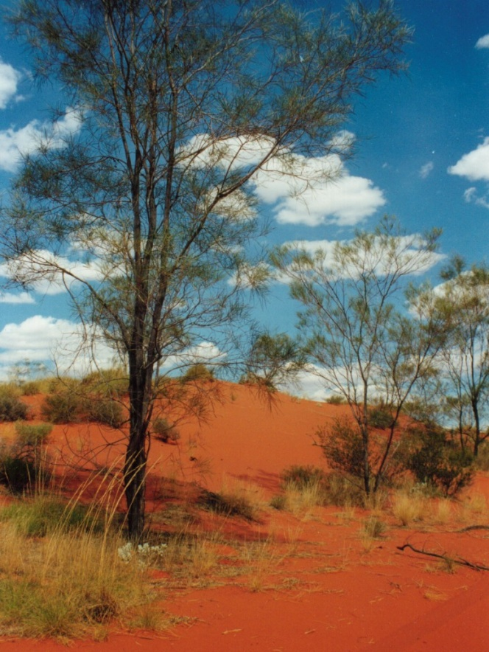

DESERT PLACE
Holy God of wonder,
how this night is new!
Solitude and stillness
draw me home to you.

I will lure you into a desert place,
There I’ll speak unto your heart.
There you’ll learn the treasures of
abandonment,
There you’ll know I’m Yahweh, God.

Holy God of wisdom,
hear this wanderer’s prayer.
Moments bathed in quiet
shield me from life’s blinding glare.

Holy God, Creator,
plant your seed in me.
Penetrate the desert,
and call forth your dream.
Trisha Watts & Monica O’Brien
Trisha Watts & Monica O’Brien
(c) 1992, Trisha Watts & Monica O’Brien (McInerney),
published by Willow Publishing Pty Ltd,
PO Box 1061 Dee Why NSW 2099.
All rights reserved.www.willowpublishing.com.au

Let us pray
Creator and Creating God, in Jesus you revealed your longings for the human community. Attune our ear to your whisperings in our own lives and in our world. Give us insight to discern your will for our time and both the hope and courage to respond to what we hear. We ask this prayer in Jesus’ name. AMEN

