**Mary MacKillop—Disciple and Prophet in our Australian context**

**BE PRESENCE**

Be presence in presence be

Listen a Spirit speaks

Be presence in presence be

Listen a Spirit speaks.

Jen Charadia

– *In God and for God*

 A reading from the prophet Micah

With what gift shall I come into Yahweh’s presence and bow down before God on high?

Shall I come with holocausts, with calves one year old?

Will God be pleased with rams by the thousand, with libations of oil in torrents?

Must I give my first-born for what I have done wrong, the fruit of my body for my own sin?

What is good has been explained to you;

this is what Yahweh asks of you:

only this:

to act justly,

to love tenderly

and to walk humbly with your God.

Micah 6:6-8

**How did Mary respond to this call from Micah?**

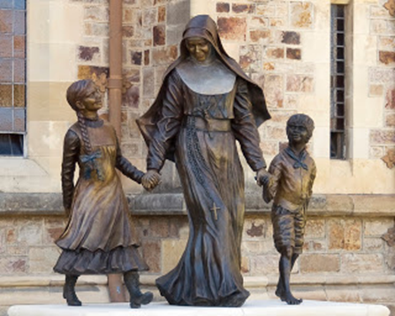

Judith Rolevink

Cathedral Adelaide

Mary MacKillop embodied all that is best

in your nation and its people:

genuine openness to others, hospitality to strangers,

generosity to the needy, justice to those unfairly treated,

perseverance in the face of adversity,

kindness and support to the suffering.

Think of Mother Mary MacKillop and learn from her

to be a gift of love and compassion for one another,

for all Australians, and for the world.

Pope John Paul 11

Sydney 1995

**Some of Mary’s Wise Words…..**

***How truly wonderful are God’s ways***

**I *was given such a sense of God’s watchful***

***presence***

***With God on our side what need we fear***

***Never see a need without trying to do something about it***

***Work on with constancy and courage***

***When I could not see my way, God kept my heart full of trust to make all come right***

***We must often feel weary and tired yet God brings us through all these things***

***God will provide for the future***

***We have much for which***

***to be thankful***

***Remember we are but***

***travellers here***

***Make allowances for those who do not see as you do***

***God will carry you safely***

***through every stage***



**Let the sculpture and Mary’s words speak to you?**

**What are you hearing, seeing, feeling?**

**Each of us has our own memories of Mary MacKillop and the work of her sisters. Let us name some of Mother Mary’s contributions to our Australian church and society.**

**Let us pray**

In your loving providence, O God, you raised up Mary MacKillop as a blessing for those in need. We pray with hearts filled with gratitude for the example this woman has given to us….

1. Mary faithfully listened and responded to her God. May her example encourage us to take time to be attentive to God’s invitations to us. Lord hear us….

1. Mary lived by faith and the transforming power of the cross. May we have the courage to embrace the challenges of life and so bring wholeness and peace to our own lives and the life of our planet. Lord hear us….

3.  Mary embraced new ways of living the Gospel. May her example inspire and encourage us to respond actively to the needs of our world and make the cry of the poor our cry. Lord hear us…..

4.  As a leader and educator Mary gave hope to the poor and the possibility for living life to the full. As leaders in Catholic education may we follow Mary’s example, speaking truth to power when necessary. Lord hear us….

5  Through the example of Mary, may we respond to the indigenous people of our lands through deeper listening, respect and awareness of their story and needs. Lord hear us…

God of the journey, with confidence we ask you to hear our prayers which we ask through the intercession of Mary MacKillop. We make these prayers through Christ your Son.

**Amen**

**THERE WHERE YOU ARE**

*There where you are, you will find God*

Mary MacKillop 1874

God in the ordinary moments each day.

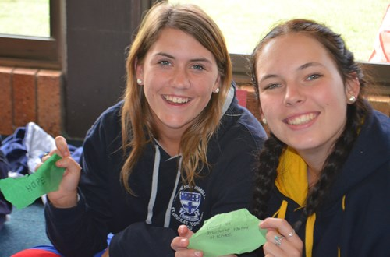

The breath of our living and the dying we face.

God in our dreaming the light ever near,

The hope in our brokenness, hardness and fear.

God in the rising from every pain,

There in the arms that reach out to embrace.

***There where you are you will find God.***

***There where you are you will find God.***

***There where you are you will find God.***

***Right there where you are you will find God.***

***Our good God.***

God in our footsteps when we dance with the lame.

The voice in the stillness and the giver of grace.

God in our blindness when we wake and we see,

Christ in the face of the lost and the weak.

Jen Charadia

– *In God and for God*

www.renewalproductions.com.au