Leading from Within…..
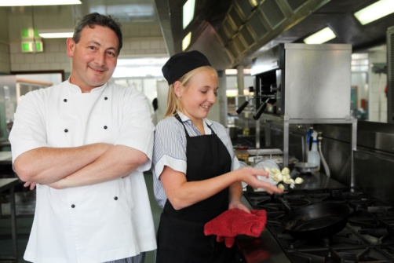
HOW BEAUTIFUL
How beautiful on the mountain tops
are the feet of those who bring your word.
How beautiful on the city streets
are the lips of those who speak your peace.
Joe Wise –
Take all the lost home
©GIA:www.giamusic.com

A reading from the gospel according to John
I am the good shepherd:
the good shepherd lays down his life for his sheep.
The hired man, since he is not the shepherd
and the sheep do not belong to him,
abandons the sheep
as soon as he sees a wolf coming, he runs away,
and the wolf attacks and scatters the sheep;
he runs away because he is only a hired man
and has no concern for the sheep.
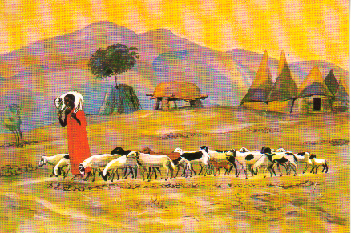
I am the good shepherd;
Jesus Mafa
I know my own
and my own know me,
just as the Father knows me
and I know the Father;
and I lay down my life for my sheep.
And there are sheep I have
that are not of this fold,
and I must lead these too.
They too will listen to my voice,
and there will be only one flock,
one shepherd.
The Father loves me,
because I lay down my life
in order to take it up again.
No one takes it from me;
I lay it down of my own free will,
and as I have power to lay it down,
so I have power to take it up again;
and this is the command I received from my Father.
John 10:11-18

What speaks to you in this text?

Share your learning with your neighbour….

From:
POPE FRANCIS: WHY HE LEADS THE WAY HE LEADS
Chris Lowney

Some challenges Francis, Bishop of Rome, has articulated:
• He challenges ‘lukewarm Christians’ and ‘couch potato’ Christians to engage much more energetically in spreading the Church's message, not to ‘take refuge … in a cosy life’, but to get beyond our ‘comfort zones’ and live with greater ‘apostolic fervour’. He challenged the Church to be more forthrightly ‘poor; and for the poor’.
• He warned Vatican diplomats–in-training that ‘careerism is leprosy’.
• He challenged the global culture in which ‘money …. for the mighty of this earth, is more important than people’.
• He challenged his fellow bishops to be ‘men who love… poverty, simplicity and austerity of life. (Page 6)

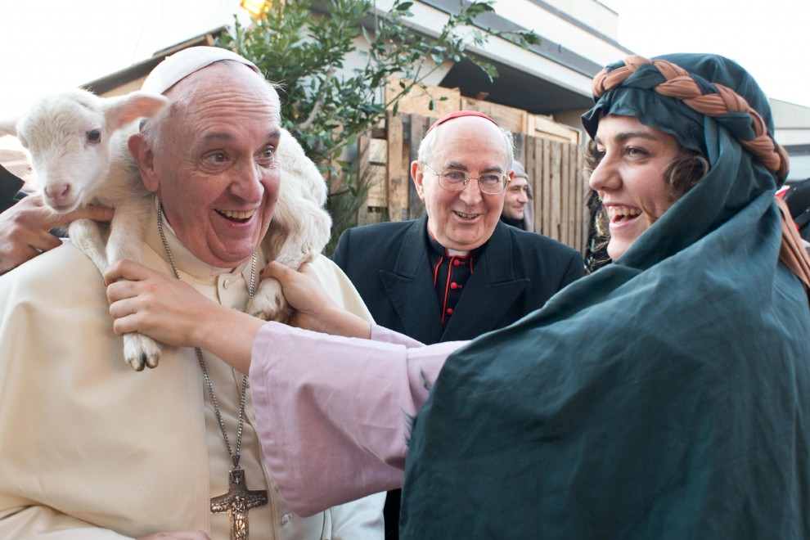

At the Chrism Mass on Holy Thursday, Francis challenged his priests to be: ‘shepherds living with the smell of the sheep’. This is an invitation to all those who are in positions of leadership….
Six foundational commitments that underpin Francis’ style of leadership:

Know yourself deeply, but live to serve others:

You cannot lead others unless you can lead yourself, so leaders dig deeply into themselves, confront their flaws, and, ultimately, achieve peaceful acceptance of themselves and the unique role they can play in the world.
But, after that introspective deep dive within, leaders turn outward. They themselves do not live for themselves alone but transcend themselves to serve others. The wisdom and energy generated from their self-knowledge isn’t bottled up but radiates outward.

Immerse yourself in the world, but withdraw from the world daily:
The new leader immerses herself in the world with eyes open to its joys and sufferings and with hands calloused from sharing the everyday struggles of those around her. She is not apart and aloof but ‘in touch’ and accountable. She cultivates solidarity, especially with those who are neglected or marginalised.
Yet, while fully immersed in the world, she is not fully ‘of’ the world. She does not drift on a tide of texts, media stimulation, and phone calls, but withdraws daily to reflect, feel gratitude for all she has, take in the big picture, and remind herself of her values and beliefs.

Live in the present and revere tradition, but create the future:
The new leader seizes today’s opportunity fully because it’s the only opportunity he is certain of having. And he stands for something, honouring the beliefs and values bequeathed by his tradition.
But deeply rooted in a tradition does not mean stuck. He is not enslaved by the past. He does not shrink from change fearfully but drives change with hope and optimism. He runs to the future, not from it.
Pages 9-10

These six commitments invite leaders to a rhythm of solitude and engagement…..
….This is reflected strongly in Jesus’ public life

Personal reflection on the six commitments:
How could I more faithfully fulfil these commitments?
I will live fully in the present and revere my tradition
I will step back for daily reflection
I will commit to know myself deeply
I will transcend myself to serve
others

I will immerse myself in the world

I will help to create the future

Is there some action I could begin to take tomorrow?

Final Reflection
STAY CENTRED
Stay centred.
It is your greatest gift
to the world,
to those
you care about,
to your own soul,
in fact.
Whatever is required
for you to stay completely
centred in your gifts –
to listen
to the silence
of the greater universe –
do that thing now,
this very moment.
Judy Brown
The Art and Spirit of Leadership

Mary Southard CSJ
Ancient Presence
www.MarySouthardArt.Org ;
and www.MinistryOfTheArts.Org

LOVE, SERVE AND REMEMBER
Why have we come to earth,
Do you remember?
Do you remember?

To love, serve and remember
To love, serve and remember
To love, serve and remember
Lyrics and music John Astin
Kathy Zavada – In Love Divine

Love-driven leadership is:
- the vision to see each person’s talent, potential, and dignity
- the courage, passion and commitment to unlock that potential
- the resulting loyalty and mutual support that energize and unite teams
Chris Lowney – Heroic Leadership page 170

Thinking and Suggestions:
Francis has captured the imagination of the world. Referring to himself as bishop of Rome sends a message that collegiality is his choice, not authoritarianism or monarchy. He sees the church as a communion of local churches as envisioned by Vatican 11 - a church serving the human community and not an institution focused in on itself and its preservation. Chris Lowney, with a background in Jesuit spirituality and in leadership, has provided an insightful look into Francis’ leadership style. It offers us a framework for reflecting upon, and exploring our exercise of leadership. In the 6 commitments Lowney names, there is focus on the inner journey - nurturing the soul, and the outer journey – engagement in and contribution to community and the unfolding of history. These two foci are essential for anyone entrusted with a role of formal leadership. They enable us to live and lead from the soul and heart – personal authority, rather than from positional power that is associated with a role.

Pope Francis: Why he leads the way he leads is published by Loyola Press Chicago and is also available on Kindle.

