A Woman Initiates an Encounter with Jesus

A Woman Anoints Jesus
(It was two days before the Passover and the feast of Unleavened Bread, and the chief priests and the scribes were looking for a way to arrest Jesus by some trick and have him put to death. For they said, ‘It must not be during the festivities, or there will be a disturbance among the people.’)
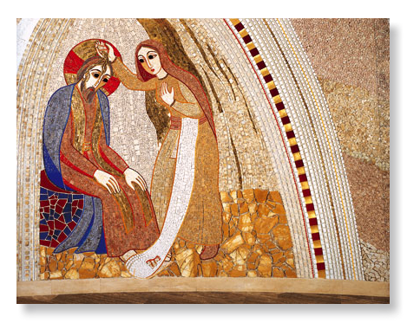
Fr. Marko I. Rupnik
& Atelier of Centro Aletti

While Jesus was at Bethany in the house of Simon the leper, as he sat at table, a woman came with an alabaster jar of very costly ointment of nard, and she broke open the jar and poured the ointment on his head. But some were there who said to one another in anger,

‘Why was this ointment wasted in this way? For the ointment could have been sold for more than three hundred denarii and the money given to the poor.”

And they scolded her.

But Jesus said,
‘Let her alone, why do you trouble her? She has performed a good service for me. For you always have the poor with you, and you can show kindness to them whenever you wish; but you will not always have me. She has done what she could; she has anointed my body beforehand for its burial. Truly I tell you whenever the good news is proclaimed in the whole world what she has done will be told in remembrance of her.’

(Judas Iscariot, one of the Twelve, approached the chief priests with an offer to hand Jesus over to them. They were delighted to hear it, and promised to give him money; and he looked for a way of betraying him when the opportunity should occur.)
Matthew 26:1-16

I’LL BE ALWAYS LOVING YOU
I am here with you by your side,
sheltering your heart from the night.

Where ever you go, whatever you do,
I’ll be always loving you.

I will be your God, your comforter.
I will hold you close in my heart.

Let me love the world through your heart.
Let me heal your wounds by my touch.

Let me see the world through your eyes.
Let forgiveness shine through your smile.
Trisha Watts & Monica O’Brien
(c) 1992, Trisha Watts & Monica O’Brien (McInerney),
published by Willow Publishing Pty Ltd,
PO Box 1061 Dee Why NSW 2099.
All rights reserved www.willowpublishing.com.au
She Has Touched Me with Authority

IN THE MIDST OF THE COMPANY

In the midst of the company I sat alone,
and the hand of death took hold of me;
I was cold with secrecy,
and my God was far away.

For this fear did my mother conceive me,
and to seek this pain did I come forth?
Did her womb nourish me for the dust,
or her breasts, for me to drink bitterness?

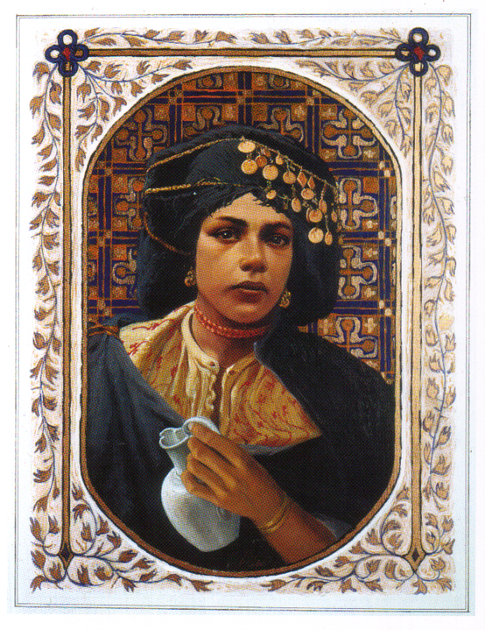
Louis Glanzmann
O that my beloved would hold me
and gather me in her arms;
that the darkness of God might comfort me,
that this cup might pass me by.

I was desolate, and she came to me;
when there was neither hope nor help for pain
she was at my side;
in the shadow of the grave she has restored me.

My cup was spilling with betrayal,
but she has filled it with wine;
my face was wet with fear,
but she has anointed me with oil,
and my hair is damp with myrrh.
The scent of her love surrounds me;
it is more than I can bear.

She has touched me with authority;
in her hands I find strength.
For she acts on behalf of the broken,
and her silence is the voice of the unheard.
Though many murmur against her, I will praise her;
and in the name of the unremembered,
I will remember her.
Janet Morley
All Desires Known

In Her Hands I Find Strength

Name people – family, colleagues, students, friends - you know who are in need of a ‘touch of tenderness’, and anointing to stir the life within them….

Is there some way you might reach out to one of these people in coming days, weeks, months…..

During the singing of this song hold these people in your heart and anoint your hands to give you the courage to reach out….

HEALING IS YOUR TOUCH
Healing is your touch, O God,
Renewing the Spirit of the broken.
Healing is your touch, O God,
Renewing the spirit of the broken.
© 1991 Monica Brown & Emmaus Productions
http://au.emmausproductions.com/
"Used with permission from
Monica Brown & Emmaus Productions".

Some Thoughts and Suggestions:
If appropriate have a sacred space with a lamp/candle and a jar of oil or ointment. If it is a large group have a number of small dishes of oil / ointment for the final anointing. You will notice that the gospel text about the woman is preceded by the religious leaders scheming to do away with Jesus and followed by one of his disciples, Judas, plotting to hand Jesus over to the High Priests. The context makes the gesture of the woman more poignant. I would suggest beginning with a reading of the anointing text. You might like to get people to take the part of narrator, the woman and Jesus as a way of strengthening the narrative. After a time of quiet, you could invite people to share an insight with the person next to them. Then read the text again but in the context of the gospel which precedes and follows it. This could add poignancy to the narrative and allow the response: I’ll be always loving you to speak from a deeper place.

Invite someone to read Janet Morley’s poem: In the midst of the company. Before reading let the people know that this reading will be followed by a time of quiet and then they will be invited to speak a word or phrase that touched them. Then invite some quiet conversation about the poem with the person next to them. If appropriate and there is time you could invite wider sharing in the gathered community.

Follow this with some personal time to ponder the questions so that the text speaks to the daily life of people and the community.

If appropriate have the ritual of anointing during the singing of Healing is your touch. Have some small containers of oil or cream so people can anoint their hands. Where they are placed will depend upon how the group is gathered. One on each table if seated at tables; in the centre if seated in a circle. Scented oil or cream if possible, as the aroma lingers and can be a reminder as people resume their daily routine.

