Discipleship - Co-Creating my Life with Spirit

TO BE EMBODIED
What does it mean to be embodied? Doesn’t it mean to be given form? We have been gifted with a particular body. It is who we are in part – but not the whole story.

Form implies content. And when form and content are wedded, an intrinsic grace emerges where beauty is revealed. To mature into such beauty takes mellowing time.

Our bodies can help us and can be avenues of prayer, for God is there in us closer than our hands or our feet. Having bodies we are invited to be incarnated spirit. We can come to learn to be conscious of our bodies as holy, as homes for spirit. That awareness alone can change how we live.

Our bodies are always with us, faithful companions to the end. They tell our stories – how we treasure or do not treasure the gift of them. Through our bodies we can participate in God’s world or trash and disregard it.

To be fully alive, fully embodied is a living prayer.
Gunilla Norris
– Simple Ways: Towards the Sacred
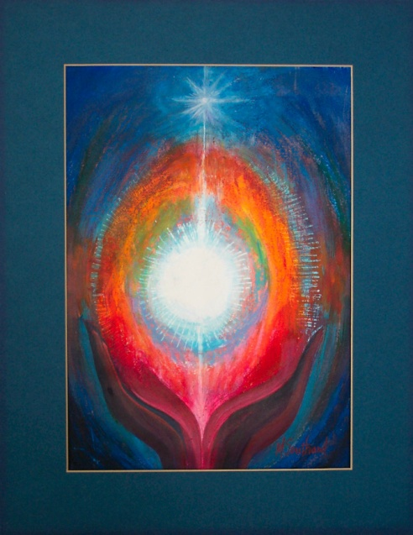

THE FULLNESS OF GOD
Deep in Christ I pray you know the power He can give.
May your hidden self grow strong and may you live
strong in faith and built on love until you know
how high and long, how wide and deep the fullness of God.

May the God of Jesus Christ, the Father we serve
Fill your hearts that you may see, deep in your heart
What hope His call now holds for you, His promise true:
To fill your heart with power to live the fullness of God.

Know the way you learnt from Christ to live life anew!
Let you heart by drawn to him, let Christ renew
The hope in you to grow into Goodness and Truth.
And living so you’ll come to know the fullness of God.
Mary Southard CSJ
Meditation 11
www.MarySouthardArt.Org ;
and www.MinistryOfTheArts.Org

Frank Andersen
– Eagles Wings

God’s Unfinished Works of Art……
Sometimes I like to imagine God as an Artist. The First Artist. And I like to imagine us as God’s unfinished art-works. Yes, unfinished. God actually doesn’t do more than sketches, never completed ‘works’. God does first drafts. God does that so we can pick up what God has started and be creators ourselves, indeed creators of ourselves……

You are meant to recognise the unfinished areas in your self and your life, and listen to the music in the silences there. You are meant to see what could be there in the blanks, if you, not God, did something to put it there. The gaps are there, intentionally, for you to play with. They are to awaken our freedom and responsibility. God gave us freedom… he wanted us to become creative like our Creator. So we are called to be creative co-creators with God and finish the ‘work of art’ God wanted us to be from the beginning.
Kevin O’Shea CSSR
Everything that happens to you is your teacher…
The secret is to sit at the feet of your own life, and be taught by it”
Polly Berends
Look at the photo of yourself as a child. Imagine and remember yourself as a child. Do some journaling.
What made you happy?
What did you love to do?
What were you curious about?
What did you dream about?
Was there someone who recognised your uniqueness as a child?
Someone who observed and named your gifts? How did they describe
you?

Now look at the photo of yourself as an adolescent. Think about how life was for you at that time. Do some further journaling.
Who encouraged you when you were exploring your
interests, identity, vocation? How did they support you?
What things did they say to you?
What were your struggles?
What did you discover about yourself?

Take time to look at the photo of yourself as an adult, spouse, parent, grandparent, leader, colleague, teacher.
What do others appreciate about you?
What do people depend on you for?
What have you learned about yourself through being a
teacher? Parent? Colleague?....

• Take 30 mins to reflect on these questions and write your responses in your journal
• Meet in groups of three
• One person begins by sharing something of their story with the others, highlighting important points from their reflection, for 10 mins.
• Others listen for the gifts they can see have developed through the person’s life; what made this child, adolescent, adult come to life?
• Once the person has finished sharing, take 5mins to share with them what you have noticed, observed, heard.
• Each other person takes their turn (You will have 60 mins sharing in this group)
• Later take time for more personal reflection
• What aspects of your gifts as a child and adolescent have flowed forward into your adult life and your role as a teacher, leader, parent, grandparent?
• What parts are lying dormant in your adult life?
• How might you re-connect with these aspects of your childhood self?

I’LL BE ALWAYS LOVING YOU
I am here with you by your side,
sheltering your heart from the night.

Where ever you go, whatever you do,
I’ll be always loving you.
I will be your God, your comforter.
I will hold you close in my heart.

Let me love the world through your heart.
Let me heal your wounds with my touch.

Let me see the world through your eyes.
Let forgiveness shine through your smile.
Trisha Watts & Monica O’Brien
(c) 1992, Trisha Watts & Monica O’Brien (McInerney),
published by Willow Publishing Pty Ltd,
PO Box 1061 Dee Why NSW 2099.
All rights reserved www.willowpublishing.com.au

Love One Another
as I have loved You

Love Your Neighbour as Yourself

Love Your Enemies

A New Commandment

Reflection and Suggestions:
This prayer needs two to three hours to engage the community at a deeper level, so is probably most suitable for a reflection day. It is a prayer that can connect the staff at a deeper level as it ‘gives permission’ to speak at depth about life’s journey and the people and events which have made who I am today. A reminder that it is important that staff honour the ‘boundary markers’ outlined in the introduction.

In preparing for this prayer it is good to give staff an invitation asking them to bring photos and suggesting that this is an opportunity to engage with each other at a deeper level. All contemporary leadership research highlights the importance of relational trust in communities where people flourish. If facilitated with respect and sensitivity, this experience can really strengthen bonds among colleagues.

If three hours are not available the staff could be given the questions for reflection at the time of issuing the invitation and encouraged to take time to ponder life’s journey prior to the gathering. They could then be drawn into the sharing experience by participating in the initial reflections and the song I’ll be always loving you. It is important to create a ‘safe’ interpersonal space before inviting such significant sharing and prayer and song can do this. You would still need about one and a half hours.

Rachel Remen’s excerpts on the importance of story could be given as pre reading to prepare for this time of more personal and intimate sharing. Another helpful article is Listening as Healing by Margaret Wheatley. It is available on the web.

SOME THOUGHTS ON STORY …

from KITCHEN TABLE WISDOM
by Rachel Naomi Remen

In telling stories, we are telling each other the human story. Stories that touch us in this place of common humanness awaken us and weave us together as a family once again. (xxvii)
The kitchen table is a level playing field. Everyone’s story matters. The wisdom in the story of the most educated and powerful person is often not greater than the wisdom in the story of a child, and the life of a child can teach us as much as the life of a sage. (xxvi)
Most parents know the importance of telling children their own story, over and over again, so that they come to know in the tellings who they are and to whom they belong. At the kitchen table we do this for each other. Hidden in all stories is the One story. The more we listen, the clearer that Story becomes. Our true identity, who we are, why we are here, what sustains us, is in this story. The stories at every kitchen table are about the same things, stories of owning, having and losing, stories of sex, of power, of pain, of wounding, of courage, hope and healing, of loneliness and the end of loneliness. Stories about God. (xxvi)
When we haven’t the time to listen to each other’s stories we seek out experts to tell us how to live. The less time we spend together at the kitchen table, the more how-to books appear in the stories and on our bookshelves. But reading such books is a very different thing than listening to someone’s lived experience. Because we have stopped listening to each other we may even have forgotten how to listen, stopped learning how to recognize meaning and fill ourselves from the ordinary events of our lives. We have become solitary; readers and watchers rather than sharers and participants. (xxvi)
Everybody has a story. When I was a child, people sat around kitchen tables and told their stories. We don’t do that so much anymore. Sitting around the table telling stories is not just a way of passing time. It is the way wisdom gets passed along. The stuff that helps us to live a life worth remembering. Despite the awesome powers of technology many of us still do not live very well. We may need to listen to each other’s stories once again. ( xvii)
Real stories take time. We stopped telling stories when we started to lose that sort of time, pausing time, reflecting time, wondering time. Life rushes us along and few people are strong enough to stop on their own. Most often, something unforeseen stops us and it is only then we have the time to take a seat at life’s kitchen table. To know our own story and tell it. To listen to other people’s stories. To remember that the real world is made of just such stories. (xxv)
Telling stories can be healing. We all have within us access to a greater wisdom, and we may not even know that until we speak out loud. (xvii)
Listening to stories can also be healing. A deep trust of life often emerges when you listen to other people’s stories. You realize you’re not alone; you’re travelling in wonderful company. Ordinary people living ordinary lives often are heroes. (xvii)
