Jesus Initiates an Encounter

THE GIFT OF ENCOUNTER

Life is filled with promises
with so many options for each of us
that in the living of it we often move and choose at random.

And then one day along the way of “life-ing”
there is an encounter
a meeting
a chance
a choice
an opportunity for living life
in a deeper, fuller way than ever before.

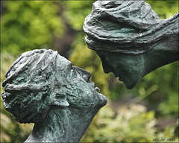
One knows when this is the moment.
One recognises that instant when another sees the dream in us
and with gentle urgings
invites us to let it be
to risk all and to let it come into being.

Mindful of God’s deep longing for each of us
and aware that this could be the moment of encounter,
let us draw close to our God in prayer.
Eleanor McNichol SSJ

LISTEN
Listen, the voice of Your God is calling.
Listen, the voice of Your God is calling,
Listen with the ear of your heart,
The voice of Your God is calling.

=Jesus Initiates an Encounter

Jesus meets a woman at a well.
John 4:1-42

http://www.youtube.com/watch?v=z7INnvnHrlg

Come to me all you who are burdened and weary
And I shall give you rest.
Come to me as you are and I shall tend to you.
Listen – Come to Me
© 1997 Monica Brown & Emmaus Productions
http://au.emmausproductions.com/
"Used with permission from
Monica Brown & Emmaus Productions".

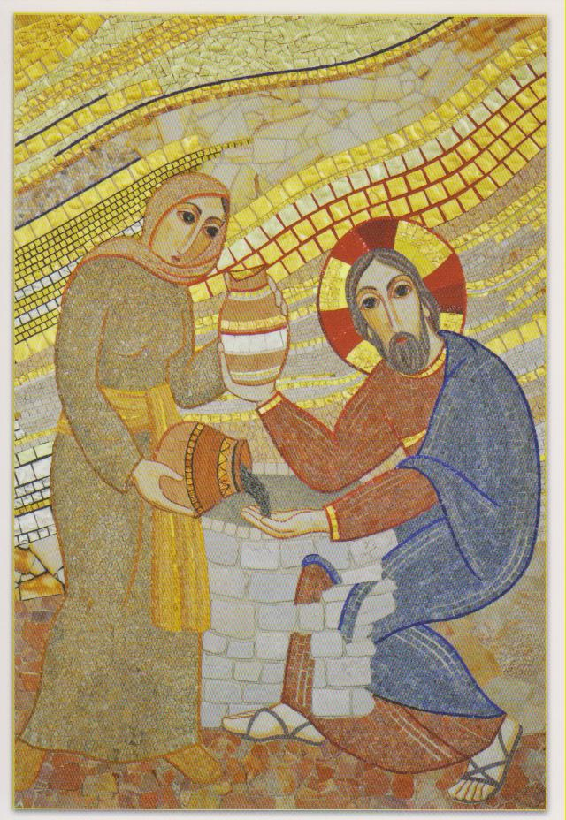
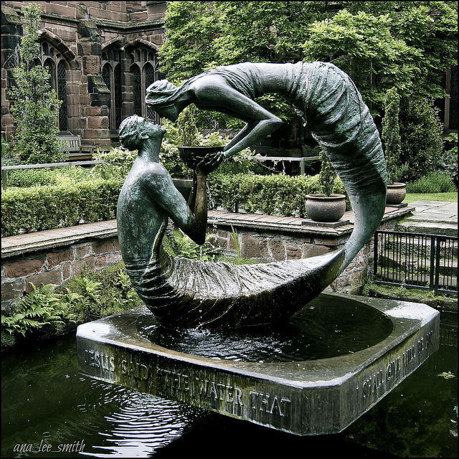
Fr. Marko I. Rupnik & Atelier of Centro Aletti
Chester Cathedral
Broadbent Studio
Let the Art Speak….

What do you:

See

Hear

Feel
Capture your reflection ….

AN ENCOUNTER AT NOON
A trip at noon.
Not the best time of the day to fetch water.
Better at dawn and dusk.

But I’m not welcome at that time.
Ignored, almost shunned by other women.
Because I’m not shunned or ignored by men.

It hurts. I long for woman’s company.

I search for the blessing in this noon trip
and find it’s the silence,
the solitude despite the heat,
the quiet rhythm of the walk.

Also there’s no queue.
Water there for the taking,
Yet I sit after drawing water.
Grateful for this well given by our father Jacob.
What would we do without water?

Today as usual I approach the well alone.
There’s someone there, sitting in my space.
From the distance I wonder who it is.
Which woman missed the morning stroll?

Arriving I am shocked,
it is a man in woman’s space!
This is not right.

Not only a man but a Jew –
his clothing tells me that.

And then he speaks to me:
‘Give me a drink.’
This is not right; it’s against the law.
I tell him so.
Almost mock him as he has no bucket!
He asks about my life.
He knows but does not judge me.
In his presence, his gaze,
something within shifts…
I am broken open –
so different from being broken down!

Broken open for living water….
Refreshed and renewed in an unexpected encounter…

I cannot hold this to myself.
In haste …back to the village where I’m shunned…
But they listen, they respond, they hasten to the well.

And a whole village is blessed with living water.
Leone Pallisier

But there is something about him
and I begin to look, to listen…
There is a presence in this man.
He’s comfortable with me.
Seems to look into my soul
not gloat over my body as so many do.

I relax. He talks about living water….
I joke with him about that –

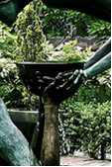
LIVING WATER
I will give you living water,
Shade to rest under,
Strength for your heart.
Grow deep within me,
Filled by my spirit,
My burdens are easy,
My life it is yours.

We have been with the lonely.
To the empty we’ve carried…
Your word of hope and of life.
Build us now beyond our hopes and dreams
‘Till we live in you.
Frank Andersen
– Eagles Wings

To the hungry we’ve given your bread.
We now come with all our hopes and dreams
To rest awhile with you.

Time Alone
Spend time alone trying to enter the
mind and heart

……of Jesus…..

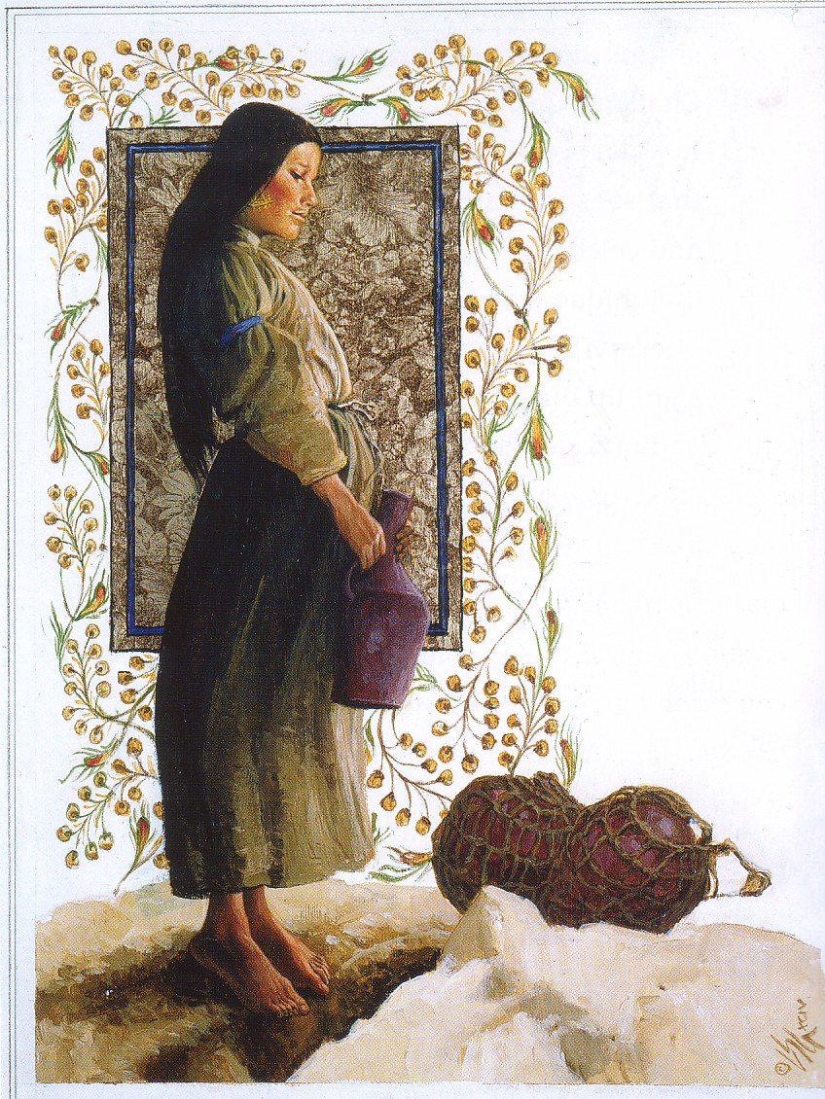
….of the Woman…..
Louis Glanzmann

What are you hearing?

Where might be ‘the well’ in your life?

Name some of the encounters in your life

…..that have been life giving….

…that enabled you to live YOUR life, not the expectations of another…..

..that maybe changed your life direction… or deepened your response to and appreciation of life...

Alive
to be really alive
that was what she wanted.
To be alive
to be taken seriously
for who she really was
that was the dream welling up in her heart
as she sauntered along with water jar in hand.

Thirst
thirsting for more of life
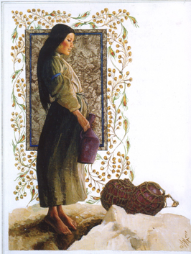
was the song which sang in her spirit
Glanzmann
as she reached the well at noon.

Gift
the gift of encounter
was God’s gift to her that day.
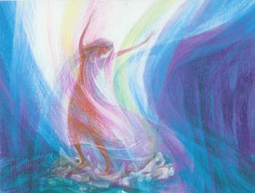
Dream
God’s dream in her was set free.

Eleanor McNichol SSJ

Thoughts and suggestions
This text appears in the early chapters of John’s gospel. In the encounter Jesus reveals himself as Messiah to a Samaritan, a Samaritan woman who is an outsider in her own community. Through this he is teaching the universal nature of his mission – that it is not for the Jews alone.

If you have access to the YouTube clip it can give you another experience of the text. If not you might get different people to take the various roles. In this way the sense of encounter is emphasised.

There is wonderful art work on this text and although readily available on the net acquiring copyright was not easy at all. I have chosen these two: Through Marko Rupnika’s mosaic, which is in the chapel of the Ursulines sisters in Slovenia, we are drawn into the encounter through the gestures and the eye contact. Notice she is pouring out the ashes of her life and receiving the promised living water. In the other which rests in the grounds of Chester Cathedral the focus is on the encounter between Jesus and the woman. I find that art so often breaks open new insights for people, and the sharing with others expands the understanding and appreciation of the text.

Poetry, art and music are the language of the soul. I suggest that you encourage people to have a go at writing some poetry – it is a wonderful way to ‘get inside’ another in a way that speaks to your life and experience. And often invitations emerge as you write. I know that from experience.

Hopefully this prayer will alert participants to the potential for life that is possible in daily and often unexpected encounters. That is where we live and share the good news, just as Jesus did.

