The Seasons of our Lives
The seasons are etched into the very fibre of our being. The unfolding of the universe, the cycle of life we see all around us each year, is displayed in the trees and plants, and in the weather we experience. In this we find a rich metaphor for the journey of our own life. The prayers that follow are crafted around these seasons.

The Sower went out to sow the seed….

TEACH ME YOUR WAYS
Teach me your ways,
Walk me in your pathways.
Teach me your ways, O Lord,
For you are my God.
Frank Andersen
– Rising Moon

TO BE OF THE EARTH
To be of the Earth is to know
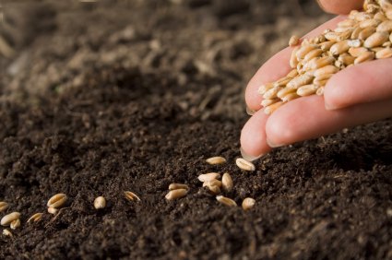
the restlessness of being a seed
the darkness of being planted
the struggle towards the light
the pain and growth of the light
the joy of bursting and bearing fruit
the love of being food for someone
the scattering of your seeds
the decay of the seasons
the mystery of death
and the miracle of birth.
-John Soos

A reading from the gospel according to Matthew
Jesus left the house and sat by the lakeside, but such crowds gathered round him that he got into a boat and sat there. The people all stood on the beach, and he told them many things in parables.
He said:
‘Imagine a sower going out to sow. As he sowed some seeds fell on the edge of the path, and the birds came and ate them up. Others fell on patches of rock where they found little soil and sprang up straight away, because there was no depth of earth; but as soon as the sun came up they were scorched and, not having roots, they withered away. Others fell among thorns, and the thorns grew up and choked them. Others fell on rich soil and produced their crop, some a hundredfold, some sixty, some thirty. Listen, anyone who has ears!”
Matthew 13:1-9

WHERE THE SEEDS FELL
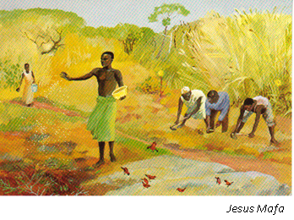
The soil
my self.

The sowers
those good and not-so:
folks and
circumstances.
And chance and grace –
yes, these twin sisters.

The seeds.
They dropped heavily
those large and fulsome seeds
unexpectedly on heart soil.
But they all but disappeared
Time and no-time
has played the lead
with my unconscious receptivity,
my ready spirit.

The flowers have bloomed,
the fruit grown ripe,
and yet more seeds take root
and harvests yet to come await.

I
I am left with wonder
knowing I am held.
- Marianne Novak Houston

those mustard seeds
of rich potential
unnoticed in their delicacy.
Those winged seeds
lightly blown on gusts
of winds at work.
Carried by rain and flood
warmed by sun
nestled in shade
the seeds.

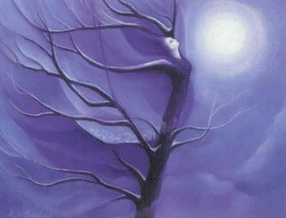
Mary Southard CSJ
Tree Dancer
www.MarySouthardArt.Org ;
and www.MinistryOfTheArts.Org

REMEMBER WHO YOU ARE
Earth are you with human face.
Earth are you with human heart.
Remember who you are.
Remember who you are.
Kathy Sherman
– Song of the Universe
Courtesy of www.ministryofthearts.org
Congregation of St. Joseph

Let your life speak….
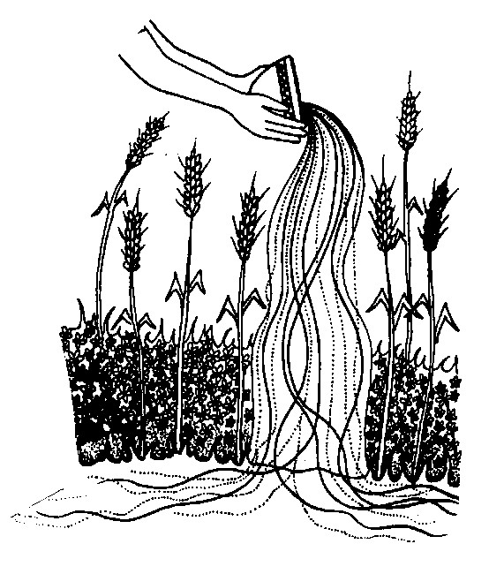

SEEDS OF MY CALLING
I never dreamed that seeds cast so seemingly at random, years ago,
would be so important to my life-sustaining vocation as an educator.

A teacher

You need only claim the events of your life to make yourself yours.
When you truly possess all you have been and done, which may take some time,
you are fierce with reality.
Florida Scott Maxwell

- Think deeply about the seeds – your natural gifts and abilities - which have grown into your life’s calling. Think about the events, relationships and decisions that have nourished these seeds in the course of your life.

- Choose three or four of these events, relationships or decisions. Soo’s poem reminds us that nurturing the seeds may involve restlessness, darkness, struggle, pain or decay, as well as joy, love, mystery and miracle.

- Write a sentence or two about each one that captures something about its significance. Feel free to sketch or draw to aid in your exploration and pondering of your thought.

Small group work: In groups of three, each will share whatever feels comfortable about what has been identified. There may be some events or relationships that you don’t feel comfortable talking about. That’s fine. In your sharing tell a brief story about the people or events you identify. Your group members will listen without giving advice or ‘fixing’ you, interacting simply by asking questions that might help you go deeper into the significance of these life-bearing moments and thus help you identify some of your natural gifts.

Let us conclude our prayer and reflection with the mantra: TEACH ME YOUR WAYS
Everything that happens to you is your teacher…
the secret is to learn to sit at the feet of your own life
and be taught by it.
Polly Berends

