Teaching as Vocation…
LISTEN
Listen, the voice of Your God is calling.
Listen, the voice of Your God is calling,
Listen with the ear of your heart,
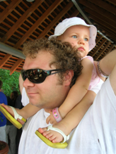
The voice of Your God is calling.
© 1997 Monica Brown & Emmaus Productions
http://au.emmausproductions.com/
"Used with permission from
Monica Brown & Emmaus Productions".
SHOULDERS
A man crosses the street in rain,
stepping gently, looking two times north and south,
because his son is asleep on his shoulder.
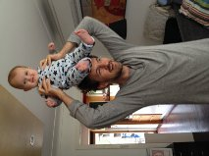
No car must splash him,
No car drive too near to his shadow.

This man carries the world’s most sensitive cargo
but he’s not marked.
Nowhere does his jacket say FRAGILE,
HANDLE WITH CARE.

His ears fill up with breathing,
He hears the hum of a boy’s dream
deep inside him.

We’re not going to be able
to live in this world
if we’re not willing to do what he’s doing
with one another.
Is there something in this poem that speaks to you?
Have some conversation with the person next to you…..

The road will only be wide.
The rain will never stop falling.
Naomi Shihab Nye

A reading from the gospel according to Matthew
People brought little children to Jesus, for him to lay his hands on them and say a prayer. The disciples turned them away, but Jesus said,
‘Let the little children alone, and do not stop them coming to me; for it is to such as these that the kingdom of heaven belongs’.
Then he laid his hands on them and went on his way.
Matthew 19:13-15

Teachers engage daily in the most profound work: nurturing the mind, heart and spirit of children, the future of a nation… let us take time to reflect deeply on the rich ministry that is entrusted to us….and explore it through the image of Midwife

Teacher as Midwife
Bringing to birth that which is already alive and becoming….. seeing the child as subject of her learning.

Creating a trusting and hospitable space where
- discovery of skill and talent is nurtured and celebrated
- ideas can be explored, expanded, corrected, affirmed – giving birth to a growing truth…
- experience can be reflected upon and values clarified and strengthened

Nurturing an interpersonal space where each is midwife to the other – the teacher is student and the student is teacher.
Student as Midwife

Let this story speak..

THE FREEDOM OF OUR DEEPEST SELF
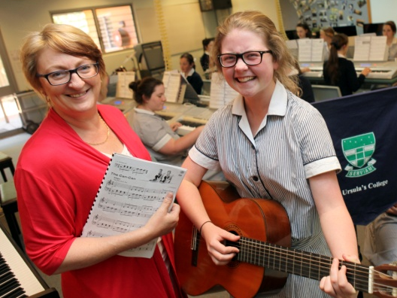
I was a junior in high school, student of a beloved English teacher who was fair, but tough. If Mrs. Allen gave a good grade you knew you had earned it. She did not grade out of kindness, nor did she reward ‘potential’. One weekend she asked our class to write a paper from the point of view of the King of England who had abdicated his throne for love.

A week later she walked between the rows putting the graded essays face down on each desk. As she laid my paper in front of me she paused and said, “Your essay made me cry”. It wasn’t much. Five words. I know I am a writer today because of that moment. I knew that her evaluation meant something.

In some respect we are always hoping for someone to see not only our talents, but our deepest self and the power it embodies. There are so many polite ‘no’s’ and ‘yes’s’ in our lives. In many ways we avoid the heart of things, and shy from what lies beneath the surface. Lending our lives to a deeper meaning and the emergence of truth is very different. It demands vigilance and commitment. It may involve choices that set us apart.

This is what’s required to be ‘born again in the spirit’. From the heart of all things the Greater Soul asks us to pull our boats up on the beach, nets and all. Put those things aside. Follow me.
Paula D’Arcy – Daybreaks 2007

Learning from our own experience…
Was there a ‘Mrs Allen’ in my life?

In The Courage to Teach Guide for Reflection and Renewal it is said:
The best gift we receive from great mentors is not their knowledge or their approach to teaching but the sense of self they evoke in us.
1. Ponder one of your favourite teachers. What do you recall most vividly about that teacher? How did he or she make you feel? What was his or her relation to the subject taught: What was the ethos in the classroom? What does that scenario tell you about the teacher’s identity and integrity?

2. Thinking about that same teacher, what does his or her story tell you about who you were at that time in your life? What was it about you, and about that moment in your life, that makes this teacher great for you? What gift or truth about yourself did that teacher help reveal?

3. Imagine yourself a student in one of your classes. How would she or he respond to question 1 in relation to you as teacher?

4. Choose two students you teach at present. Commit to words what you imagine each of them is asking of you as teacher in their present life situation?

5. What aspects of your current work seem most congruent with your own nature, your soul’s needs?

6. What dimensions of yourself or soul seem most endangered by the work you do?

7. What could you do to make teaching more fruitful for yourself and for the students you teach? Is there a seed within you awaiting birth?

TEACHERS AS MIDWIVES
Within that student lie
hopes and dreams
often not recognised
sometimes dormant through fear.

As teacher may I midwife
these hopes and dreams.

Within that student
are talents galore
awaiting a word of encouragement,
the support to have a go
keep exploring, stretching
until the skill is honed.

As teacher may I midwife
these talents and skills.

I ponder that student
sitting quietly….
revealing little…
what is her story?
Who is her listening ear?

As teacher may I midwife
a confidence to tell her story.

That young boy before me
experiencing disappointment
and failure
longing for someone
to believe in him.

As teacher may I midwife
the strength not to give up.
Leone Pallisier
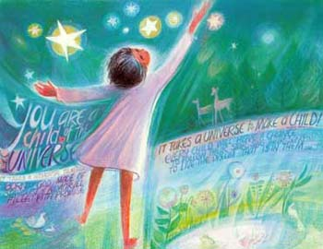
Mary Southard CSJ
Child-of-the-Universe
www.MarySouthardArt.Org ;
and www.MinistryOfTheArts.Org
YOU RAISE ME UP
When I am down, and oh my soul so weary
When troubles come and my heart burdened be.
Then I am still and wait here in the silence
Until you come and sit awhile with me.

You raise me up so I can stand on mountains.
You raise me up to walk on stormy seas
I am strong, when I am on your shoulders
You raise me up to more than I can be.

There is no life, no life without its hunger.
Each restless heart beats so imperfectly;
But when you come and I am filled with wonder
Sometimes I think I’ve glimpsed eternity.
Lyrics by Brendan Graham
Secret Garden

