Nurturing a Contemplative Heart

HOLY GROUND
You are here, so this is holy ground.
In all that is, You are here.
This is holy ground, the ground of my being now.
My spirit bows to you upon this holy ground.
© 2000 Monica Brown & Emmaus Productions
http://au.emmausproductions.com/
"Used with permission from
Monica Brown & Emmaus Productions".

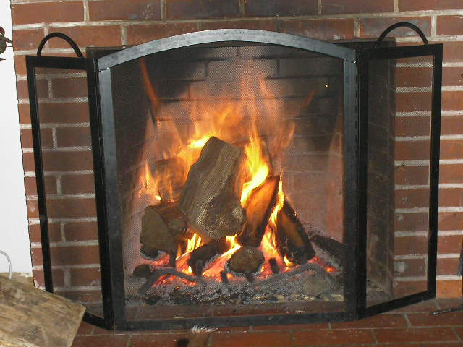FIRE

What makes a fire burn
is space between the logs,
a breathing space.
Too much of a good thing,
too many logs
packed in too tight
can squelch a fire,
can douse the flames
almost as surely
as a pail of water can.

So building fires
requires tending in a special way,
attention to the wood
Then we can watch it as it leaps and plays,
burns down and then flames up
in unexpected ways.

Then we need only lay a log on it
from time to time.
Then it has life all of its own,
a beauty that emerges
not where logs are
but where spaces can invite the flames
to burn, to form exquisite
patterns of their own,
their beauty possible
simply because the space is there,
an opening in which flame
that knows just how it wants
to burn can find its way.
Judy Brown
The Art and Spirit of Leadership
as well as the spaces in between,
so fire can catch, can grow, can breathe,
can build its energy and warmth
which we so need in order
to survive the cold.

We need to practise
building open spaces
just as clearly as we learn
to pile on the logs.
It’s fuel, and absence of the fuel
together, that make fire possible,
let it develop in the way that’s
possible when we lay logs in just the
way the fire wants to go.

What words, phrases or lines spoke to you …

Jesus urges us to seek solitude

A reading from the gospel according to Matthew
And when you pray, do not imitate the hypocrites: they love to say their prayers standing up in the synagogues and at the street corners for people to see them. I tell you solemnly, they have had their reward. But when you pray, go to your private room and, when you have shut the door, pray to your Father who is in that secret place, and your Father who sees all that is done in secret will reward you.
Matthew 6:1-6

What do we do in solitude?

LISTEN TO THE SPACES
Spaces have their own lives.

Let them speak
Listen to them with your eyes
in the quiet of your mind.

Give them the time they need
to tell their stories
for they are the nurseries and pits of life
the fields of strength ready for the harvesting
the cultivators of our bigger minds.
We crowd them out to stifle our fears
to douse the pain refining our humanity.

Let them be.
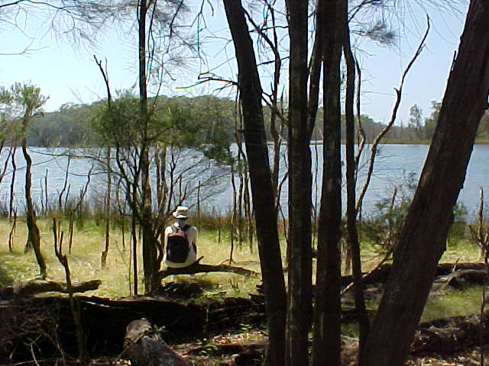
Wonder in the beauty of their being
like the unseen air we breathe
the wind now still.
They hold the silence vibrant with life
the source of all being.

Listen then to their stories
and they will take you
deep into the naked heart of your reality
and there gift you with new sight.

Noel Davis
– Heart Gone Walkabout

As you listen to and ponder the wisdom in the poems and the scripture, what are you seeing, hearing, feeling?

Is there an invitation? How will I respond?

A song to remind us we are never alone….

YOU ARE MINE
I will come to you in the silence,
I will lift you from all your fear.
You will hear my voice,
I claim you as my choice,
be still and know I am here.
I am strength for all the despairing,
healing for the ones who dwell in shame.
All the blind will see,
the lame will all run free,
and all will know my name.

I am the Word that leads all to freedom,
I am the peace the world cannot give.
I will call your name,
Embracing all your pain,
stand up, now walk and live.
David Haas
The Best of David Haas 2
©GIA:www.giamusic.com

I am hope for all who are hopeless,
I am eyes for all who long to see.
In the shadows of the night,
I will be your light,
Come, and rest in me.

Do not be afraid I am with you.
I have called you each by name.
Come and follow me,
I will bring you home.
I love you and you are mine.

Thoughts and Suggestions
In our increasingly busy lives and world a regular practice to move into a quiet space enables us to remain centred and listen to the longings deep within. In her book, The Art and Spirit of Leadership, Judy Brown, leadership educator, poet, writer and speaker articulates twelve practices / principles that invite us to attend to the inner life. If we take the inner life seriously, we will live more fulfilled lives and contribute to the well-being of those with whom we live and work.
Here are the practices:
- Listen to yourself. Know what makes your heart sing.

- Pay attention to small, early signs of the presence of the world you long for.

- Model humour, humanity and humility.

- Practise generous, wide curiosity.

- Create open spaces for yourself and for others

- Practise creativity and hold on to the powerful images that emerge from that practice.

- Expect to find gems, gifts and great surprises in the most unexpected packages.

- Take the risk of being less than perfect.

- Lead with story and invite story from others.

- Follow the threads of aliveness.

- Risk speaking in your natural voice.

- Take are of yourself; you are a treasure.

It is hoped that the reflections in each section of this publication will assist you to explore these practices and enable you to live with greater awareness and integrity.

