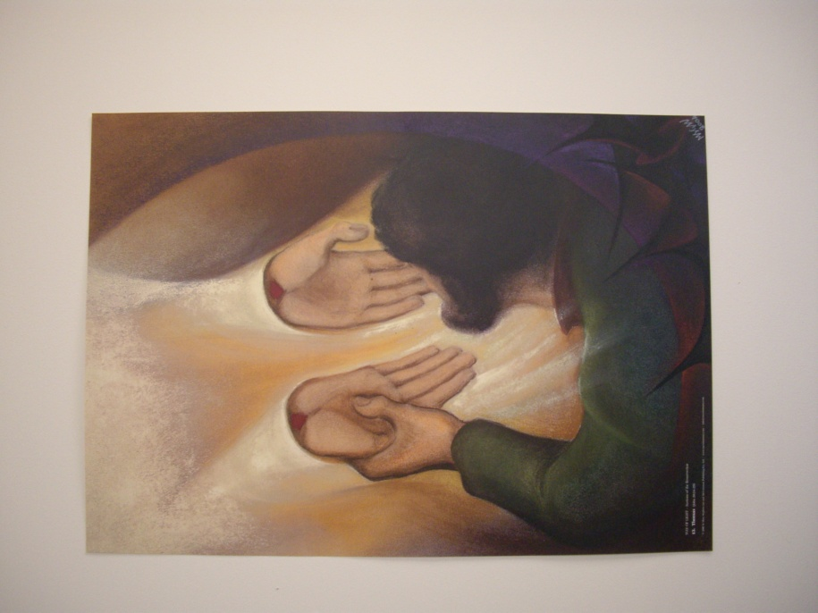Lent an invitation to live with greater awareness and intention….
Mary Stephen CRSS

LEAD ME, GUIDE ME
Lead me, guide me in your way
Lead me, guide me in your way
Lead me, guide me in your way
Your holy way, O my God.

© 1993 Monica Brown & Emmaus Productions
http://au.emmausproductions.com/
"Used with permission from
Monica Brown & Emmaus Productions

A reading from Paul’s second letter to the Corinthians
We are ambassadors for Christ; it is as though God were appealing through us, and the appeal that we make in Christ’s name is: be reconciled to God. For our sake God made the sinless one into sin, so that in him we might become the goodness of God. As his co-workers, we beg you once again not to neglect the grace of God that you received. For he says: At the favourable time, I have listened to you; on the day of salvation I came to your help. Well, now is the favourable time; this is the day of salvation.
2Corinthians 5:20-6:2

During this Lenten journey our task is to reflect upon our life as disciples of, and ambassadors for Christ. We are asked to ponder how we fail to love, to forgive, to speak out for the oppressed. We are invited to accompany Jesus in his final weeks as the religious and political leaders, fearful of Jesus’ increasing influence and following, begin to plot against him.
What action can I take to make me a more joy-filled disciple as Francis, Bishop of Rome, has encouraged us to be? Is there a phrase or a line in the song or the scripture that caught your attention? If so, sit with it and let it speak, let the Spirit speak through these words…
Can I look differently at sin? As an invitation to grow into a more loving person? If I am holding something from the past that is diminishing a relationship can I release both myself and the other through letting go and some healing gesture? Do I judge people or situations hastily and refuse to consider that I might be wrong? Have I imbibed the culture of individualism so that I am unaware of the calls to engage within the community of family, work, local church, civic community? In what ways do I contribute to the life of others?
Where is the invitation for me as we begin this Lenten journey?

In John’s Gospel we read:
To the Jews who believed in him Jesus said:
If you make my word your home
you will indeed be my disciples;
you will learn the truth
and the truth will make you free.
John 8:31

Is there a word, phrase or text of Scripture that you could use as a mantra to remind you of the Lenten call to a deeper sense of discipleship? E.G. In the secret of my heart teach me wisdom (Psalm 50); Lord that I might see (Luke 18:41); Follow me (Matthew 4:19);
Write the text on the piece of paper provided, place it in the envelope with your name and during the final song place it in the Lenten basket.
This final song reminds us that we do not journey alone…. Our God is always with us even if we are unaware…

STRONG AND CONSTANT
I will be Yahweh who walks with you!
You will be always within my hand!
Take your heart and give it all to me!
Strong and constant is my love!
Strong and constant is my love!

Should you wander far away from me,
I will search for you in every land!
Should you call, then you will truly know:
Strong and constant is my love!
Strong and constant is my love!

When you know sorrow within your life,
I will come! I will embrace your heart!
Through your pain you will discover me!
Strong and constant is my love!
Strong and constant is my love!
Frank Andersen
– Eagle’s Wings

Go forth aware that you do not walk alone…

Thoughts and Suggestions:
The community can call us to a more conscious engagement in our faith journey during Lent. And some tangible ritual can focus us. I suggest a basket into which these Lenten decisions can be placed be left in a place in the staff room where they can be a constant reminder to staff. Half way through Lent you might invite people to open them and have a moment of quiet to ponder the journey to date. You will need to provide envelopes and a piece of paper for each person.

