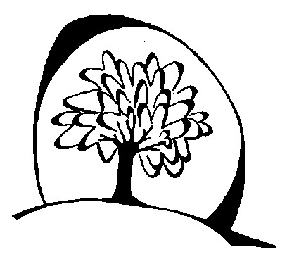

Introduction
The Seasons of our Lives
The seasons are a rich metaphor through which to ponder the unfolding of our lives. They are with us daily even if we are not conscious of them. However If we become attuned to their rhythm with both their demands and gifts, the seasons might invite us to live with greater awareness, attention and intention.
Seasons could be the focus of an entire year of prayer and reflection for a staff. Within them is etched the Paschal Mystery, the heart of our faith. It was through the life, growth, death and rising to new life that Jesus shared with us the mystery of God at the heart of our being.
The seasons provide a gentle way for those disengaged with religious practice to enter into the inner journey through another door. Pondering the seasons can lead to deep personal reflection, sharing and dialogue. In this way relationships can be strengthened among staff nurturing a deeper trust which is the heart of a vibrant learning community, a community where staff and students flourish. As Margaret Wheatley keeps reminding us: Relationships are all there is. That too is the heart of the gospel ‘I have come that you might have life, and have it to the full.’ We experience this in community.
The following reflections are an introduction to the seasonal nature of our lives. Additional resources can be found in the following publications:
Let your life speak: Listening to the voice of vocation
Parker Palmer Jossey Bass Inc. Publishers. ISBN 0-7879-4735-0
This is available in Kindle

The Circle of Life: The heart’s journey through the seasons
Joyce Rupp and Macrina Wiederkehr Sorin Books Indiana ISBN1-893732-82-7
This is available in Kindle

A Mystic Garden : Working with soil, attending to soul
Gunilla Norris BlueBridge NY ISBN1-933346-01-9

